2.4 Dry Bulk and Neo-Bulk Cargo Assessment Update

2.4.1 Introduction
This section presents dry bulk and neo-bulk cargo forecasts for Port Everglades through the 2029 planning horizon, updating the information provided in the 2006 Port Master Plan. The forecast development is based on the historical Port Everglades reported cargoes, detailed trade data from the Journal of Commerce (JoC) PIERS system, interviews with shippers and terminal operators for major commodities, and economic and population forecasts.
Methodology. Historical data for dry bulk and neo-bulk cargoes handled by Port Everglades were initially obtained for FY 2000 through FY 2006. Recent data were obtained for this update for FY 2007 and FY 2008 plus preliminary data for the first half of FY 2009. These data were utilized to develop the historical trends by commodity.
Detailed trade data from the JoC PIERS system were originally obtained for FY 2005 and for calendar year 2005, plus sample months from 2004 and 2006. Updated JoC data were obtained for the fourth quarter of 2007 and all of 2008. The JoC data were calibrated against the Port Everglades data. The JoC data included detailed information on shippers and consignees, carriers, vessels, and inland origins and destinations. After calibration of the JoC data with the Port Everglades data, interviews were conducted with the major shippers for each of the major dry bulk and neo-bulk commodities.
Finally, forecasts of population, construction, and other economic data were obtained for Florida and Broward County for both the near-term and the long-term. Forecasts from February and October 2006 were used in the initial analysis. Updated data from March and May 2009 were obtained for this analysis. The housing-start growth rate for Florida represents an appropriate mix between single-unit and multi-unit construction and between slower and faster growing areas, all of which is served by Port Everglades. The severe decline in housing starts in Florida has significantly impacted the short-term market for dry bulk and neo-bulk commodities moving through Port Everglades.
The forecasts included in this section, as a result, reflect the short- and long-term economic trends applied to the base cargo tonnages, combined with the additional factors identified through shipper interviews. The factors impacting the key commodities in the short- and long-term were identified and incorporated into the forecasts.
As part of this assessment, a baseline forecast, a low forecast, and a high forecast were developed. The high forecast includes the development of facilities for handling a significant increase in imported crushed rock aggregate that may result from court-ordered limitations on the Lake Belt mines in Miami-Dade County.
Housing Start and Population Factors. The primary factor impacting this update is the collapse of the housing market in 2007 and 2008. Florida housing starts declined between 2006 and 2008 by 70.9 percent from the peak in 2006. Housing starts are projected to decline further in 2009 and 2010 by another 61.4 percent before recovering.
Tables 2.4-1 and 2.4-2 provide the latest housing start and population forecasts for Florida. Housing start projections are available from FY 2004 through FY 2019. Population projections from 2019 through 2029 were used to forecast housing starts through 2029, as shown in Figure 2.4-1.

Figure 2.4-1

Florida Private Housing Starts
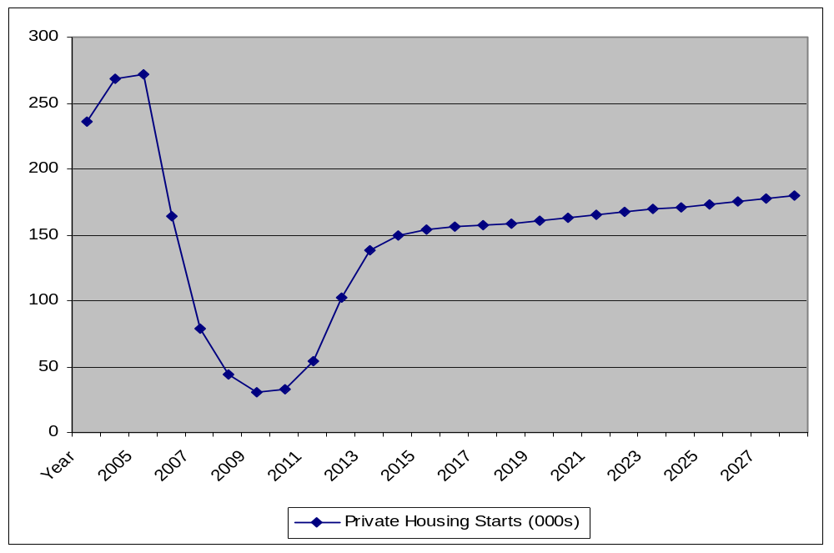

Since the previous forecast in 2006, projections of population growth for 2029 have decreased by 4.02 percent and projections of 2029 housing starts have decreased by 30.4 percent. This decline in long-term housing starts reduces the future levels of dry bulk and neo-bulk commodities projected to move through Port Everglades.

Table 2.4-1
Florida Economic Forecasts

Fiscal Year | 03-04 | 04-05 | 05-06 | 06-07 | 07-08 | 08-09 | 09-10 | 10-11 | 11-12 | 12-13 | 13-14 | 14-15 | 15-16 | .16-17 | 17-18 | 18-19
Private Housing Starts | 236.3 | 269.1 | 271.9 | 163.8 | 79.2 | 43.7 | 30.6 | 32.8 | 54.3 | 102.2 | 138.7 | 149.1 | 153.4 | 155.8 | 157.4 | 158.6
Single Family Starts | 163.2 | 182.0 | 180.2 | 87.6 | 44.9 | 24.9 | 16.2 | 17.9 | 32.5 | 61.5 | 89.4 | 96.9 | 99.1 | 100.7 | 101.8 | 102.4
Multi Family Starts | 73.2 | 87.1 | 91.7 | 76.2 | 34.3 | 18.8 | 14.4 | 14.9 | 21.8 | 40.7 | 49.3 | 52.3 | 54.2 | 55.0 | 55.6 | 56.2
Total Construction $ | 54,994 | 63,916 | 73,740 | 60,063 | 49,764 | 33,779 | 28,318 | 29,132 | 35,612 | 48,301 | 61,704 | 68,347 | 72,595 | 76,569 | 80,510 | 84,388
Percent Change
Private Housing Starts |  | 13.9% | 1.0% | -39.8% | -51.6% | -44.8% | -30.0% | 7.2% | 65.5% | 88.2% | 35.7% | 7.5% | 2.9% | 1.6% | 1.0% | 0.8%
Single Family Starts |  | 11.5% | -1.0% | -51.4% | -48.7% | -44.5% | -34.9% | 10.5% | 81.6% | 89.2% | 45.4% | 8.4% | 2.3% | 1.6% | 1.1% | 0.6%
Multi Family Starts |  | 19.0% | 5.3% | -16.9% | -55.0% | -45.2% | -23.4% | 3.5% | 46.3% | 86.7% | 21.1% | 6.1% | 3.6% | 1.5% | 1.1% | 1.1%
Total Construction $ |  | 16.2% | 15.4% | -18.5% | -17.1% | -32.1% | -16.2% | 2.9% | 22.2% | 35.6% | 27.7% | 10.8% | 6.2% | 5.5% | 5.1% | 4.8%
Source: Florida Economic Estimating Conference Long Run Tables, March 09

Table 2.4-2
Florida Population Projections

2000 | 2001 | 2002 | 2003 | 2004 | 2005 | 2006 | 2007 | 2008 | 2009 | 2010
15,982,824 | 16,330,224 | 16,674,608 | 17,071,508 | 17,516,732 | 17,918,227 | 18,349,132 | 18,680,367 | 18,851,975 | 19,058,404 | 19,308,066
 | 2.17% | 2.11% | 2.38% | 2.61% | 2.29% | 2.40% | 1.81% | 0.92% | 1.09% | 1.31%
2011 | 2012 | 2013 | 2014 | 2015 | 2016 | 2017 | 2018 | 2019 | 2020 | 2021
19,632,445 | 19,976,994 | 20,312,447 | 20,637,535 | 20,955,858 | 21,266,839 | 21,574,348 | 21,878,443 | 22,180,747 | 22,477,886 | 22,770,553
1.68% | 1.75% | 1.68% | 1.60% | 1.54% | 1.48% | 1.45% | 1.41% | 1.38% | 1.34% | 1.30%
2022 | 2023 | 2024 | 2025 | 2026 | 2027 | 2028 | 2029
23,060,425 | 23,353,733 | 23,651,001 | 23,955,119 | 24,245,452 | 24,527,276 | 24,804,983 | 25,078,222
1.27% | 1.27% | 1.27% | 1.29% | 1.21% | 1.16% | 1.13% | 1.10%
Source: Florida Legislature, Office of Economic and Demographic Research, Florida Demographic Estimating Conference, February 2008 and the Florida Demographic Database, August 2008.

2.4.2 Commodity Overview

The overwhelming proportion of the dry bulk and neo-bulk cargoes handled through Port Everglades are related to the construction industry. Dry bulk cargoes are dominated by cement and aggregates, which are used in the production of cement, including gypsum, bauxite, and fero (iron oxides and slag), etc. Other than these commodities, Port Everglades’ dry bulk revenue category includes only tallow exports and, previously, an occasional coal shipment.
Similarly, the largest proportion of the neo-bulk cargoes is related to the construction industry, including steel (rebar and sheets) and, previously, lumber. Lumber and auto tonnages are not currently handled at Port Everglades in significant volumes. Other than steel, the Port’s neo-bulk revenue category includes yachts and a few one-time commodities. Recently, only yachts and bagged cement have moved in addition to steel.

2.4.3 Dry Bulk Cargoes (Cement and Aggregates)

Long-Term Forecasts. Over the long-term, construction industry growth rates will approach population growth rates. The growth rates of commodities related to the construction industry will approach construction growth rates and, therefore, population growth rates. In the long-term, growth rates for construction-related commodities are projected to approach the long-term population growth rates for Florida.
The short-term economic cycles impacting construction growth have dominated the long-term trends; for example, the housing downturn that occurred in 2001 occurred again to a much greater extent in 2007 and 2008. The previous economic forecasts for housing starts projected a 2007 decrease of 36 percent for Florida followed by limited recovery in 2008 and growth in the following years. As shown in Table 2.4-1, however, housing starts declined 39.8 percent in FY 2007, followed by a decline of 51.6 percent in FY 2008. This decline is projected to continue with a further 44.8 percent drop in FY 2009 and another 30.0 percent in FY 2010.
Cement. Inventory level changes for cement imports and adjustments for new cement plant capacity levels and import cycles for rebar imports have also impacted the short-term trends. As a result, the decrease in cement imports in 2007 and 2008 was greater than the decrease in housing starts, due to the addition of domestic cement capacity. At the same time, imports of aggregates did not fall with the decline in housing starts, since aggregates are required for domestic cement production.
As shown in Figure 2.4-2, cement import tonnages appear to be leveling off in 2009, despite the continued decline in housing starts projected for 2009 and 2010. Cement decreased by 79.9 percent between 2006 and 2008 due to the decline in housing starts and the increase in domestic cement production. Decreased domestic production, combined with the potential impact of volume minimums through Port Everglades, appear to have contributed to this leveling of cement imports in 2009, based on the first half of FY 2009 tonnages.

Figure 2.4-2
Cement, Gypsum, Bauxite and Fero

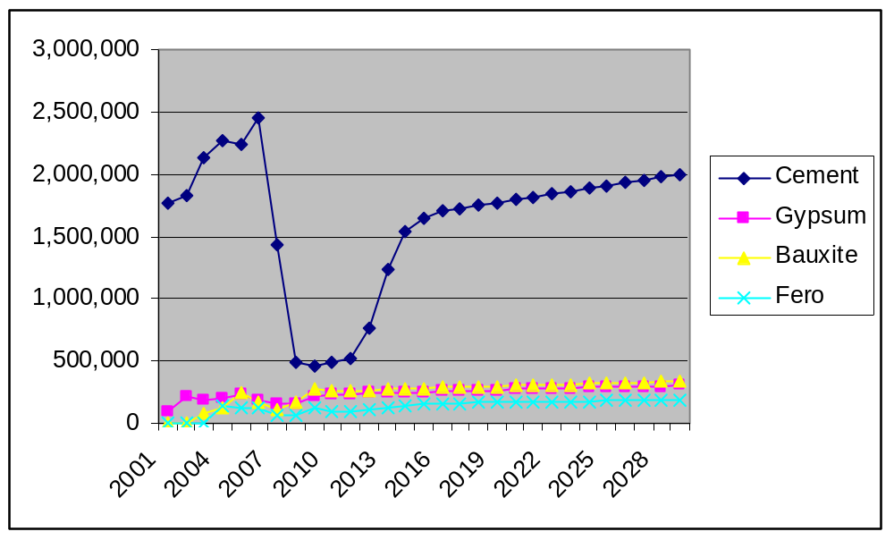

Crushed Rock. The court-ordered limitation on Lake Belt mining in Miami-Dade County creates an opportunity for significant imports of crushed rock aggregate through Port Everglades. This event represents only a contingency, however, given the continued uncertainty of future court decisions. Nevertheless, it must be considered due to its major upside potential. Since the previous forecast, the court has temporarily ordered mining in the Lake Belt to cease, the appeals court reversed that ruling, and a final court order has stopped Lake Belt mining.
Having released a Supplemental Environmental Impact Statement (SEIS) in May 2009, and received comments through June 2009, the ACOE was preparing a Record of Decision as of October 2009, which should be available by the end of the year. The findings will determine whether new mining permits will be issued. Those permits are likely to be challenged again, however, and the net result should be limited mining in the Lake Belt region, which will not meet Florida’s future requirements. The SEIS identified the Port of Jacksonville and the Port of Tampa as major ports for expanded crushed rock imports. Although Port Everglades was mentioned in the SEIS, it was not identified as a potential importer of crushed rock because of the lack of suitable facilities. Nevertheless, Port Everglades represents a primary location for imported crushed rock.
Concerned with the impact of the Lake Belt mining ban on the state’s supply of aggregate for construction, FDOT commissioned a Strategic Aggregates Study, which was released in March 2007. That study confirmed the importance of the high quality product mined from the Lake Belt region and expressed concern about the adequacy of the aggregate reserves to meet the long-term statewide demand. At the time, it was estimated that the annual statewide demand was approximately 150 million tons and that the known in-state reserves did not appear adequate to supply the projected 5- to 10-year growth. The study also confirmed that, despite the presence of mining resources elsewhere in the state, as shown in Figure 2.4- 3, the quality of rock outside the Lake Belt region is not as high as that found within the region.
Figure 2.4-3
Limestone and Sand Resource Areas
Source: Strategic Assets Study
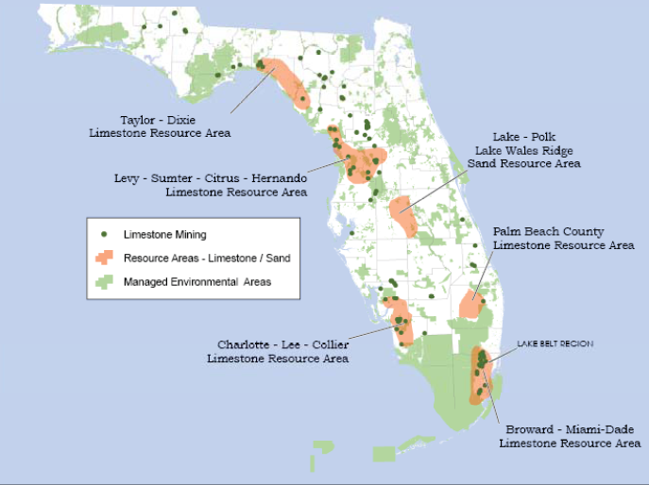

In view of those findings, the study also suggested that imports of crushed rock through the state’s seaports may need to be increased to augment domestic supply, requiring upgrades to both port and rail infrastructure.
Since that study was released, the economy has taken a serious downtown and as discussed earlier, construction and housing starts have declined dramatically and even the state’s population growth, once among the fastest in the nation has slowed. These slowdowns have given the state a bit of breathing room, but once construction picks up again, maintaining an adequate aggregate supply will again become an issue.
In the meantime, permits for new or expanded mines throughout Florida, including the South Florida region, continue to be sought. As of May 2009, 71 applications were being processed through the ACOE (9 projects) and the FDEP (62 projects). Seventeen of the permit applications are in Miami-Dade County, several are in Palm Beach County, and the rest are distributed in sixteen other counties.
According to the information provided in the applications, of the nine projects for which ACOE public notices have been issued, 20,686 acres of new or additional mining would result in impacts to 1,070 acres of existing jurisdictional wetlands. The average size of the projects described in the ACOE public notices is approximately 2,300 acres, and the average size of wetland impacts per project is approximately 120 acres. Extrapolating these averages to all 71 mining projects in Florida suggests that approximately 163,300 acres of mining activities could be pursuing environmental resource permit applications that would result in approximately 8,520 acres of impacts to jurisdictional wetlands.
The implications of this information are that, unlike imported crushed rock, increased domestic production currently being solicited in Florida could have significant environmental impacts and, thus, permit challenges, providing further impetus to importing the product to meet the state’s construction needs. These implications provide an analytical foundation for the crushed rock forecast in this assessment.
Short-Term Forecast. In the short-term, the impact of the construction cycle and the 2005-2006 inventory surges are significant. As noted, cement imports declined by 79.9 percent between 2006 and 2008. The base forecast for 2009 shows a modest decline, as cement imports appear to have reached a bottom level, potentially due to a balance between domestic production and imports and minimum throughput requirements in Port Everglades. Cement imports are projected to remain near the current levels until housing starts turn up significantly in 2013.
The impact of the potential increase in crushed rock aggregate is included in the revenue category of rock and sand. It is included in the high forecast, since it depends both on extraneous factors and on Port Everglades’ ability to utilize the crushed rock aggregate opportunity economically. The forecast requirement for crushed rock aggregate cited in interviews ranges between 2 and 4 million tons per year. Interviews identified the potential need for a facility capable of handling 5 million tons, while berth capacity could limit tonnages to 4 million tons or less. In this forecast, crushed rock imports are shown beginning in 2013 (due to the potential timing of an aggregate import facility) and ramping up to 4 million tons over 5 years. Although these imports are assumed to replace existing demand, dwindling quantities of domestic crushed rock indicate the need for additional imports, independent of the court decision, as reported by FDOT.
The other aggregates, particularly bauxite, gypsum, and fero, have continued to move through Port Everglades to supplement domestic cement production.
Crushed rock imports are projected to move at a 25,000-ton level in the base case due to a potential need for projects such as the recently initiated improvements to the I-595 corridor. These imports are not significant, however, due to the limited ability to store such cargo at the Port or move them off the dock efficiently.

2.4.4 Neo-Bulk Cargoes (Steel and Lumber)

The forecasts for steel and lumber have been impacted by downside factors similar to the forecasts for the dry bulk commodities. Steel imports have decreased dramatically and lumber imports have ceased to move through Port Everglades.

Steel. Steel, in particular, spiked in 2006 due to inventory adjustments. Following the period of high-level growth, the expectations were for a relatively large decline in 2007, followed by recovery with the construction cycle. With the reduction in housing starts, recent imports of steel through Port Everglades have been sporadic and represent only opportunistic shipments until housing starts recover and future demand shifts domestic steel production back to higher valued products.
.Lumber. The lumber category had already declined over the previous 6 years, including 2006. Therefore, this commodity was projected to show a decline in 2007 and only moderate recovery growth rates in the future. Due to the limited demand, lumber imports have ceased to move through Port Everglades.

2.4.5 Other Dry Bulk and Neo-Bulk Commodities

Tallow represents the only other “dry bulk” commodity included in this revenue category, even though it is an export and moves in tankers, unlike the bulk cement imports. Tallow has been a relatively small tonnage commodity at the Port and has fluctuated, with relatively lower volumes in 2006, but with sustained volume in recent years.
In the neo-bulk category, the two additional commodities have been yachts and cars. Yachts represent a commodity with a significant growth trend. Yachts are imported and outfitted in Port Everglades for the Florida, Caribbean, and other U.S. markets. This market is projected to decline slightly in the near term and level out in the future.
The auto market has been limited to the handling and re-handling of used cars. In Florida, the major car manufacturers route new cars through the Port of Jacksonville. Calls by pure car carriers have dropped off and the volumes of cars moved through the Port have declined. The used car market has, however, shown some growth potential and interviews indicated some market expansion opportunities. Nevertheless, this is not a major market or a major growth market, and the modest handling of used cars is not projected to continue in significant volume.
Figure 2.4-4 illustrates the historic trends and the forecasts through 2029 for the above neo-bulk commodities.

Figure 2.4-4
Tallow, Steel, Yachts, and Other (Xfile)

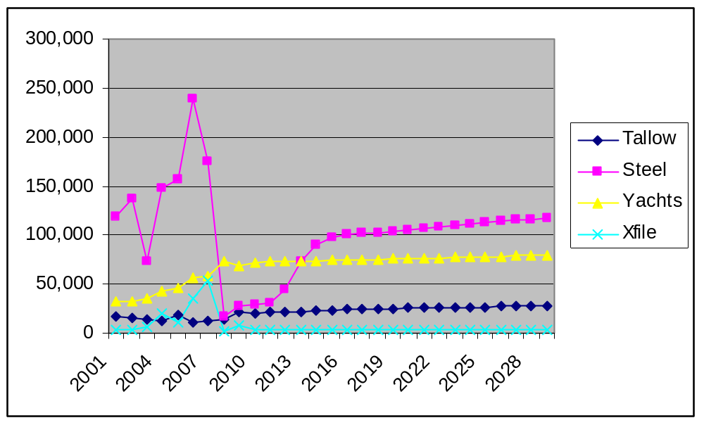
2.4.6 Forecast Summaries

Summaries of the forecasts for dry bulk and neo-bulk throughputs at Port Everglades are provided in Tables 2.4-3 and 2.4-4. Table 2.4-3 shows the baseline, high, and low forecasts for the dry bulk, neo-bulk, and total markets. Table 2.4-4 and the summary chart included in that table (Figure 2.4-5) compare the total tonnages for the baseline, high, and low forecasts.
- As shown in Table 2.4-3, from a 2006 level of 3,328,696 tons, the baseline forecast decreases to 90,918 tons in 2008, but is forecast to rebound to 3,067,348 tons by 2029, due to the recovery in cement.
- The high forecast shows significant growth to 7,625,627 tons in 2029, primarily due to the added growth of crushed rock aggregate combined with increases relative to the baseline forecast in other commodities.
- The low forecast remains below the 2006 tonnage of 3,328,696 throughout the forecast period with a 2029 tonnage of 2,061,698.

Table 2.4-3
Summary of Baseline, High, and Low Forecasts

Port Everglades Dry Bulk and Neo-Bulk Cargo

Baseline Forecast
Year | 2000 | 2001 | 2002 | 2003 | 2004 | 2005 | 2006 | 2007 | 2008 | 2009 | 2010 | 2011 | 2012 | 2013 | 2014 | 2015
Dry Bulk | 2,455,205 | 2,141,057 | 2,395,935 | 2,618,654 | 2,854,588 | 2,882,597 | 2,952,161 | 1,752,972 | 895,145 | 1,084,634 | 1,102,613 | 1,152,337 | 1,415,491 | 1,917,139 | 2,244,752 | 2,379,108
Neo-Bulk | 273,542 | 202,879 | 207,256 | 159,095 | 297,678 | 279,139 | 376,535 | 302,299 | 90,918 | 102,839 | 104,470 | 106,887 | 121,316 | 149,295 | 167,746 | 174,893
BaseForecast | 2,728,747 | 2,343,936 | 2,603,191 | 2,777,749 | 3,152,266 | 3,161,736 | 3,328,696 | 2,055,271 | 986,063 | 1,187,474 | 1,207,084 | 1,259,224 | 1,536,807 | 2,066,434 | 2,412,498 | 2,554,002
Percent Change |  | -14.1% | 11.1% | 6.7% | 13.5% | 0.3% | 5.3% | -38.3% | -52.0% | 20.4% | 1.7% | 4.3% | 22.0% | 34.5% | 16.7% | 5.9%
High Forecast
Year | 2000 | 2001 | 2002 | 2003 | 2004 | 2005 | 2006 | 2007 | 2008 | 2009 | 2010 | 2011 | 2012 | 2013 | 2014 | 2015
Dry Bulk | 2,455,205 | 2,141,057 | 2,395,935 | 2,618,654 | 2,854,588 | 2,882,597 | 2,952,161 | 1,752,972 | 895,145 | 1,084,634 | 1,135,808 | 1,220,936 | 1,581,875 | 2,404,732 | 3,284,948 | 3,829,541
Neo- Bulk | 273,542 | 202,879 | 207,256 | 159,095 | 297,678 | 279,139 | 376,535 | 302,299 | 90,918 | 102,839 | 105,424 | 109,007 | 127,384 | 164,545 | 191,087 | 202,150
HighForecast | 2,728,747 | 2,343,936 | 2,603,191 | 2,777,749 | 3,152,266 | 3,161,736 | 3,328,696 | 2,055,271 | 986,063 | 1,187,474 | 1,241,233 | 1,329,944 | 1,709,259 | 2,569,276 | 3,476,035 | 4,031,691
Percent Change |  | -14.1% | 11.1% | 6.7% | 13.5% | 0.3% | 5.3% | -38.3% | -52.0% | 20.4% | 4.5% | 7.1% | 28.5% | 50.3% | 35.3% | 16.0%
Low Forecast
Year | 2000 | 2001 | 2002 | 2003 | 2004 | 2005 | 2006 | 2007 | 2008 | 2009 | 2010 | 2011 | 2012 | 2013 | 2014 | 2015
DryBulk | 2,455,205 | 2,141,057 | 2,395,935 | 2,618,654 | 2,854,588 | 2,882,597 | 2,952,161 | 1,752,972 | 895,145 | 797,605 | 797,932 | 831,267 | 1,017,875 | 1,355,021 | 1,559,237 | 1,638,849
Neo-Bulk | 273,542 | 202,879 | 207,256 | 159,095 | 297,678 | 279,139 | 376,535 | 302,299 | 90,918 | 77,737 | 72,007 | 67,264 | 69,104 | 82,444 | 91,023 | 93,955
LowForecast | 2,728,747 | 2,343,936 | 2,603,191 | 2,777,749 | 3,152,266 | 3,161,736 | 3,328,696 | 2,055,271 | 986,063 | 875,343 | 869,939 | 898,531 | 1,086,978 | 1,437,465 | 1,650,260 | 1,732,804
Percent Change |  | -14.1% | 11.1% | 6.7% | 13.5% | 0.3% | 5.3% | -38.3% | -52.0% | -11.2% | -0.6% | 3.3% | 21.0% | 32.2% | 14.8% | 5.0%

Table 2.4-3 (Continued)
Summary of Baseline, High, and Low Forecasts

Port Everglades Dry Bulk and Neo-Bulk Cargo

2016 | 2017 | 2018 | 2019 | 2020 | 2021 | 2022 | 2023 | 2024 | 2025 | 2026 | 2027 | 2028 | 2029 | CAGR08to29 | CAGR06to29
2,439,522 | 2,476,648 | 2,504,623 | 2,538,913 | 2,572,630 | 2,605,725 | 2,638,508 | 2,671,680 | 2,705,299 | 2,739,688 | 2,772,508 | 2,804,374 | 2,835,780 | 2,866,688 | 5.70% | -0.13%
178,066 | 180,003 | 181,419 | 183,212 | 184,983 | 186,735 | 188,475 | 190,234 | 192,013 | 193,826 | 195,576 | 197,289 | 198,984 | 200,660 | 3.84% | -2.70%
2,617,589 | 2,656,651 | 2,686,042 | 2,722,126 | 2,757,613 | 2,792,460 | 2,826,984 | 2,861,914 | 2,897,312 | 2,933,514 | 2,968,084 | 3,001,663 | 3,034,764 | 3,067,348 | 5.55% | -0.35%
2.5% | 1.5% | 1.1% | 1.3% | 1.3% | 1.3% | 1.2% | 1.2% | 1.2% | 1.2% | 1.2% | 1.1% | 1.1% | 1.1%
2016 | 2017 | 2018 | 2019 | 2020 | 2021 | 2022 | 2023 | 2024 | 2025 | 2026 | 2027 | 2028 | 2029 | CAGR08to29 | CAGR06to29
4,443,641 | 5,120,559 | 5,707,029 | 6,301,371 | 6,839,659 | 7,069,922 | 7,108,785 | 7,148,108 | 7,187,962 | 7,228,730 | 7,267,638 | 7,305,415 | 7,342,646 | 7,379,283 | 10.57% | 4.06%
207,478 | 210,614 | 213,121 | 216,111 | 219,090 | 222,061 | 225,035 | 228,048 | 231,104 | 234,219 | 237,275 | 240,302 | 243,325 | 246,343 | 4.86% | -1.83%
4,651,119 | 5,331,173 | 5,920,150 | 6,517,482 | 7,058,749 | 7,291,983 | 7,333,820 | 7,376,156 | 7,419,065 | 7,462,949 | 7,504,913 | 7,545,716 | 7,585,970 | 7,625,627 | 10.23% | 3.67%
15.4% | 14.6% | 11.0% | 10.1% | 8.3% | 3.3% | 0.6% | 0.6% | 0.6% | 0.6% | 0.6% | 0.5% | 0.5% | 0.5%
2016 | 2017 | 2018 | 2019 | 2020 | 2021 | 2022 | 2023 | 2024 | 2025 | 2026 | 2027 | 2028 | 2029 | CAGR08to29 | CAGR06to29
1,673,800 | 1,698,994 | 1,717,470 | 1,740,654 | 1,763,451 | 1,785,914 | 1,808,174 | 1,830,717 | 1,853,583 | 1,876,996 | 1,899,347 | 1,921,046 | 1,942,435 | 1,963,487 | 3.81% | -1.76%
94,903 | 95,237 | 95,314 | 95,582 | 95,844 | 96,099 | 96,351 | 96,616 | 96,895 | 97,194 | 97,465 | 97,719 | 97,969 | 98,211 | 0.37% | -5.68%
1,768,703 | 1,794,230 | 1,812,784 | 1,836,236 | 1,859,294 | 1,882,013 | 1,904,526 | 1,927,334 | 1,950,478 | 1,974,190 | 1,996,812 | 2,018,765 | 2,040,404 | 2,061,698 | 3.57% | -2.06%
2.1% | 1.4% | 1.0% | 1.3% | 1.3% | 1.2% | 1.2% | 1.2% | 1.2% | 1.2% | 1.1% | 1.1% | 1.1% | 1.0%

Table 2.4-4
Summary Comparison of Base, High, and Low Forecasts
Port Everglades Dry Bulk and Neo-Bulk Cargo

Year | 2000 | 2001 | 2002 | 2003 | 2004 | 2005 | 2006 | 2007 | 2008 | 2009 | 2010 | 2011 | 2012 | 2013 | 2014 | 2015
BaseForecast | 2,728,747 | 2,343,936 | 2,603,191 | 2,777,749 | 3,152,266 | 3,161,736 | 3,328,696 | 2,055,271 | 986,063 | 1,187,474 | 1,207,084 | 1,259,224 | 1,536,807 | 2,066,434 | 2,412,498 | 2,554,002
HighForecast | 2,728,747 | 2,343,936 | 2,603,191 | 2,777,749 | 3,152,266 | 3,161,736 | 3,328,696 | 2,055,271 | 986,063 | 1,187,474 | 1,241,233 | 1,329,944 | 1,709,259 | 2,569,276 | 3,476,035 | 4,031,691
LowForecast | 2,728,747 | 2,343,936 | 2,603,191 | 2,777,749 | 3,152,266 | 3,161,736 | 3,328,696 | 2,055,271 | 986,063 | 875,343 | 869,939 | 898,531 | 1,086,978 | 1,437,465 | 1,650,260 | 1,732,804

2016 | 2017 | 2018 | 2019 | 2020 | 2021 | 2022 | 2023 | 2024 | 2025 | 2026 | 2027 | 2028 | 2029 | CAGR08to29 | CAGR06to29
2,617,589 | 2,656,651 | 2,686,042 | 2,722,126 | 2,757,613 | 2,792,460 | 2,826,984 | 2,861,914 | 2,897,312 | 2,933,514 | 2,968,084 | 3,001,663 | 3,034,764 | 3,067,348 | 5.55% | -0.35%
4,651,119 | 5,331,173 | 5,920,150 | 6,517,482 | 7,058,749 | 7,291,983 | 7,333,820 | 7,376,156 | 7,419,065 | 7,462,949 | 7,504,913 | 7,545,716 | 7,585,970 | 7,625,627 | 10.23% | 3.67%
1,768,703 | 1,794,230 | 1,812,784 | 1,836,236 | 1,859,294 | 1,882,013 | 1,904,526 | 1,927,334 | 1,950,478 | 1,974,190 | 1,996,812 | 2,018,765 | 2,040,404 | 2,061,698 | 3.57% | -2.06%

Figure 2-4.5
Summary Chart of Base, High, and Low Forecasts
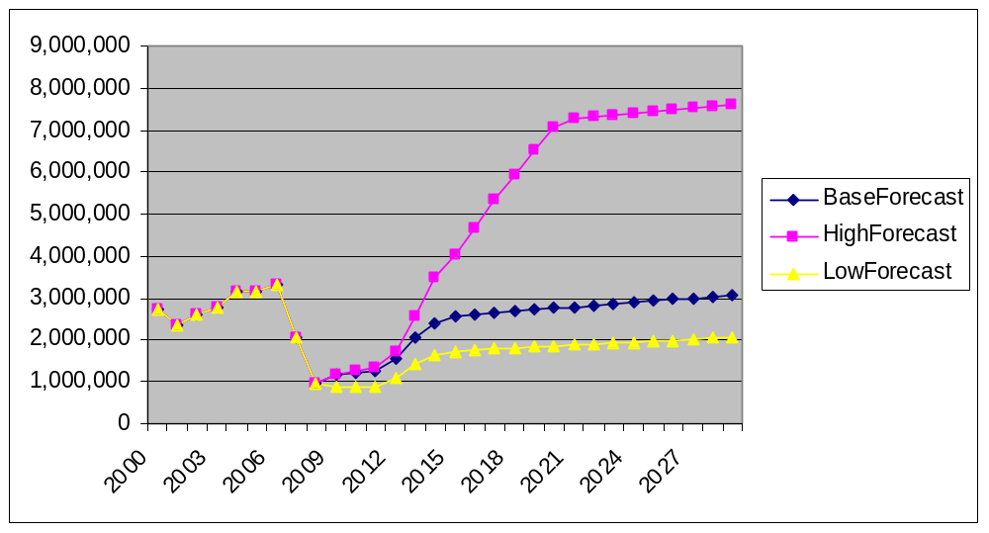
2.4.6 Forecast Details
Baseline Forecast. The baseline forecast for dry bulk cargoes through Port Everglade is for a growth of 5.55 percent per year between 2008 and 2029, equating to a 0.35 percent per year decline from the peak in 2006 (see Figure 2.4-6). Neo-bulk is projected to increase 3.84 percent from 2008 due to the partial recovery in steel imports and the continued imports of yachts. Since steel is not expected to recover to 2006 levels, neo-bulk imports are projected to decline by 2.7 percent per year between 2006 and 2029.
Figure 2.4-6

Baseline Forecast Summary
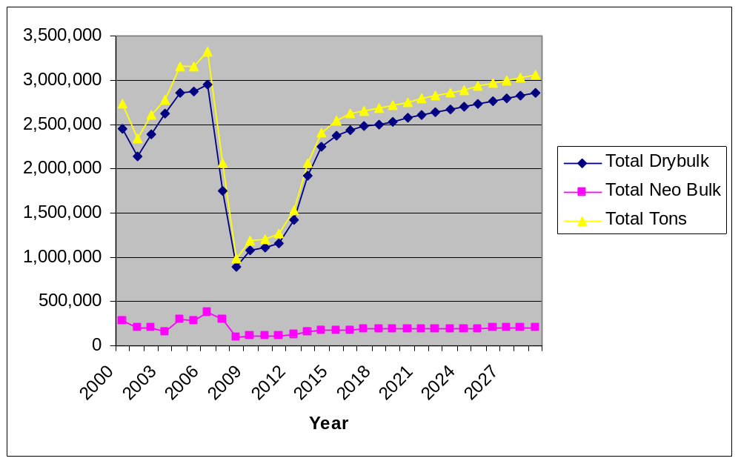
In the short-term, the total dry bulk and neo-bulk markets declined by 38.3 percent in 2007 and 52.0 percent in 2008. The baseline forecast includes continued volumes near current levels until the upturn in housing starts in 2013 and beyond, which brings the total dry bulk plus neo-bulk tonnage almost back to 2006 levels by 2029. By 2029, the dry bulk plus neo-bulk tonnages are projected to be 92.1 percent of 2006 levels. Dry bulk represents 93.5 percent of the total dry bulk plus neo-bulk market by 2029 and cement represents 69.7 percent of the dry bulk market in 2029 in the baseline forecast.
High Forecast. The high forecast results in a growth rate of 4.82 percent between 2006 and 2026 for dry bulk plus neo-bulk cargoes (see Figure 2.4-7). The projected tonnage increase is from 3,328,696 tons in 2006 to 7,625,627 tons in 2029, an increase of 229.1 percent. Between 2008 and 2029, the high forecast increases by 773.3 percent.
The primary growth factor in this high forecast is the potential requirement to handle significant volumes of crushed rock aggregate to replace a portion of the aggregate that was mined in the Lake Belt region of Miami-Dade County. The crushed rock increase requires the Port’s economic and strategic evaluation. In the case of the major increase in crushed rock aggregate tonnage, as discussed elsewhere in this Plan, a location must be developed within the Port, which can handle the volume with adequate berths, draft, and rail access.

Figure 2.4-7

High Forecast Summary
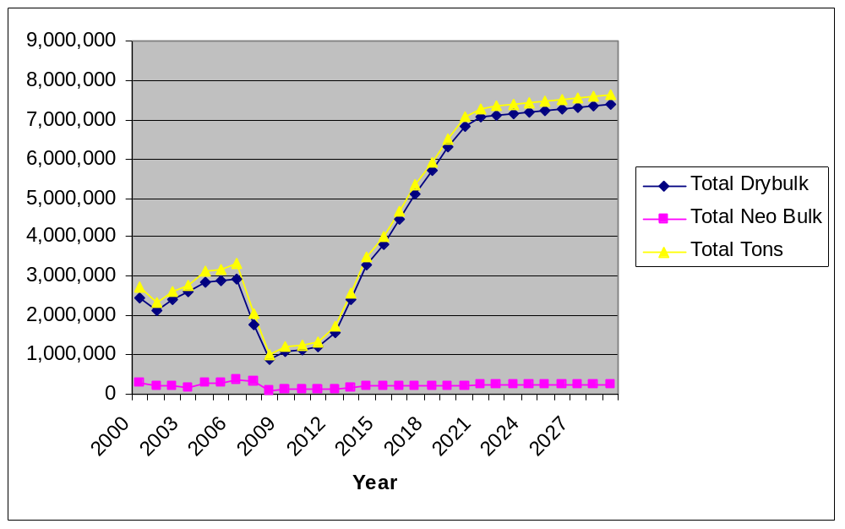

Low Forecast. Under the low forecast, the dry bulk plus neo-bulk cargoes moving through Port Everglades fall from 3,328,696 tons in 2006 to 2,061,698 by 2029, well below the 2006 levels at 3,238,080 tons (see Figure 2.4-8).

Figure 2.4-8
Low Forecast Summary
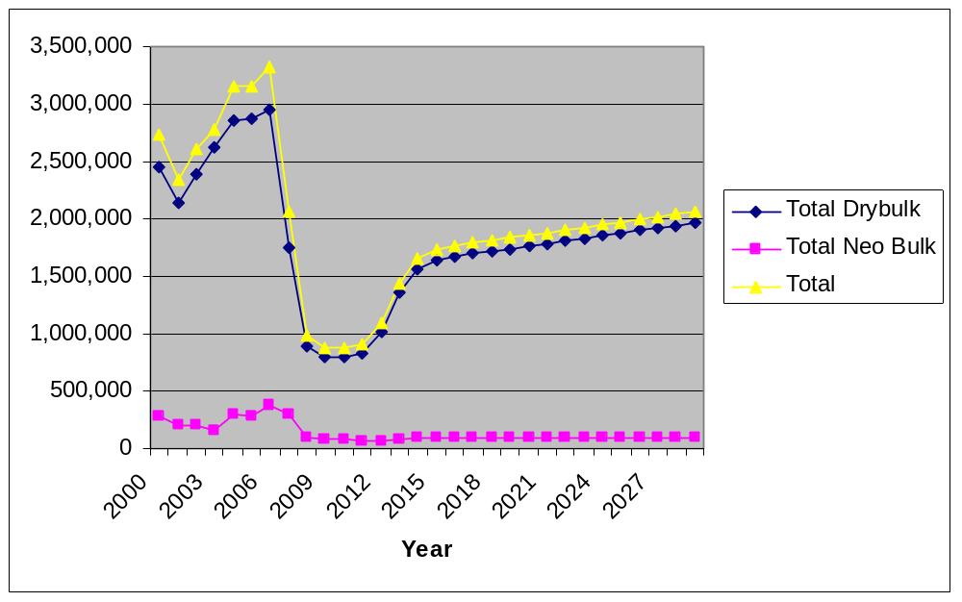

Under the low forecast, the net result is a decrease of -1.76 percent for the total of dry bulk and neo-bulk between 2006 and 2029. Dry bulk declines by -0.16 percent per year and neo-bulk increases by 0.06 percent per year.

2.4.7 Assessment Conclusions

Given the above factors, the dry bulk and neo-bulk markets for Port Everglades are projected to recover to 92.1 percent of the peak 2006 levels by 2029 under the base line forecast. Continued depressed tonnages and more muted recovery result in a low forecast that reaches only 61.9 percent of the peak 2006 levels. A significant upside is primarily dependent on the potential addition of 2 to 4 million tons of crushed rock aggregate. Under the high forecast, Port Everglades dry bulk and neo-bulk cargoes reach 7.626 million tons or 229.1 percent of the peak volumes in 2006.

The Lake Belt is an approximately 57,515-acre area that was established by the Florida Legislature in 1997 to implement the Miami-Dade County Lake Belt Plan. The area lies west of Miami and east of Everglades National Park. Miami-Dade County’s Lake Belt mining region represents more than half of the state’s production of crushed rock aggregate and limestone.
Strategic Aggregates Study: Sources, Constraints, and Economic Value of Limestone and Sand in Florida, Prepared by Lampl Herbert Consultants for the Florida Department of Transportation, March 12, 2007

