2.3 Containerized Cargo Market
2.3.1 Introduction
This section assesses the containerized cargo market at Port Everglades. It summarizes the Port’s historical and current containerized cargo throughput, reviews the global and US markets and trade lanes, and discusses what other East Coast ports are doing to compete in these markets. After an analysis of Florida’s import and export markets and Port Everglades’ competitive advantages and disadvantages, the section concludes with a forecast of the Port’s potential containerized cargo market through the 2029 planning horizon.

2.3.2 Historical and Current Port Everglades Conditions
In FY 2008 (October 2007 through September 2008), Port Everglades handled nearly 6.6 million tons or 985,095 TEUs of waterborne containerized cargo. Since 1996, containerized cargo handled at the Port has grown at 2.9 percent annually. Figure 2.3-1 graphically depicts the historical annual TEUs handled at the Port over the past decade.

Figure 2.3-1
Historical TEUs Handled at Port Everglades
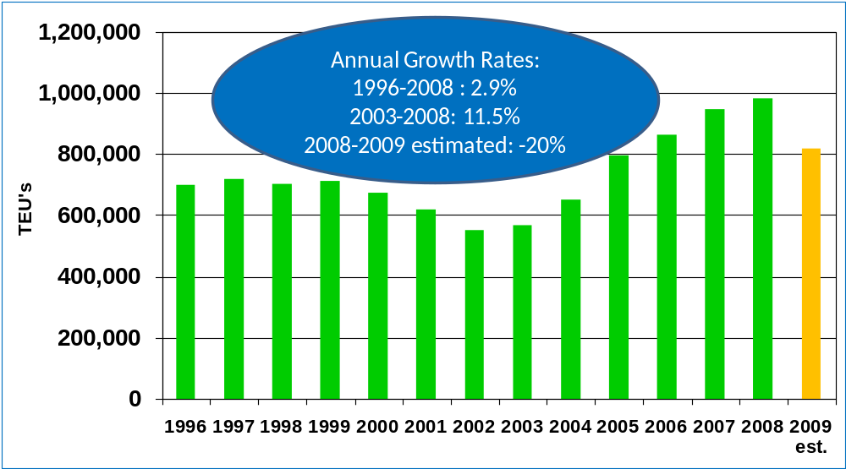
Source: Port Everglades
As this figure shows, traffic declined from 2000 through 2003, a decline attributable to acquisitions and mergers of shipping lines and the resulting relocation of these carriers to the Port of Miami. Since 2003, the Port has experienced steady growth in container traffic, averaging 11.5 percent annually. The current economic downturn has, however, dramatically affected trade growth. While, full FY 2009 figures were not available when this assessment was prepared, ten-month actual TEU counts provided by the Port Everglades Department were extrapolated to estimate the FY 2009 total. The actual year-to-date figures indicate that the Port’s container traffic is expected to decline by about 20 percent over FY 2008.
Figure 2.3-2 details the change in TEU count by terminal operator over the first six months of FY 2008 versus FY 2009. The departure of Universal/APM Terminals in February 2008 and the consolidation of APL services, formerly handled by Port Everglades Terminal (PET), in Miami in January 2009 have impacted the Port’s FY 2009 figures
Figure 2.3-2
Change in TEUs during the First Six Months of FY 2008 and of FY 2009
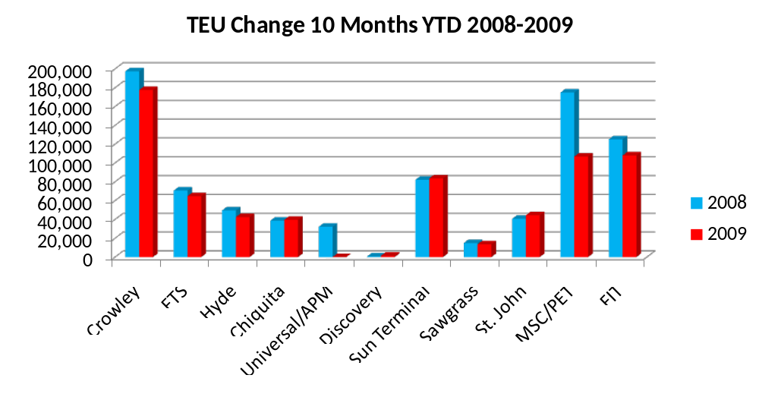

Source: Port Everglades Department
As illustrated in Figure 2.3-3, 35 percent of Port Everglades’ container trade is with Central America, while 24 percent and 26 percent of the TEUs are with the South American and Caribbean trades, respectively. Therefore, 85 percent of the cargo handled at Port Everglades is dedicated to the Latin America and Caribbean regions. The remaining 15 percent primarily comprises Asian/Indian Sub-Continent (ISC) (8 percent) and European (6 percent) cargoes. The Port’s large share of Latin American/Caribbean cargo is attributed to the strong presence of Latin American-related businesses and shippers in South Florida.
Figure 2.3-3
Share of Port Everglades Containerized Cargo by Trade Route – FY 2008 Loaded TEUs

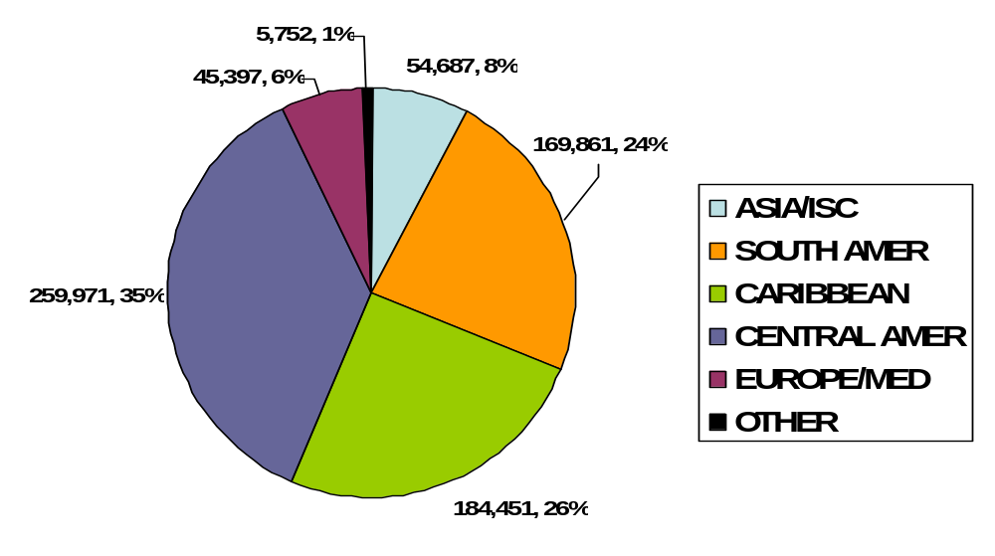

Source: PIERS, Journal of Commerce
In terms of tonnage, the Latin American market accounts for 82 percent of the short tons handled at Port Everglades. Specifically, the Central American market represents 32 percent of this tonnage, while the Caribbean accounts for 25 percent and South America for 25 percent, as presented in Figure 2.3-4. The balance is distributed between Asia/ISC and Europe/Mediterranean cargoes.

Figure 2.3-4
Share of Port Everglades Containerized Cargo by Trade Route – FY 2008 Short Tons

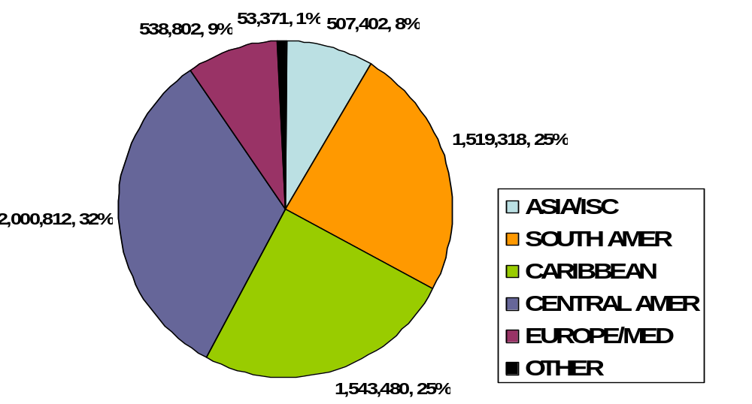

Source: PIERS, Journal of Commerce

Ten terminal operators located in Port Everglades’ Midport and Southport areas handle the Port’s container operations. Table 2.3-1 identifies the terminal operators, the acreages they occupy, and their TEU volumes in FY 2008.
Table 2.3-1
Port Everglades FY 2008 Container Throughput by Terminal

TERMINAL/LINE | TEU | ACRES* | TEU/ACRE
CROWLEY | 236,488 | 75.35 | 3,139
FTS | 83,589 | 24.50 | 3,412
HYDE | 58,968 | 7.22 | 8,167
CHIQUITA | 46,836 | 13.10 | 3,575
UNIVERSAL/APM** | 32,176 | 25.81 | 1,247
SUN TERMINAL | 100,733 | 22.84 | 4,411
SAWGRASS (DOLE) | 17,959 | 6.00 | 2,993
ST. JOHN | 46,101 | 13.84 | 3,331
MSC/PET | 208,518 | 44.40 | 4,673
G&G | 885 | NA | NA
FIT | 152,832 | 36.72 | 4,162
TOTAL | 985,085 | 269.78 | 3,651

*Acres represent Leased Acres and Fiscal Year 2008 Average Grid Land Acres
**Universal/APM ceased operations in February, 2008
Source: Port Everglades Department
A current description of each of the terminal operators and their facilities follows:
- Crowley
  - 68.2 leased acres at Southport and 7.15 grid land acres (FY 2008 average).
  - Nine vessel calls per week to Latin America and Caribbean.
  - Composition of vessel fleet has shifted since 2006 - Higher-capacity lift-on/lift-off (LO/LO) vessels have replaced some RO/RO on Latin American services.
- Florida Transportation Services (FTS)
  - Operates on the Port’s grid-lease system, with approximately 24.5 acres (FY 2008 average) over two areas.
  - Stevedores for Seafreight, – primarily Caribbean service.
  - Seafreight currently operates 2 weekly calls.
- Hyde Shipping
  - Operates on 7.22 acres at Midport.
  - Stevedores for Thompson Line (Cayman service), HT Shipping, and Hybur Limited (Mexico/Honduras/Belize).
  - Handled 228 total vessel calls in FY 2008.
  - Operates over 60,000 square feet of container freight station (CFS) space in Medley.
- Chiquita
  - Operates 13.1 acres at Midport.
  - Weekly call – Central America (Honduras/Guatemala).
  - Inbound fruit shipped direct to customers as far north as Atlanta.
  - Also operates distribution center facility on Port property – serves Southern Florida market as far north as Vero Beach.
- Universal/APM Terminals
  - Ceased operations in February 2008.
- Sun Terminal
  - In FY 2008, operated 22.84 acres at Midport; currently operating in Southport due to cruise terminal construction at Midport.
  - Stevedores for Sea Star Line and King Ocean.
  - Handled 206 vessel calls in FY 2008.
- Sawgrass/Dole
  - 6 acres at Midport.
  - One call per week – Central America.
  - Inbound fruit distributed regionally; southbound loads to Central America.
- St. John Shipping
  - Operates on 13.84 grid-lease acres (FY 2008 average) at Midport.
  - Handled 279 calls in FY 2008 for various Latin American and Caribbean carriers including Frontier Liner Service, Interocean, and Trinity.
- MSC (Port Everglades Terminal - PET)
  - Operates 39 acres at Southport and 5.4 acres (FY 2008 average) on the Port’s grid-lease system.
  - 4 calls per week – MSC vessels with services to East Coast South America/Mediterranean/Asian.
  - APL service ceased in January, 2009.
  - Majority of MSC cargo is transshipment cargo from Freeport hub (inbound and outbound loads).
- G&G Shipping
  - Operates facility on Dania Cut-Off Canal, outside of the Port’s jurisdictional boundary.
  - Operates smaller vessels drawing 7 feet of water.
  - Calls Bahamas (Nassau and Freeport) and Turks and Caicos.
- Florida International Terminal (FIT)
  - Operates approximately 36.72 acres of lease and grid land property at Southport.
  - Stevedores for Hapag Lloyd, CSAV, CCNI and Hamburg Sud.
  - Handled 190 vessels in FY 2008.
  - Service routings include East Coast and West Coast of South American markets.

2.3.3 Overview of US Containerized Cargo Market

Between 1990 and 2008, containerized cargo handled at the US ports increased from 15.6 million TEUs to nearly 43 million TEUs. This increase represents an average annual growth rate of 5.8 percent over the period. Figure 2.3-5 shows the growth in containerized cargo at the key port ranges in the United States: the Pacific Coast, the Atlantic Coast, and the Gulf Coast. The Pacific Coast ports have dominated the container trade in terms of volume in the United States and have shown a 5.8 percent annual growth over the 18-year period. The Atlantic Coast ports have experienced a 5.7 percent annual growth rate, while containerized cargo at the Gulf Coast ports has grown by 6.5 percent annually; however, this growth is for a much smaller containerized cargo base. The slowing of trade is evident in the 2006-2007 period. Reflecting the effects of the global economic downturn, TEUs exhibit a decline in 2008.
Figure 2.3-5
Total Containerized Cargo Activity by Port Range (TEUs)
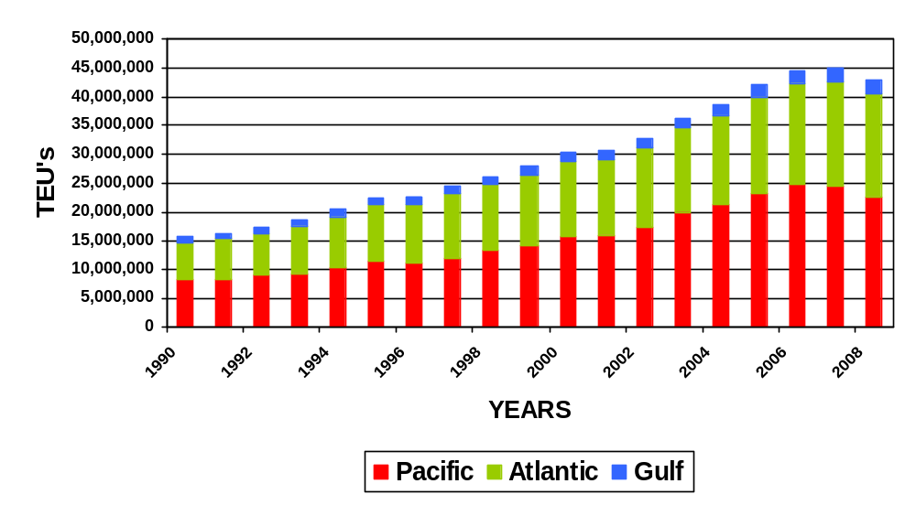

Source: American Association of Port Authorities

To further underscore the severity of the recession on trade flows, Figure 2.3-6 compares first quarter container statistics for calendar years 2008 and 2009, showing dramatic declines at each port range. The Southern California ports show the steepest decline, at nearly 23 percent. The Pacific Northwest (PNW) ports are experiencing a 20 percent decline. Both these cases illustrate that intermodally dependent port ranges are suffering more than other regions, highlighting the increase of all-water services to the Atlantic and Gulf Coasts to serve regional markets. Atlantic and Gulf ports have declined by 17.5 percent and 12 percent, respectively.

Figure 2.3-6
Percent Change in TEUs by Range Q1/2008-Q1/2009

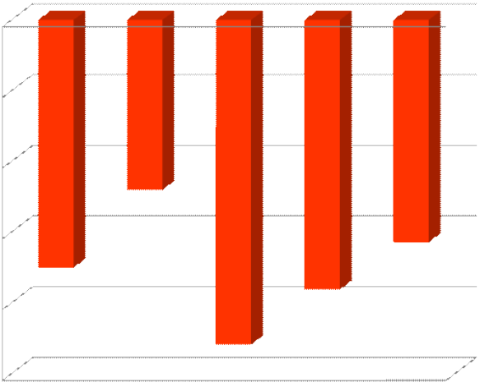
-
25.00%
-
20.00%
-
15.00%
-
10.00%
-
5.00%
0.00%
Atlantic
Gulf
S. Cal
PNW
N.Cal
% Change In TEU's

Source: American Association of Port Authorities

Container trade growth has been driven by imported cargo, which has shown a 7.5 percent annual growth rate since 1995. Containerized cargo imports, however, grew by less than 1 percent between 2006 and 2007, and declined in the 2007-2008 period, reflecting the weakened US economy and subsequent global recession.
The historical volumes of imported containerized cargo tonnage presented in Figures 2.3-7 and 2.3-8 show the growth in container tonnages and market shares into the US by world trade area. As these exhibits also demonstrate, the growth in imported containers has been historically driven by the growth in trade with China.

Figure 2.3-7
Imported Containerized Cargo Tonnage by Overseas Trading Area
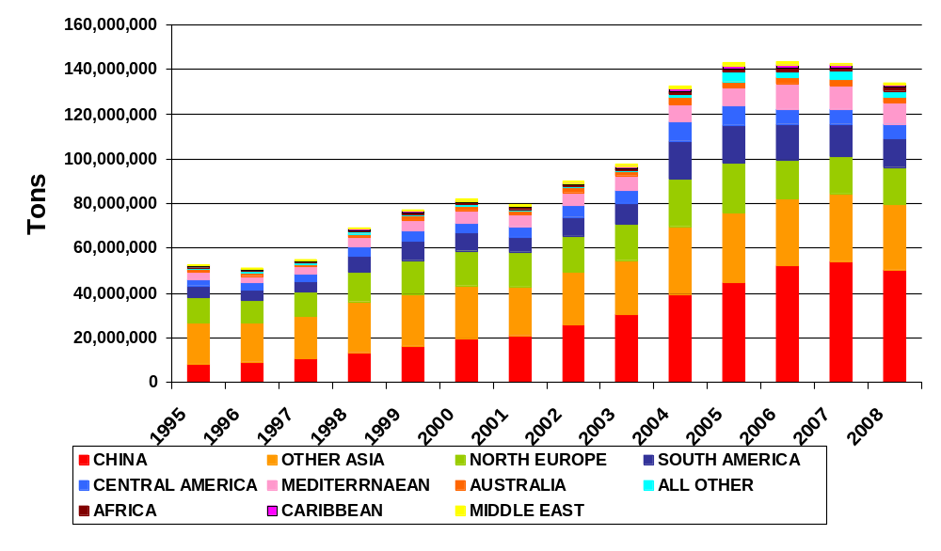

Source: US Maritime Administration

Figure 2.3-8
Share of Imported Containerized Tonnage by Overseas Trading Area

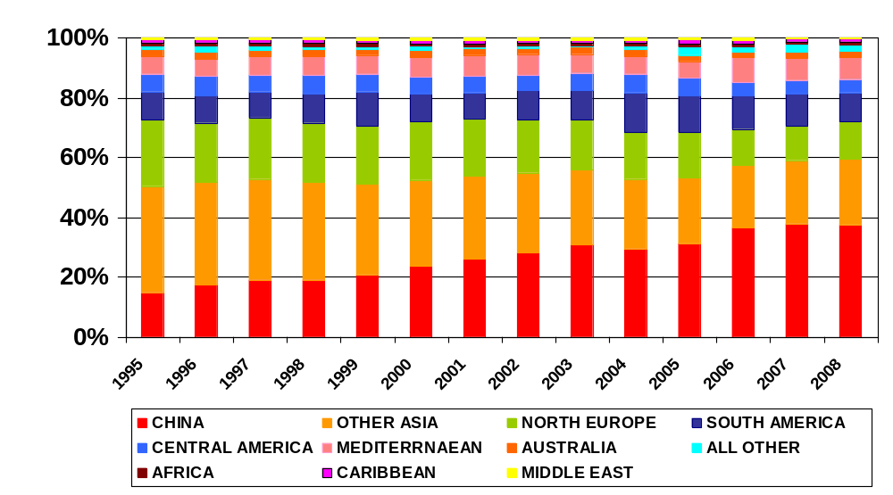

Source: US Maritime Administration

While China has been the key source of imports to the US, production and manufacturing sources are shifting away from China to South Asia countries, including India and Vietnam. Figure 2.3-9 illustrates the growth in imports by key Asian countries between 2003 and 2008. Over the period, China exhibited a 10 percent increase; however, Vietnam registered the highest growth rate at 23 percent, and Cambodia followed with nearly 14 percent, albeit the volumes of these two countries are significantly less than China’s. Furthermore, over the 2007-2008 period, Vietnam was the only Asian country to post a significant increase, at nearly 10 percent. Conversely, China exhibited a decline of 7.3 percent during the same period.
Figure 2.3-9
Percent Change in Asian Sources of US Imports 2003-2008
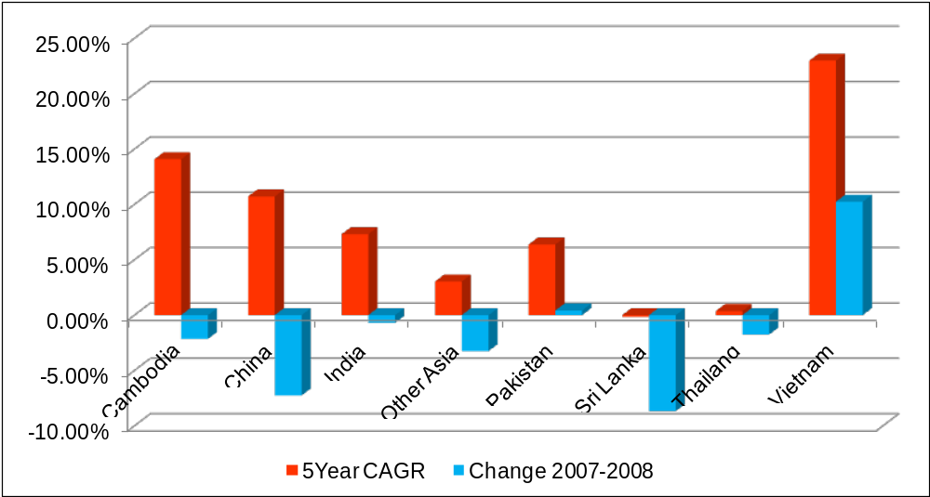
Source: US Maritime Administration, Foreign Trade Statistics

The West Coast ports have handled about 47 percent of all imports into the United States, followed by the South Atlantic ports (from Norfolk to Miami), which handled 24 percent of the total containerized import tonnage. The North Atlantic ports handled about 21 percent of the total import containerized tonnage. Figure 2.3-10 shows the distribution of these tonnages by port range.

Figure 2.3-10
Imported Containerized Tonnage by Port Range
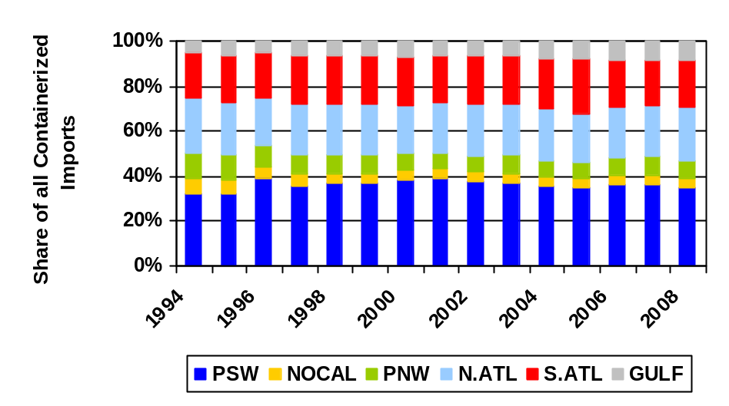

Source: US Maritime Administration
The dominance of the containerized trade by the West Coast ports, and in particular by the Ports of Los Angeles and Long Beach in San Pedro Bay, especially in the late 1990s through 2002, was driven by importers viewing these ports as the major linkages in the imported cargo supply chain. Prior to the mid- to late-1990s, the steamship lines determined the port routings and importers were essentially “port blind.” They selected an ocean carrier and the carrier decided at which port the cargo would be discharged and how it would be delivered to the customer.
As the concentration of large importers such as Wal*Mart, Target, Cost Plus, etc. increased in the late 1990s, these importers invested in large distribution centers in the Los Angeles/Long Beach (San Pedro) area to serve as points in their logistic supply chains. Then, as these importers gained bargaining power in terms of contract negotiations with the ocean carriers, they were able to “demand” a San Pedro Bay port routing from the carriers. Hence, with the development of the distribution centers and cross-dock operations in the San Pedro Bay region, the concentration of imported Asian containers at the Ports of Los Angeles and Long Beach increased. Furthermore, the railroads providing intermodal services at the San Pedro ports further increased investment in rail trackage and intermodal yards to facilitate the flow of containers from the Los Angeles area to the key Midwestern and Eastern consumption centers such as Chicago, Memphis, St. Louis, New York, Atlanta, and Columbus, etc.
This concentration of containerized cargo import activity continued to increase until several events occurred. These events included 9/11, which had an impact on the distribution supply chain; the 2002 West Coast port shutdown; and the major congestion that arose in 2004 due to rail meltdowns at the two San Pedro Bay ports. As a result of these events, the diversification of containerized cargo via various US ports has increased in focus. This new focus is evident by the growth in container volumes at the North Atlantic, South Atlantic, and Gulf Coast ports. The growth of all-water service from Asia to the East Coast and Gulf Coast ports has been increasing significantly since 2002.
Two routings are available for all-water services: through the Panama Canal and through the Suez Canal. Each of these all-water routings provides both advantages and disadvantages when compared with the intermodal land bridge from the West Coast ports. For example, the current dimensions of the Panama Canal limit the size (width and depth) of the vessels that can transit it. Also, the transit time using all-water service to an East Coast port and then a rail move to a Midwestern consumption point is longer than using an intermodal move via a West Coast port. This longer transit time from Asia results in increased inventory-carrying costs, and is more pronounced for higher- value cargo than for lower-value cargo.
Changes are in play, however, that will moderate the current negatives of using the Panama Canal. The Canal will be enlarged by 2014, allowing for the transit of much larger container vessels, which tend to have a lower per unit operating cost than smaller container vessels. Thus, the ocean carriers are introducing more direct all-water services that are improving the transit times from Asia. Ocean carriers prefer to internalize the revenue for the entire trip from Asia to the East Coast rather than sharing the revenue with a rail carrier from the West Coast to an East Coast consumption point.
Underscoring the focus on all-water container services via the Panama Canal is the evidence that, during the first quarter of 2007, prior to the economic downturn, container vessel transits via the Panama Canal were nearly 13 percent higher than for the same period in 2006. This is in contrast to the less than 3 percent annualized growth rate realized by the San Pedro Bay ports in 2007.
With respect to the Suez Canal, the Canal’s dimensions do not limit the size of the container ships that can transit it, but there is some concern over political instability in the region. The Suez routing from Asia to the East Coast is longer than via the Panama Canal, but, as production centers shift to South Asia and India, this routing can, in some cases, provide very competitive transit times to the Trans-Pacific routings and the use of intermodal moves from the West Coast to the East Coast. In addition, ocean carriers are increasing India-Europe express services, using Mediterranean ports as transshipment centers for cargo destined further to the US and Europe.
With the shift of production centers into India and Vietnam, the Suez routing is becoming particularly attractive. Supporting the development of production centers in India, the Indian government and private sector interests are investing heavily in port infrastructure to accommodate the country’s growth. Indian government investment is estimated at $12.5 billion and private sector investment is estimated at another $8.5 billion.
These all-water services have grown at the expense of the West Coast ports, particularly between 2006 and 2007. The Journal of Commerce reports that, in 2007, containerized cargo imported via the West Coast ports fell by 1.5 percent while imports via the East Coast ports grew by 8.9 percent. In addition to the decline in West Coast imports, intermodal cargo moving from the West Coast to Midwestern, Gulf, and East Coast points has fallen over the past year, further reflecting the growth in all–water services. The Intermodal Association of North America reports intermodal moves from the West Coast to the Northeast fell by 27 percent between 2006 and 2007. This reflects not only the growth in all-water services, but also the desire for ocean carriers to reduce systemwide operating costs by increasing the control of equipment, particularly empty equipment.
Also, the increased environmental and infrastructure fees at West Coast ports, particularly in Los Angeles and Long Beach have increased the cost of doing business at these ports by more than $100 per loaded TEU. These fees are:
- Alameda Corridor fee for intermodal containers - $30 per TEU.
- PierPass - $50 per TEU on peak-hour pricing.
- Proposed dirty truck fee - $35 per loaded TEU.
- Proposed Lowenthal fee - $30 per loaded TEU.
- $15 per TEU infrastructure fees.
These fees are expected to continue increasing.
Environmental regulations are also choking development at the Port of Los Angeles. For example, Mitsui O.S.K. Lines (MOL)/TraPac has been trying to modify its terminal in Los Angeles since 1997, and plans have just passed environmental review. The completion date is now projected to 2015. The inability to complete terminal expansion plans at the Ports of Los Angeles and Long Beach is a major concern of shipping lines and terminal operators and is contributing to the increased development of all-water services to the East Coast and Gulf Coast ports.
Terminal productivity and costs at the Ports of Los Angeles and Long Beach have also become an issue with ocean carriers and terminal operators at these San Pedro Bay ports. The typical vessel discharge/load productivity at the San Pedro Bay ports is 25 to 27 moves per gang hour compared with typical vessel productivity at Atlantic and Gulf Coast ports, which ranges from 35 to 40 moves and even higher per gang hour. As stated above, there have also been historical congestion issues as well as longshore worker and management disruptions. The impact of the West Coast port shutdown in 2002 is still fresh in the minds of importers/exporters and ocean carriers/terminal operators. This shutdown had a major impact on the diversification of ports used by importers, which in turn has fueled the growth in all-water service and the development of distribution centers at Atlantic Coast and Gulf Coast ports since 2002.
Many major importers are developing distribution centers in proximity to Atlantic and Gulf Coast ports, further enhancing the all-water service growth. For example, the Georgia Port Authority has attracted 19 distribution centers totaling 15 million square feet. The Virginia Port Authority has also been aggressively pursuing distribution center development. Current distribution centers in the Hampton Roads area and the Front Royal area (the location of the Virginia Port Authority’s inland port) include:
- Target - 1.5 million square feet and expanding.
- Wal*Mart Distribution Center - expanding to 3 million square feet.
- Cost Plus expanded to 1.1 million square feet.
- Dollar Tree.
- QVC.
- Home Depot at Front Royal.
- Family Dollar at Front Royal.
Similar distribution center development is also occurring in Houston, fueling growth in Asian cargo imports at the Port of Houston. These developments include:
- Cedar Crossing area, site of a 4-million-square-foot distribution center for Wal*Mart.
- Home Depot potential development.
- 8,000 acres of land available for distribution center and industrial development.
Other ports, including Charleston, Wilmington (NC), and New York are also aggressively pursuing distribution center development. The property previously occupied by General Motors and now owned by Duke Realty is currently the only “near port” location for distribution center development at the Port of Baltimore, but the potential development of property in the Cox Creek area could provide a significant opportunity for distribution center development near the port’s Seagirt Marine Terminal.
Paralleling the growth in distribution center development and the growth in all-water service is the development of new container terminal capacity on the Atlantic and Gulf Coasts. Examples, in addition to Port Everglades’ Southport Phase VIII expansion, include the following:
- In addition to the carriers’ interest in JAXPORT, AP Moeller and CMA/CGM have developed the 135-acre Choctaw Point Container Terminal at the Port of Mobile.
- The Port of Houston is developing its Bayport Container Terminal.
- Also in Texas, the Port of Corpus Christi is marketing the La Quinta container terminal and container terminal development plans have been discussed for Pelican Island in Galveston.
- The Port of Charleston is developing a new 286-acre, 3-berth container terminal at the Charleston Navy Base.
- The North Carolina State Ports Authority is developing a 600-acre container complex near Wilmington, NC.
- AP Moeller has developed a nearly 300-acre terminal at Portsmouth, Virginia, and the Virginia Port Authority is developing a 600+-acre facility at Craney Island.
Other terminal development is planned along the Delaware River, including a 200-acre facility in Wilmington, DE, and a 150-acre terminal in Philadelphia. Land is available for terminal development at Savannah, and the Georgia Ports Authority and South Carolina State Ports Authority have the ability to develop the jointly owned 1,800-acre plus Jasper Ocean Terminal on the Savannah River in South Carolina.

2.3.4 Impact of Changing Logistics Patterns on All-Water Services at Atlantic Coast and Gulf Coast Ports
The growth in all-water services, distribution centers, and terminal development at Atlantic and Gulf Coast ports is reflected by the growth in Asian imported containerized cargo at these ports.
Figures 2.3-11 and 2.3-12, respectively, show the growth in TEUs handled as well as Asian containerized import tonnages at the North Atlantic ports, and confirm the dominance of the Port Authority of New York and New Jersey.
Figure 2.3-11
Containerized Cargo Activity at North Atlantic Ports (TEUs)
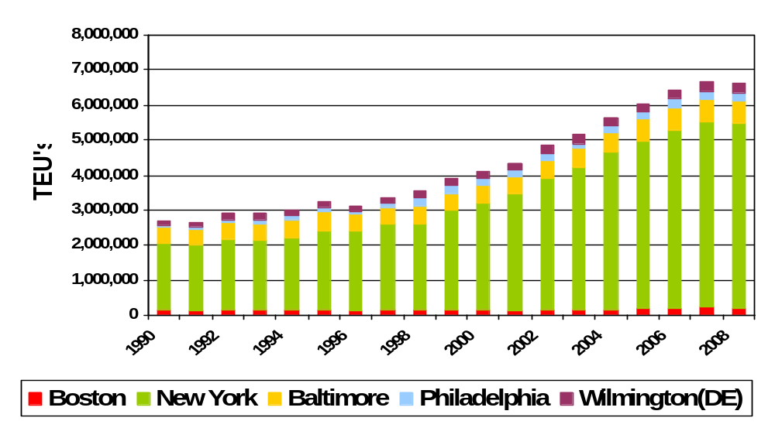

Source: American Association of Port Authorities

Figure 2.3-12
Imported Asian Containerized Cargo at North Atlantic Ports
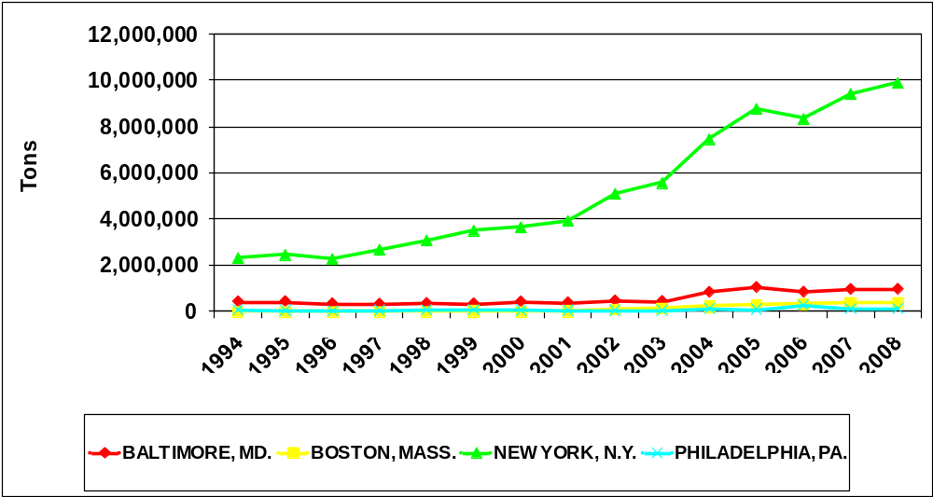

Source: US Maritime Administration

Figures 2.3-13 and 2.3-14, respectively, present total TEU and Asian imported containerized tonnage throughput at key South Atlantic ports. The Port of Savannah is the dominant port in terms of imported Asian containerized cargo, and Norfolk has overtaken the Port of Charleston in terms of this cargo. This growth in imported containerized cargo from Asia reflects the change in logistics patterns after 2002, and the accompanying growth in distribution centers at these two ports.

Figure 2.3-13
Total Containerized Cargo Activity at South Atlantic Ports (TEUs)
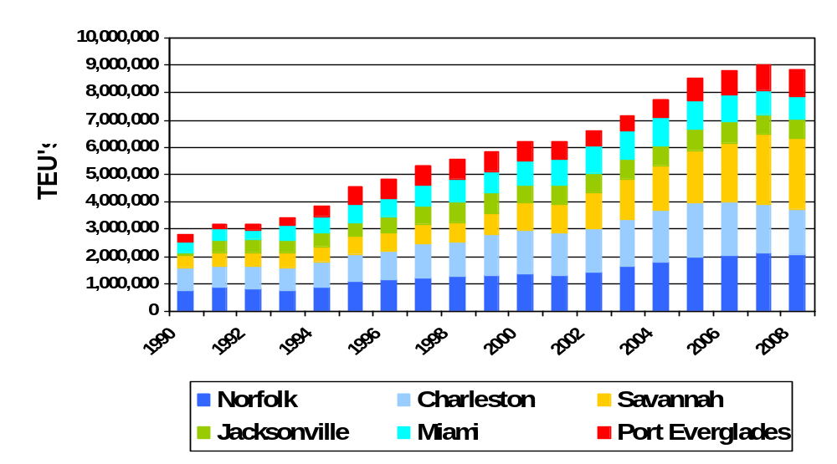

Source: American Association of Port Authorities

Figure 2.3-14
Imported Asian Containerized Tonnage at South Atlantic Ports
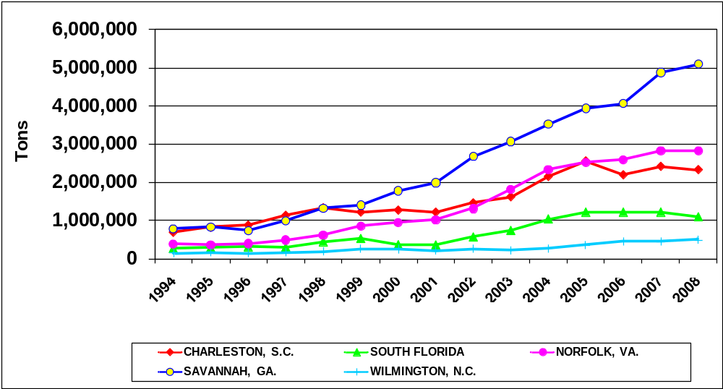
Source: US Maritime Administration
Similarly, Figures 2.3-15 and 2.3-16, respectively, depict TEU throughput and the growth in Asian imported containerized tonnage at the Gulf Coast ports. These figures demonstrate the strong growth in the all-water services at the Port of Houston (reflecting the accompanying growth in distribution center development) as well as at the Port of New Orleans, and the recovery of the latter port from the impact of Hurricane Katrina in 2005.
Figure 2.3-15
Containerized Cargo Activity at Gulf Coast Ports (TEUs)
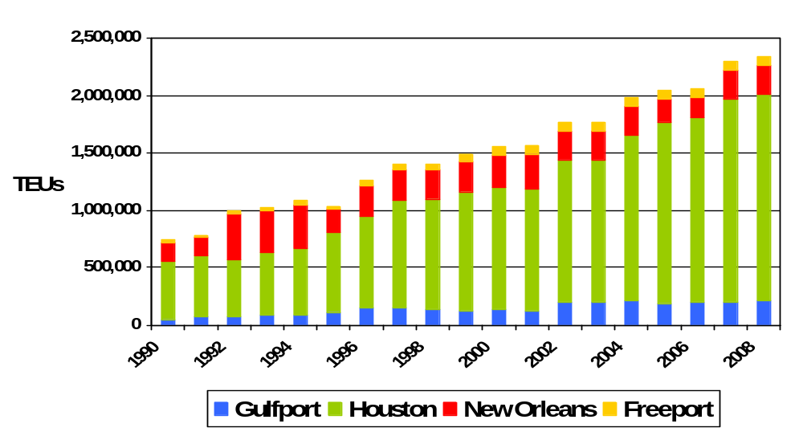

Source: American Association of Port Authorities

Figure 2.3-16
Imported Asian Containerized Cargo at Gulf Coast Ports
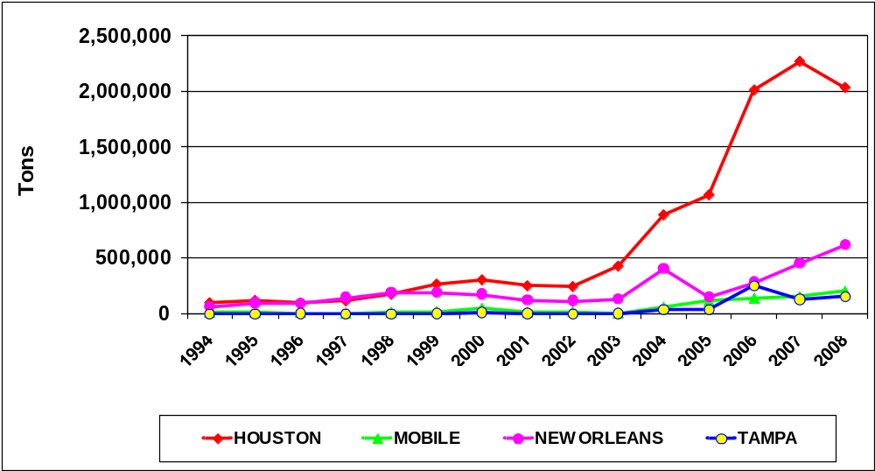
Source: US Maritime Administration

2.3.5 Current South Atlantic and Florida Containerized Trade Markets
Overview of the South Atlantic and Florida Containerized Cargo Markets. While Port Everglades competes directly with the Port of Miami for the Latin American and Caribbean cargo markets, the Port also competes against other key South Atlantic ports, specifically the Ports of Jacksonville, Tampa, Savannah, and Charleston for Asian and European cargoes. The balance of this section focuses on the South Atlantic and Florida markets in which Port Everglades competes.
Figures 2.3-17 and 2.3-18 illustrate the growth in container traffic at the key South Atlantic ports.
Figure 2.3-17
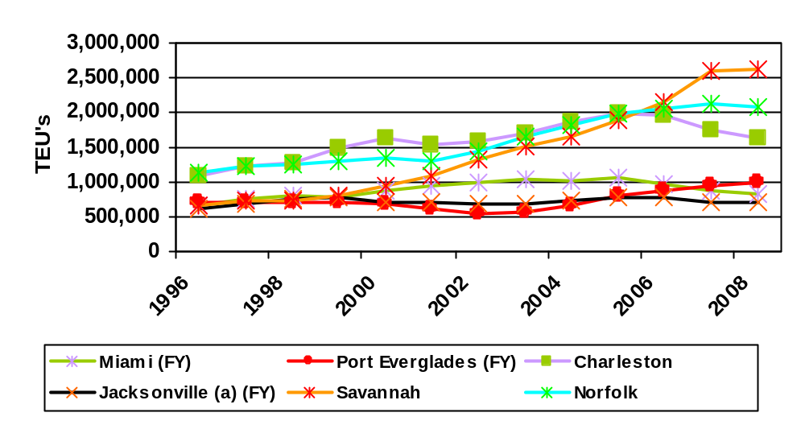South Atlantic Ports Historical Containerized Growth (TEUs)

Source: American Association of Port Authorities
Figure 2.3-18
Indexed Container Growth of South Atlantic Ports (TEUs)
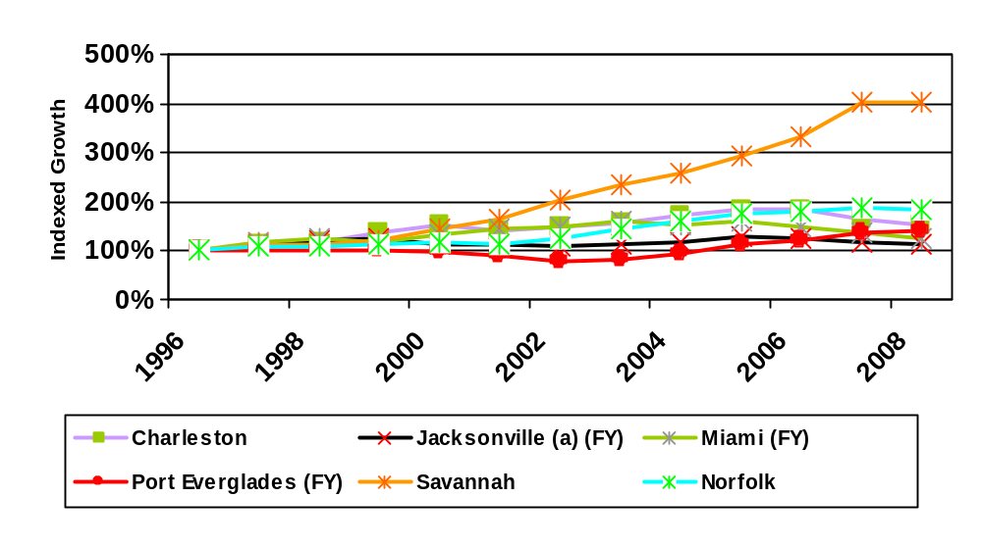

Source: American Association of Port Authorities
As these figures show, Norfolk, Savannah, and Charleston have dominated containerized cargo in the South Atlantic.
With respect to the Florida ports, the Port of Miami was the dominant player through 2005; however, with its more robust growth in recent years, Port Everglades has since eclipsed Miami, as shown in Figure 2.3-19.
Figure 2.3-19
Florida Ports Container Activity (TEUs)
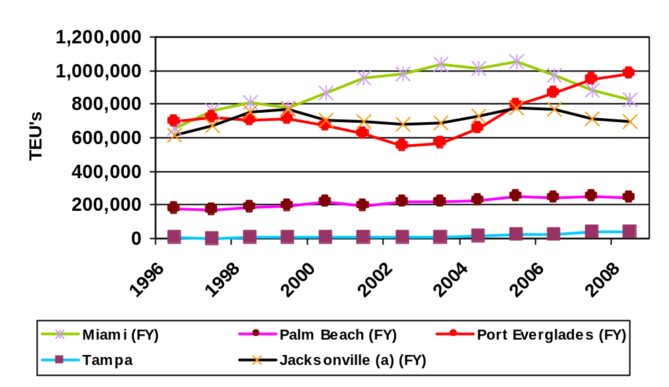

Source: American Association of Port Authorities
The growth at the Florida ports as a whole has, however, lagged behind that of the US and South Atlantic ports, as shown in Figure 2.3-20.
Figure 2.3-20
Indexed Growth of Port Everglades and the Florida Ports
in Comparison with US and South Atlantic Ports (TEUs)
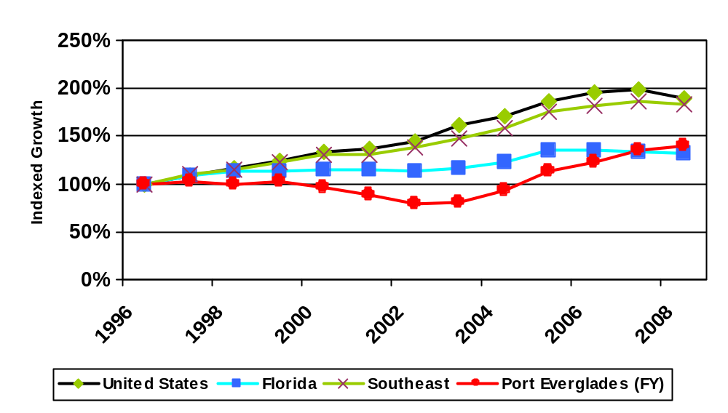

Source: American Association of Port Authorities

Summary of Competing Ports in the South Atlantic Container Market. A port-specific discussion of the recent improvements and future strategies at Port Everglades’ competition in the South Atlantic port range follows.
Port of Charleston (South Carolina State Ports Authority). The Port of Charleston has traditionally led the South Atlantic in container moves, experiencing a 4.0 percent annual growth over the 1990-2008 period. Since 2001, however, the Port of Charleston has not recorded the explosive growth experienced at Norfolk and Savannah. Container moves via Charleston have declined since 2005. One key reason Charleston has not shown double-digit annual growth in recent years is that it has not increased its share of the Asian imported containerized cargo market as have Norfolk and Savannah.
Figure 2.3-21 shows the Port’s historical growth in container throughput, while Figure 2.3-22 depicts the composition of Charleston’s trading partners, reflecting the heavy presence of European cargo.
Figure 2.3-21
Container Throughput at the Port of Charleston (TEUs)
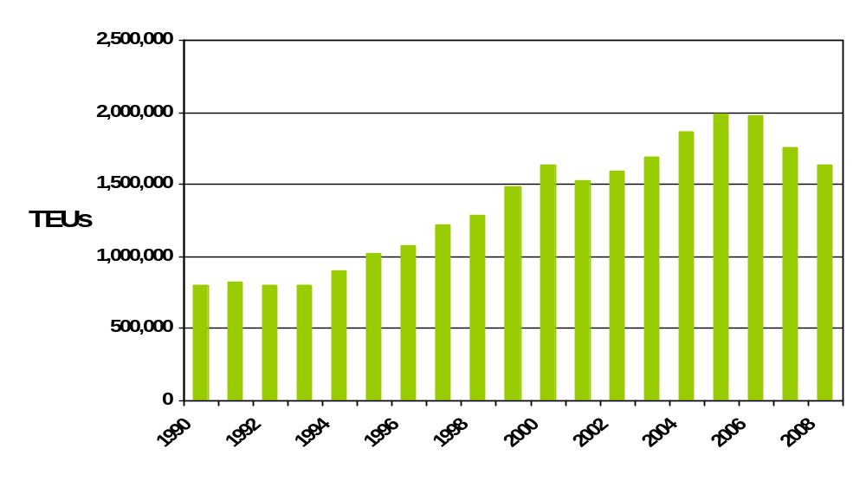

Source: American Association of Port Authorities

Figure 2.3-22
Charleston’s Share of Containerized Cargo by Trade Lane - FY 2008 Loaded TEUs

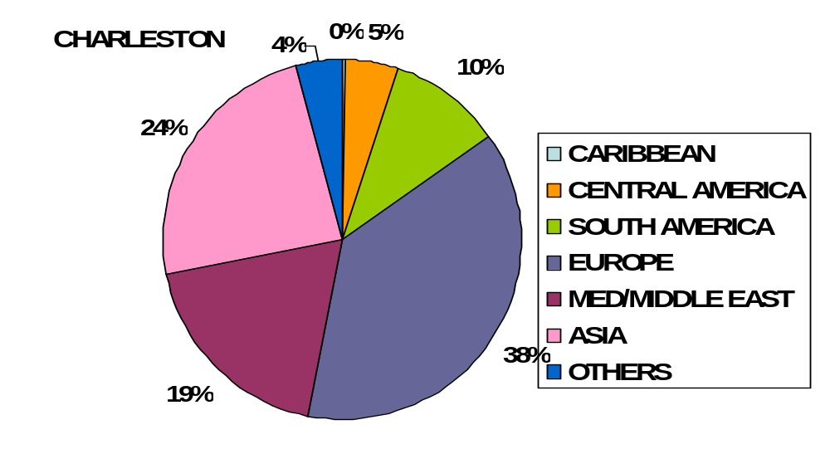

Source: PIERS, Journal of Commerce
The Port of Charleston completed a $148-million harbor-deepening and widening project In May 2004. To accommodate the larger container ships serving world trade, the Charleston Harbor channels leading to all container terminals are now -45 feet at mean low water (5- to 6-foot tidal lift), while the entrance channel has been deepened to -47 feet.
In addition, Charleston's new real-time, RF (radio frequency identification)-based container inventory network, yard management system (YMS), is now operational at all of its container terminals. YMS has allowed the port to handle a much larger cargo volume, with the same staff, while cutting turn times. The average trucker turn time is 20 minutes, averaging 41 moves per hour per crane. In addition, Charleston has 72 container interchange lanes to minimize congestion.
The Port of Charleston’s plan includes the development of a new container terminal, for which construction permits have been received and work has already begun on the site. The 280-acre container terminal on the former Charleston Naval Complex will have three post-Panamax ship berths that will boost capacity by 1.4 million TEUs. The first phase is expected to be completed in 2014.
The Port is also involved with a bi-state commission with the Georgia Ports Authority to develop a marine terminal on the South Carolina side of the Savannah River in Jasper County. In addition, the Port recently expanded the Wando Welch Terminal by 25 acres to be used for handling refrigerated containers. This expansion is off-dock, allowing the current reefer area to be used for loaded dry containers and adding more than 1,000 slots to the port, with additional acreage on the terminal for future development.
To attract additional Asian container service, the South Carolina Ports Authority has been pursuing a distribution strategy. To date, several distribution centers have located near the port or on port property:
- American Port Services operates a distribution center for Wal*Mart on port property.
- Sam’s Club has a distribution center near Wando Terminal.
- Fruit of the Loom is opening a 350,000-square-foot distribution center.
- Many distribution centers are located in the middle of the state (1.3 million square feet).
- 10,000 acres are available within a 1-hour drive of Charleston.
Port of Savannah (Georgia Ports Authority). The Georgia Ports Authority (GPA) has exhibited strong growth in container moves, averaging a 10.7 percent annual growth over the 1990-2008 period. The most explosive growth has, however, occurred since 2000, with container moves via the Port of Savannah more than doubling between 2000 and 2008. This growth in the last eight years reflects the continued development of distribution centers in the Savannah area and the growth in all-water Asian container services. Figure 2.3-23 illustrates the rapid growth in container moves between 2000 and 2008, while Figure 2.3-24 shows the impact of trade with China and other Asian countries, which have become the dominant trading lanes for the Port of Savannah’s containerized cargo.
Figure 2.3-23
Container Throughput at the Port of Savannah (TEUs)

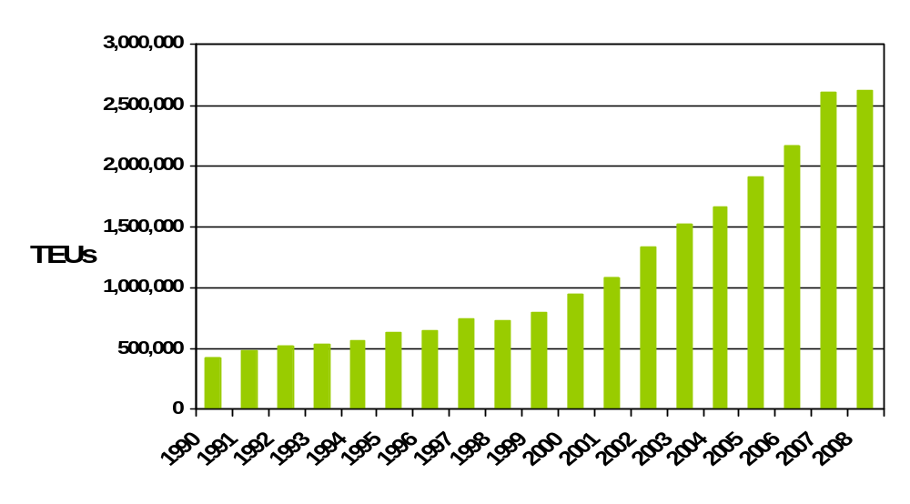

Source: American Association of Port Authorities

Figure 2.3-24
Savannah’s Share of Containerized Cargo by Trade Lane - FY 2008 Loaded TEUs
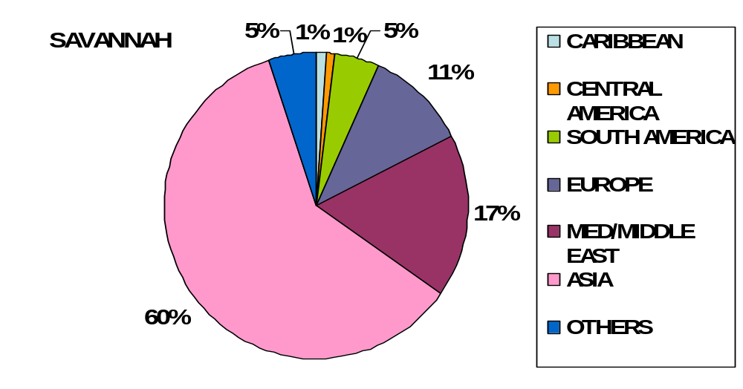

Source: PIERS, Journal of Commerce

The Port of Savannah is the fastest growing port in the South Atlantic with respect to trade with China and other Asian countries. It currently handles 2.6 million TEUs. By increasing terminal density and throughput capacity, the port can expand capacity to about 3 million TEUs.
The Port of Savannah is home to the largest single-terminal container facility of its kind in North America; the facility comprises two modern deepwater terminals, Garden City Terminal – the key container terminal --and Ocean Terminal – a mixed-use facility for break-bulk, container, and RO/RO cargo. The Garden City Terminal is a 1,200-acre facility that features 9,693 linear feet of continuous berthing and more than 1.2 million square feet of covered storage. The terminal is equipped with eighteen high-speed container cranes (eight super post-Panamax and eleven post-Panamax) as well as an extensive inventory of yard-handling equipment.
The port plans to spend $1.2 billion over the next ten years on terminal densification efforts, including the addition of two post-Panamax cranes every 18 months for a total of 25 cranes. As part of an overall full RTG conversion at the terminal, the Port plans to add 86 RTGs. In addition, Garden City Terminal is within 6.3 miles of I-16 (east/west) and 5.6 miles of I-95 (north/south), with access to more than 100 trucking companies.
CSXT and NS provide Class I rail service to the port. As a key intermodal advantage, the Port of Savannah’s dual on-dock rail facilities – the James D. Mason ICTF and the Chatham ICTF, both of which are served by CSXT and NS – offer two- and three-day transit times to key hubs such as Atlanta and Memphis. Due to this on-dock rail access, Savannah’s intermodal business has grown 67 percent over the past five years. Approximately 18 percent of the Garden City Terminal‘s TEUs move via rail.
In addition to increasing throughput by increasing densification, the Port of Savannah has additional land for future container terminal development. The GPA can add another 80 to 90 acres to Garden City, plus another 150 acres in the longer term. An additional 500 acres is available in the long-term for terminal development on Kings Island.
As the volume of cargo moving through the Port of Savannah rises and the ships carrying that cargo grow even larger, the Port is seeking to dredge 26 miles of the Savannah River Navigation Channel from the current depth of -42 feet to -48 feet at mean low water to accommodate the next generation of deep-draft vessels. The authorization of this project is currently under ACOE review.
The expansion projects will increase throughput capacity at the Port of Savannah from 2.62 million TEUs currently to 6 million TEUs in 2018.
The Port of Savannah has set the standard for distribution center development on the East Coast, beginning with K-Mart in the early 1980s. This development reflects Savannah’s proximity to Atlanta and other Southeastern markets. The GPA has attracted over 18 high-volume import distribution centers, totaling nearly 15 million square feet and generating more than 500,000 TEUs annually. These distribution centers include:
- Advance Auto Parts.
- Bass Pro Shops.
- Best Buy.
- IKEA.
- Lowe’s.
- Pier 1.
- Target.
- The Home Depot.
- Wal*Mart (Savannah and Statesboro).
- Oneida.
In addition to land available for future container growth, 350 acres are still available at the former BASF property (now owned by GPA). This acreage has been targeted for distribution center and industrial development use. Finally, in Chatham County, suitable land has been identified for 10 million square feet of distribution center development. With the rapid growth in container movements in the last five years, and the aggressive distribution center strategy, the Port of Savannah will likely continue to remain a dominant player in the South Atlantic market.
Jacksonville Port Authority (JAXPORT). JAXPORT has not been a key player in the container markets, with the exception of its Puerto Rico and Caribbean trade. The port controls nearly 75 percent of the US-Puerto Rican trade. Figure 2.3-25 presents the historical cargo throughput via Jacksonville while Figure 2.3-26 demonstrates Jacksonville’s concentration in the Caribbean trade.

Figure 2.3-25
Container Throughput at JAXPORT (TEUs)
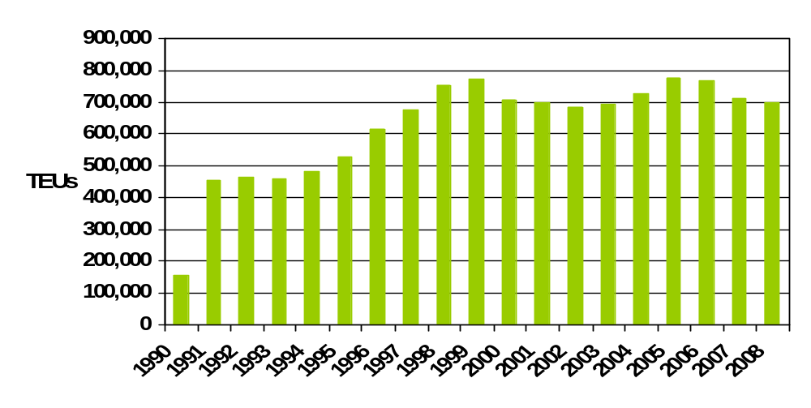

Source: American Association of Port Authorities

Figure 2.3-26
JAXPORT’s Share of Containerized Cargo by Trade Lane - FY 2008 Loaded TEUs

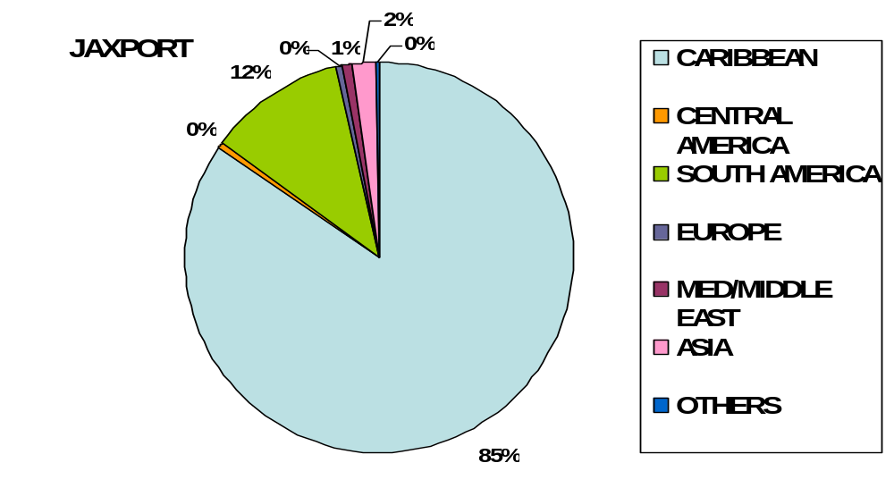

Source: PIERS, Journal of Commerce

MOL, along with TraPac, recently completed a 158-acre dedicated container terminal at Dames Point, the most modern, state-of-the-art container terminal on the East Coast. The terminal consists of two 1,200-foot berths and six Post-Panamax cranes and will add nearly 1 million-TEU capacity to the port.
In December 2008, Hanjin Shipping Company signed a 30-year lease (with an option for further expansion) to develop a 90-acre container facility at Dames Point. The $300 million terminal will include two berths able to accommodate post-Panamax vessels and is designed to handle 1 million TEUs annually at full capacity. According to JAXPORT officials, the project is scheduled for completion in 2013.
JAXPORT offers excellent transportation access:
- Superior north-south rail access to Southern Florida via the FEC.
- East-west rail service via CSXT and NS and excellent northbound service as well.
- Excellent highway access to key southeastern markets.
In addition to the container terminal development at Jacksonville, significant interest has been shown in distribution center development. Currently BJ’s and Wal*Mart have distribution centers near the port; these are primarily used for export activity to the Caribbean. The greatest demand for distribution centers is located in Jacksonville’s Northside and Westside.
The Northside area consists of three primary business parks: North Point Industrial Park, Imeson, and Jacksonville Tradeport. The North Point Industrial Park is located about 4 miles from the port and consists of 350 acres of build-to-suit lease or sale sites from 10 to 150 acres.
The Westside area consists of the Westside Industrial Park, the Westlake Industrial Park, and the Cecil Commerce Center. The Westside Industrial Park consists of a 960-acre master planned development with 4 million square feet of space. Current tenants include:
- UPS.
- HJ Heinz.
- Michaels.
- Samsonite.
- W.W. Granger.
- Pepsi.
The City of Jacksonville is also pursuing a strategy for distribution center development and is in full support of the Port of Jacksonville’s growth.
Given MOL’s development of the Dames Point container terminal and the interest by other carriers in Jacksonville’s strategic transportation location, it is likely that containerized cargo throughput will grow strongly in the short- to medium-term.
Port of Palm Beach. With respect to containerized cargo, the Port of Palm Beach primarily competes in the Caribbean market, which accounts for approximately 93 percent of the port’s container volume. In 2008, the port handled just under 250,000 TEUs, representing a steady 4.1 percent compound annual growth rate (CAGR) since 1990. This growth has been attributed to the success of the port’s key container carrier, Tropical Shipping, which serves ports throughout the Caribbean, including the Bahamas, US Virgin Islands, and the Dominican Republic. The historical growth and market share of containerized traffic handled at the Port of Palm Beach are depicted in Figures 2.3-27 and 2.3-28.

Figure 2.3-27
Container Throughput at the Port of Palm Beach (TEUs)
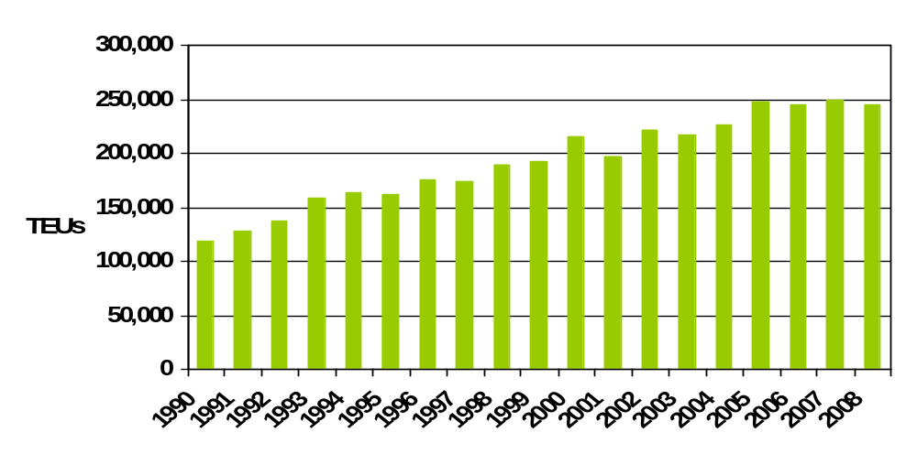

Source: American Association of Port Authorities

Figure 2.3-28
Palm Beach’s Share of Containerized Cargo by Trade Lane - FY 2008 Loaded TEUs
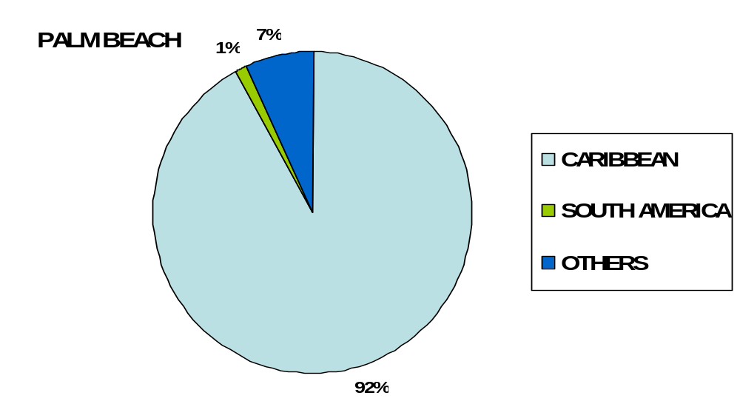

Source: PIERS, Journal of Commerce
While it is expected that the Port of Palm Beach will continue to maintain market share in the Caribbean, specifically the Bahamas trade, it is unlikely that the port will compete for cargoes from other world areas, including Asia, the Indian Sub-Continent, and Europe. This is due to the port’s limited draft of 32 feet at high water slack and a channel configuration that permits only vessels with less than a 600-foot length overall (LOA) to enter the port. Land availability and current infrastructure constraints are also deterrents to additional services.
Port of Miami. While the Port of Miami’s primary cargo markets are Latin America and the Caribbean, which account for 56 percent of the Port’s cargo, the port also competes in the Asian market, which accounts for 25 percent of the port’s total. The port has experienced a 4.5 percent annual growth rate in container throughput over the 1990-to-2008 period, as presented in Figure 2.3-29. Figure 2.3-30 illustrates the Port of Miami’s current container traffic by trading partner. Historically, this growth has been driven by the port’s proximity to a major consumption market and the community’s geographical, cultural, and commercial connections to the Latin American markets.
Figure 2.3-29
Container Throughput at the Port of Miami (TEUs)
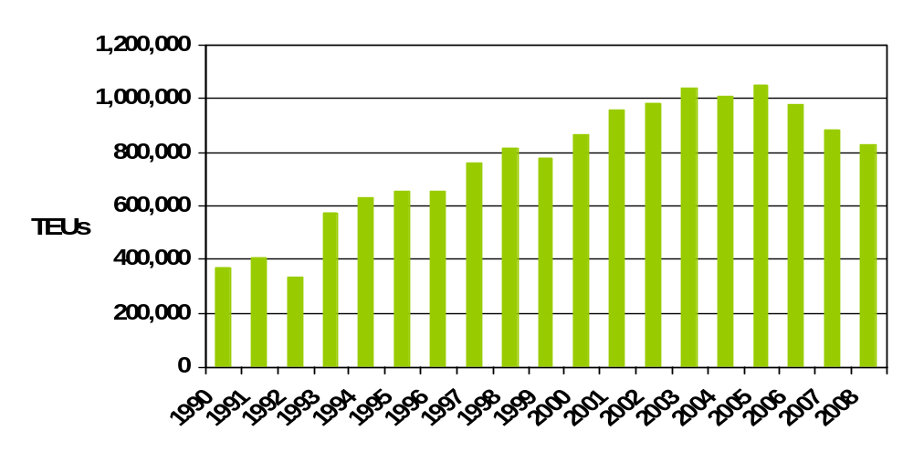

Source: American Association of Port Authorities
Figure 2.3-30
Miami’s Share of Containerized Cargo by Trade Lane - FY2008 Loaded TEUs
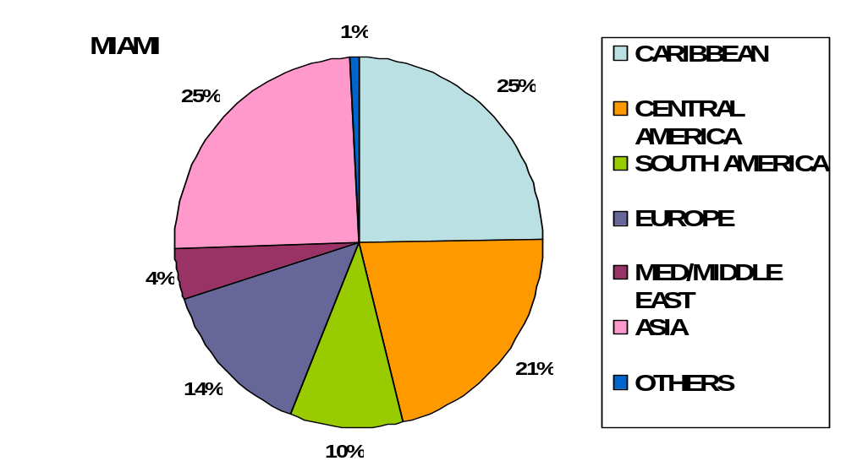

Source: PIERS, Journal of Commerce
While the port is land-constrained, a capital improvement program is in place to increase capacity through yard densification as well as phased dredging. The Port of Miami completed Wharves 6 and 7, at a cost of $13.8 million. The two wharves were designed to accommodate post-Panamax vessels, those too large to transit through the Panama Canal. The addition of 1,145 feet to the gantry docks brought the total length of these wharves to approximately 6,120 feet. The combination of an expanded gantry crane area and two new container cranes allows the Port of Miami to continue its aggressive marketing efforts to attract more cargo carriers and pursue new markets.
Also completed is the resurfacing of the Port of Miami Terminal Operating Company’s (POMTOC) and Seaboard Marine's container yards as well as drainage system improvements. These enhancements will contribute to greater operating efficiencies and allow the terminal operators to boost their container-marshalling capacity by increasing the vertical density at their respective yards.
Phase II of the Port of Miami’s harbor-dredging project was completed in June 2006. This second phase of the project involved the deepening of the South Ship Channel (also known as Fisherman’s Channel) and the Central Turning Basin from -34 feet to -42 feet. Maintenance dredging of all berthing areas was also part of the project.
Prior to the deepening to -42 feet, the port offered only two berths that could accommodate the larger cargo ships. The completion of Phase II provides four additional berths to handle the deeper-draft vessels, placing the Port of Miami in a more competitive standing in relation to other deepwater seaports, and positioning it to reap spillover economic benefits.
Phase III of the port’s harbor-dredging project involves deepening the South Ship Channel and the Central Turning Basin to -50 feet and the Entrance Channel and Government Cut to -52 feet, and widening the South Ship Channel by 100 feet. This large-scale dredging project, expected to take up to six years, was recommended by the ACOE and has been authorized by Congress, but is awaiting funding in the Water Resource Development Act. The project has a price tag estimated at more than $170 million, of which $69 million is anticipated as federal cost-sharing expenses with potential State of Florida funds.
The Port of Miami experiences severe traffic congestion moving cargo to and from the port over the City of Miami’s downtown street system. To alleviate this congestion, twin tunnels have been proposed which will connect the port with the interstate system, bypassing the downtown streets. The Port of Miami Tunnel project is a public/private partnership among the FDOT, Miami-Dade County; the City of Miami, and Miami Access Tunnel (MAT), a private consortium awarded the contract in February 2008. In October 2009, after the project’s original 90 percent equity partner experienced financial trouble, new financing was put in place and the project received the go-ahead. The goal is completion by 2014.
Overall, it is likely that the Port of Miami will continue to be a regional port, primarily serving South Florida, and will continually have to compete with an aggressive pricing situation at Port Everglades. There is some possibility that more of the Miami market can be served from JAXPORT due to advantageous north-south truck backhaul rates as well as the use of the FEC. This possibility will increase as the level-of-service increases at JAXPORT.
Port of Tampa. Historically, the Port of Tampa’s tonnage has been concentrated in liquid and dry bulk commodities, as the Port had not participated heavily in the containerized market. Figure 2.3-31 depicts the port’s historical containerized throughput.
Figure 2.3-31
Containerized Throughput at Port of Tampa (TEUs)
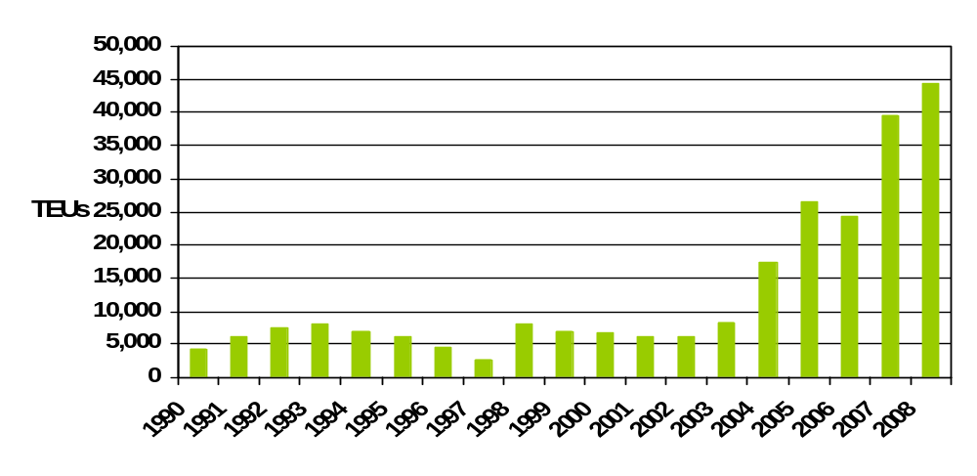

Source: American Association of Port Authorities

The addition of Zim Container Line has boosted the Port of Tampa’s throughput. Zim has been replacing all ten of its vessels serving Tampa directly from Asia with new, large Panamax vessels. Although historically the port’s trade in containers has been in the Latin American and Caribbean markets, diversification of world markets has increased in recent years, as illustrated in Figure 2.3-32.
Figure 2.3-32
Tampa’s Share of Containerized Cargo by Trade Lane – FY 2008 Loaded TEUs
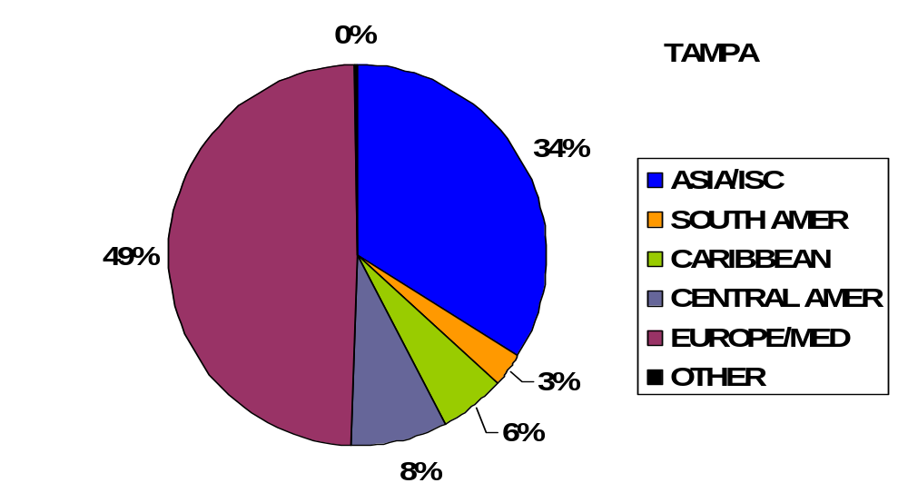

:
PIERS, Journal of Commerce
The Tampa Port Authority and Ports America completed the extension of the port’s container berths to 2,100 feet in late 2008. Expansion of the entire terminal is currently underway, with Phase 1, which includes adding 15 acres of paved storage area and additional cargo-handling equipment, to be completed during 2009. Subsequent phases planned for the next 3 to 5 years will more than quadruple the terminal size (from 25 acres to 160 acres); will include acquisition of additional cranes; and will extend berths to 2,700 feet, at a cost of nearly $100 million.
With capital investment in container operations, the Port of Tampa has the potential to serve the growing consumer market in Central Florida’s I-4 Corridor. Recently, over 40 million square feet of new distribution center capacity has been announced for the Tampa region. For example, Rooms to Go Furniture plans to add an additional 700,000 square feet, for a total of 3.2 million square feet; and Premier Beverage is planning to build up to 1.5 million square feet.
CSX Intermodal (CSXI) is planning to develop an Integrated Logistics Center in Polk County, approximately 50 miles east of the Port of Tampa. Phase 1 of the statewide rail-to-truck distribution center project includes a 318-acre container and vehicle rail terminal. The Florida Department of Community Affairs approved the plan in early December 2008 and construction is expected to begin in 2009. Phase 2 includes a 950-acre distribution center park.

Current Import and Export Hinterland Markets Served via Southeast Ports. The market in which Port Everglades competes comprises two distinct sectors: import goods for consumption and distribution in Florida and the Southeast, and export goods to Latin America and the Caribbean. Transshipment cargoes handled by the two South Florida ports -- Port Everglades and the Port of Miami -- have diminished over the past decade, declining from approximately 25 percent to less than 5 percent. This decline is attributed to several factors, including a change in carrier base, US governmental regulations (including post-9/11 security as well as USDA APHIS/PPQ policies) and the development of other key transshipment facilities in the Caribbean. While small percentages may continue to exist, any large-scale future growth of transshipment cargoes handled at Port Everglades appears unlikely. Capacity expansion and developments at key Caribbean transshipment hubs such as Colon (Panama), Kingston (Jamaica), Freeport (Bahamas), Caucedo (Dominican Republic), Cartagena (Colombia), and Port of the Americas (Puerto Rico) will compete for east-west traffic. Furthermore, offshore labor rates and productivity are more conducive to transshipment operations than US labor structures.
Historically, Port Everglades competes against other regional ports to serve the import hinterland market (distribution centers) in the South/Central Florida region. With the exception of JAXPORT, which controls the Puerto Rican trade, Port Everglades, the Port of Miami, and the Port of Palm Beach also compete for the export market that serves Latin America and the Caribbean. The South Florida ports have been (and will continue to be) successful due to the large Latin American business community in South Florida. Furthermore, the South Florida export market is complemented by a large presence of shippers and consolidators in the Miami-Dade County region.
The locations of the key import distribution centers are plotted in Figure 2.3-33. As shown, these import distribution center are concentrated in three areas: Jacksonville, South Florida, and Central Florida along the I-4 Corridor (Tampa-Lakeland-Orlando).

Figure 2.3-33
Concentration of Distribution Centers of Top Florida Importers
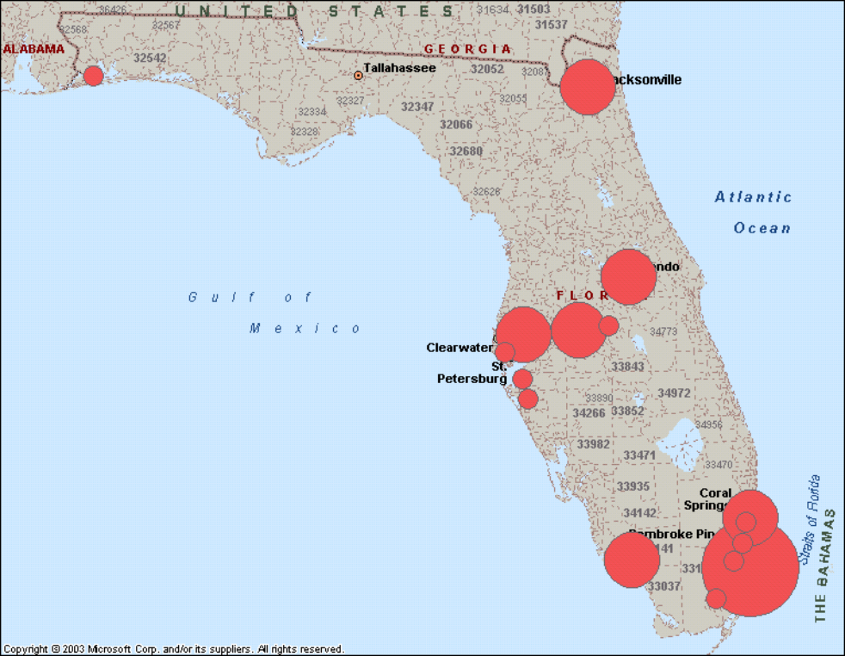

Source: Chain Store Guide, Dunn & Bradstreet

The key distribution and consolidation centers for the export market are mapped in Figure 2.3-34. Again, there is a strong concentration in South Florida due to the Latin American influence and business community. This consolidation stronghold will continue strengthening the South Florida ports’ advantage to grow and serve this market.

Figure 2.3-34
Concentration of Key Exporter Distribution Center and Consolidation Facilities
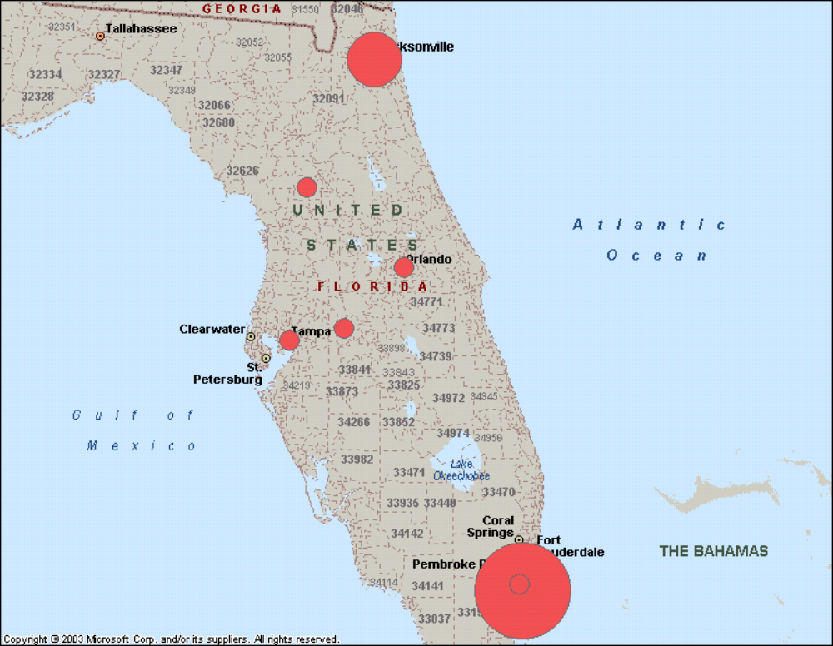

Source: Chain Store Guide, PC Miler, and Dunn & Bradstreet

This concentration of export distribution and consolidation centers provides Port Everglades and the Port of Miami with the necessary support infrastructure to maintain market share in the Latin American and Caribbean export markets. It encompasses regional carriers such as Seafreight, Hyde Shipping, and Crowley as well as third party, non-vessel operating common carrier (NVOCC) shippers such as Econo Caribe, Aqua Gulf Transport, Danzas, and Expeditors, which support the global carriers as well as the strong local truck market. Due to these factors, it is likely that Port Everglades and the Port of Miami will remain strong and compete directly for these export cargoes. Furthermore, Free Trade Agreements with Peru and Chile, the Central America Free Trade Agreement (DR-CAFTA) and the anticipated agreement with Colombia will likely strengthen and sustain the Latin American and Caribbean economies that rely on this US export market.
As demonstrated in the South Atlantic market, specifically in Norfolk, Savannah, and Charleston, the increase in container throughput is directly related to the development of import distribution centers. The current and future development of regional distribution centers to serve this market, as shown in the previous section, will influence port-routing decisions. To examine this potential, it is necessary to understand the current Broward County market for industrial development.
Table 2.3-2 illustrates the Broward County industrial land market as compared with Miami and other key Florida regions. From a rental perspective, Broward County’s industrial NNN (triple net) lease rates are the most expensive, at $7.37 per square foot. Lease rates in the South Florida markets of Broward, Miami-Dade, and Palm Beach Counties all exceed $6.70 per square foot, while rates in Orlando, Tampa, and Jacksonville are significantly lower. These lower rates are more appealing to potential industrial distribution tenants, further underscoring the trend of distribution center growth in Central Florida, specifically the I-4 Corridor, and in the Greater Jacksonville region, as evidenced by the square footage under construction in that region depicted in Table 2.3-2.
Table 2.3-2
Industrial Lease Rates in Key Florida Markets

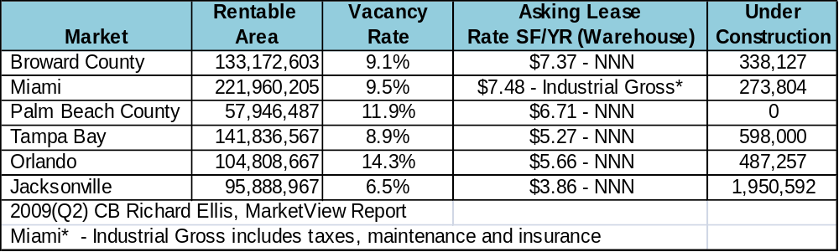

Source: CB Richard Ellis MarketView Reports
To determine the current and future trends in the Florida import and export markets, detailed analyses of Florida importers and exporters were conducted. Using PIERS data, the key locations of importers and exporters for each trade lane and the key Southeast ports serving those markets were identified.
The following series of maps illustrates the Southeast ports’ respective shares of those import/export locations. The location of each pie indicates the location of the importer/exporter, as identified by the PIERS database. The size of the pie corresponds to the range of TEU volumes, as shown on each map’s key.

Figure 2.3-35 demonstrates that the Port of Savannah is clearly the dominant player in terms of Asian imports, penetrating into South Florida, while the Port of Charleston appears to offer some competition in South Carolina and South Florida. Port Everglades and the Port of Miami do not currently serve a significant share of the local South Florida Asian import market. As shown in Figure 2.3-36, Port Everglades and the Port of Miami do, however, control the South Florida export market to Asia..

Figure 2.3-35
Share of Southeast Port TEUs Serving Key ASIA IMPORT Locations

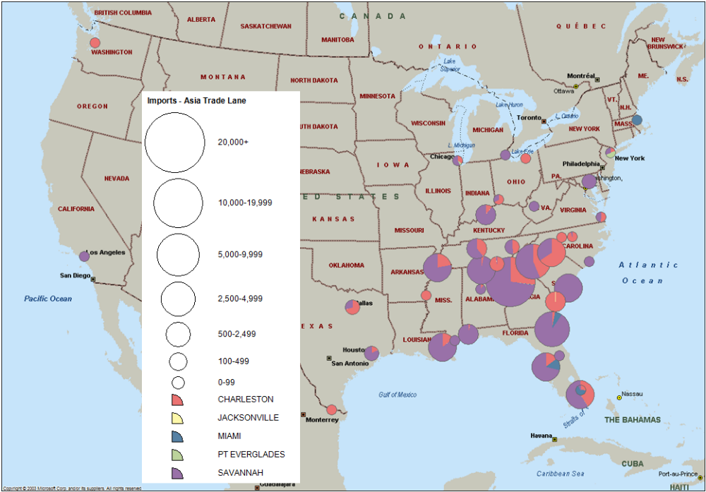
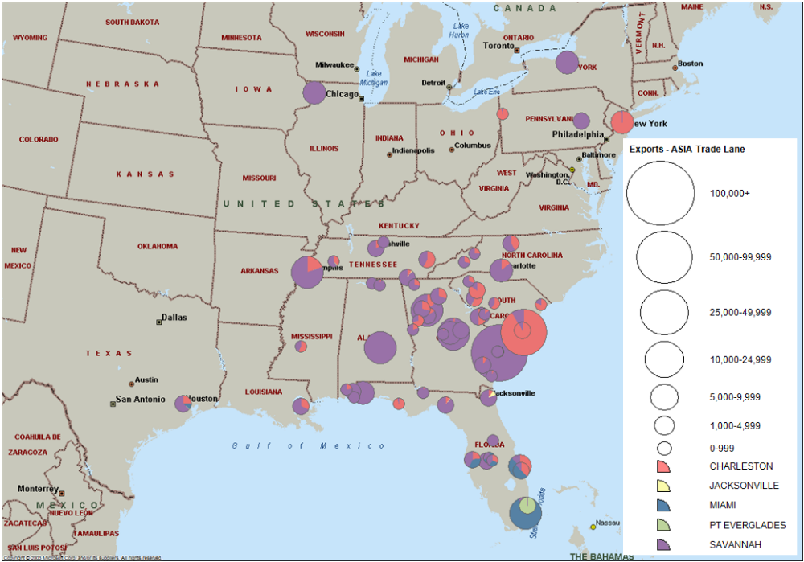
Figure 2.3-36
Share of Southeast Port TEUs Serving Key ASIA EXPORT Locations

Figure 2.3-37 depicts the Port of Charleston’s dominance in the European import trade. The Port of Miami maintains a presence in the South and Central Florida European import market and controls the South Florida export market (see Figure 2.3-38).

Figure 2.3-37
Share of Southeast Port TEUs Serving Key NORTH EUROPE IMPORT Locations
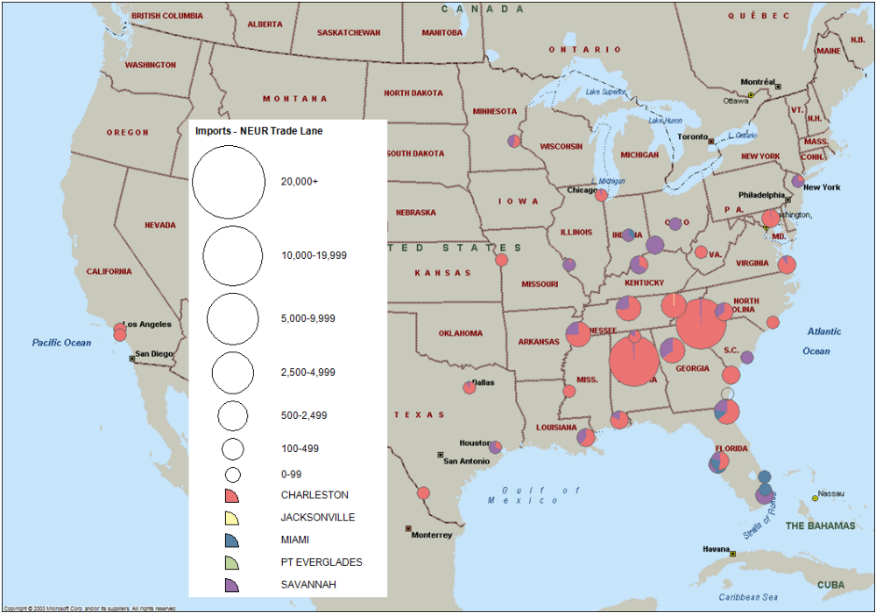

Figure 2.3-38
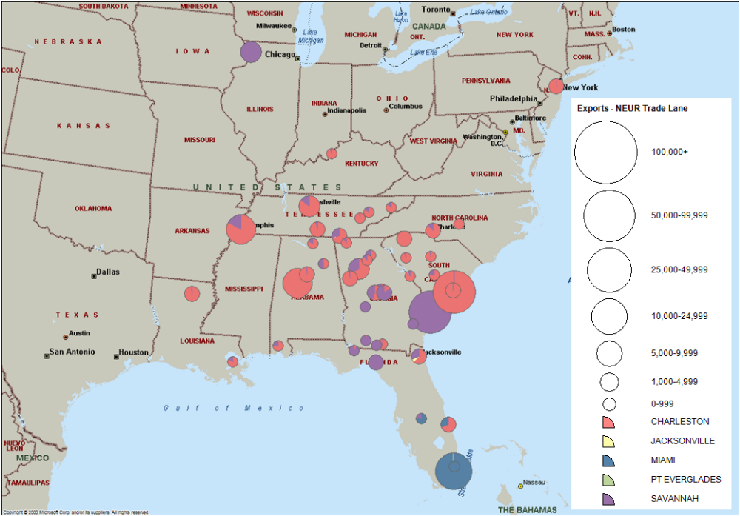
Share of Southeast Port TEUs Serving Key NORTH EUROPE EXPORT Locations

Figure 2.3-39 demonstrates that Savannah is clearly the dominant player in terms of Mediterranean imports, particularly into Jacksonville and Tampa. Port Everglades and Miami appear to compete for the South Florida Mediterranean export market, as shown in Figure 2.3-40.

Figure 2.3-39
Share of Southeast Port TEUs Serving Key MEDITERRANEAN IMPORT Locations
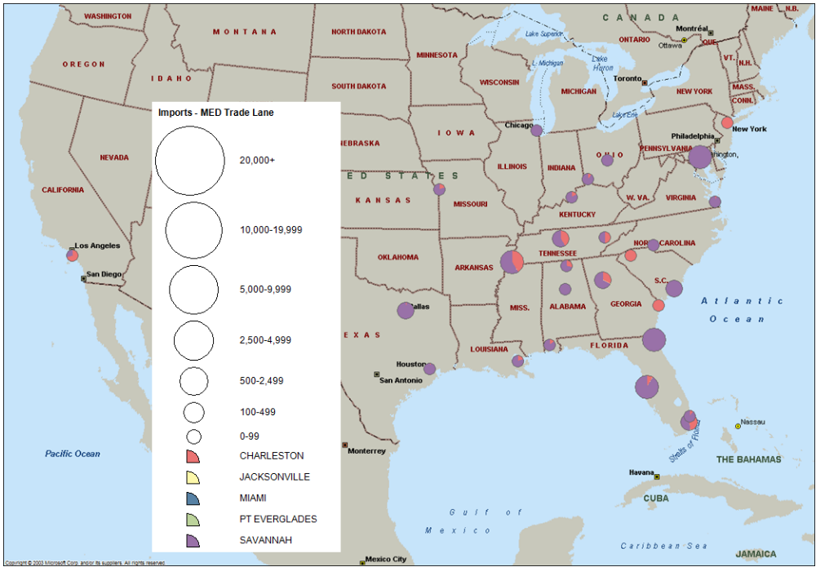

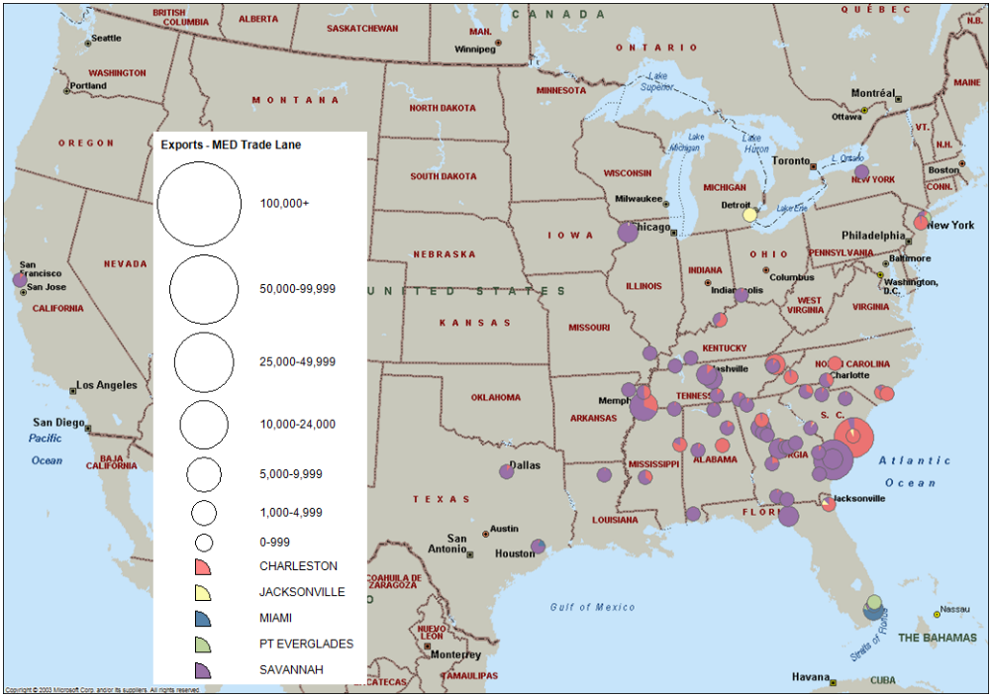
Figure 2.3-40
Share of Southeast Port TEUs Serving Key MEDITERRANEAN EXPORT Locations

Although Middle Eastern imports and exports are smaller market, the Port of Savannah and the Port of Charleston control the key inland destinations in the South Atlantic, as shown in Figure 2.3-41. Figure 2.3-42 demonstrates that these ports also control the majority of the export market with the exception of South Florida, where Port Everglades and Miami maintain a significant share.

Figure 2.3-41
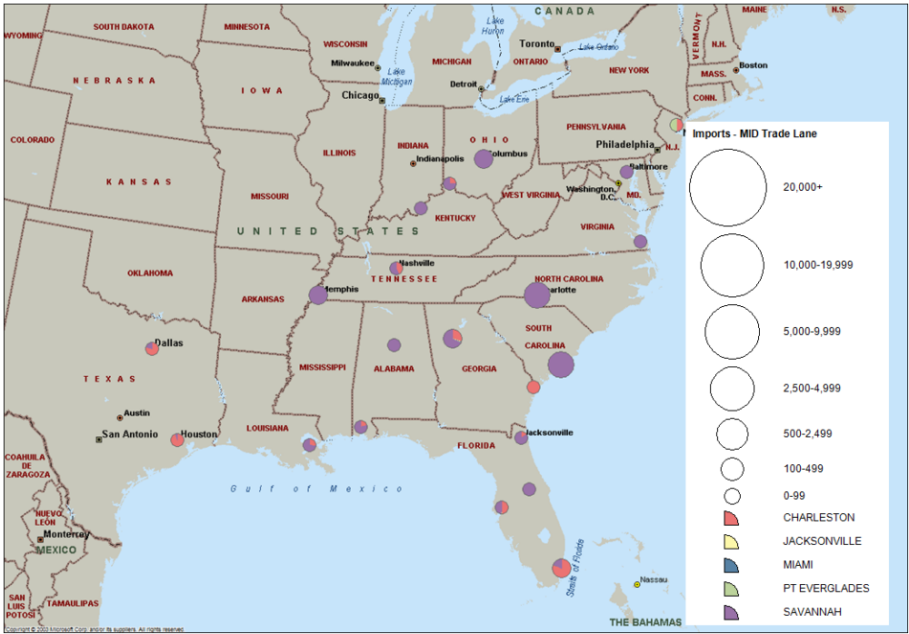
Share of Southeast Port TEUs Serving Key MIDDLE EASTERN IMPORT Locations

Figure 2.3-42
Share of Southeast Port TEUs Serving Key MIDDLE EASTERN EXPORT Locations
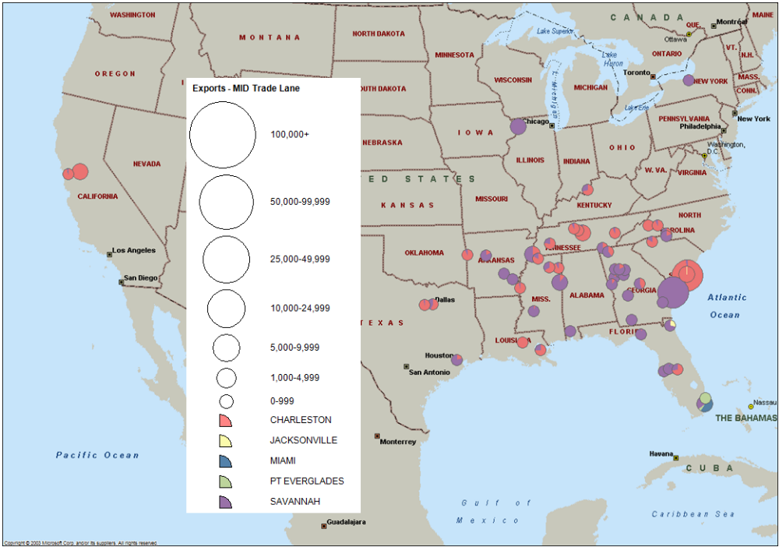
Port Everglades and Miami, as expected, control a majority of the Caribbean imports along the East Coast and Midwest, as illustrated in Figure 2.3-43.

Figure 2.3-43
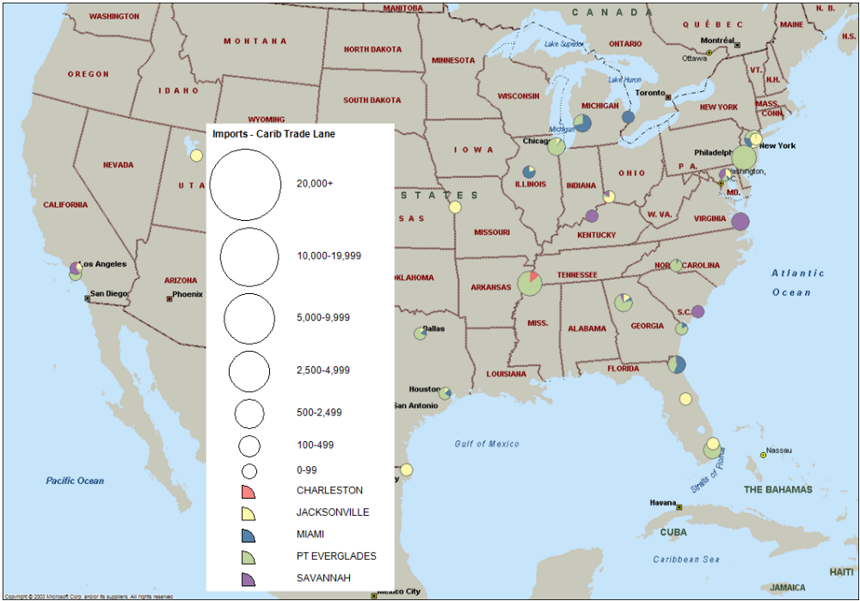
Share of Southeast Port TEUs Serving Key CARIBBEAN IMPORT Locations

In terms of Caribbean exports, Figure 2.3-44 indicates that JAXPORT controls a majority of the South Atlantic while Port Everglades and the Port of Miami clearly dominate the South Florida market, due to the strong presence of consolidation operations in the Medley and Hialeah areas in western Miami-Dade County.

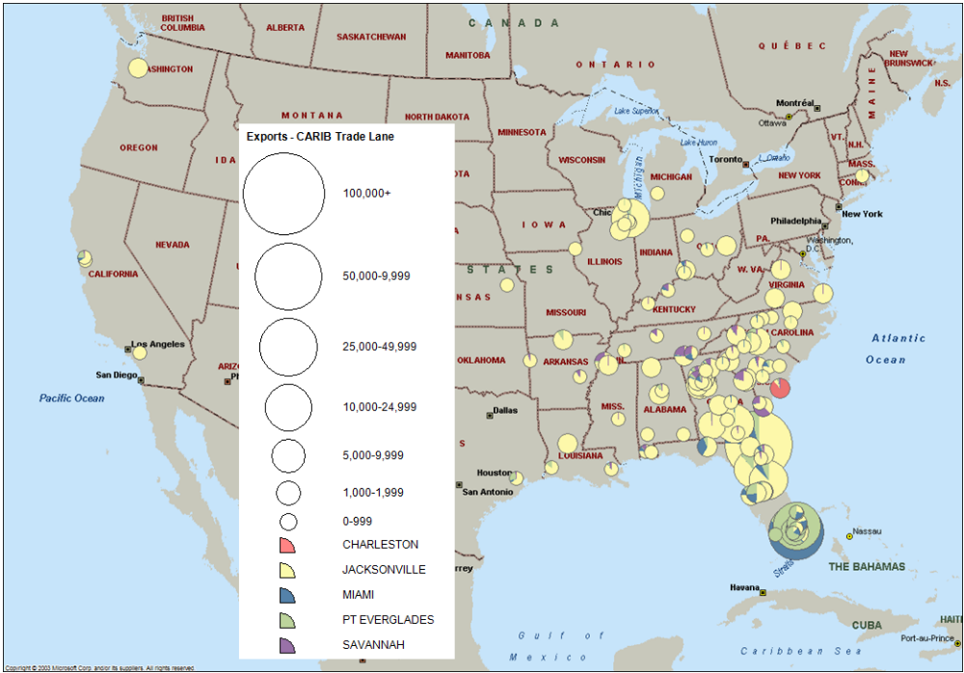
Figure 2.3-44
Share of Southeast Port TEUs Serving Key CARIBBEAN EXPORT Locations

Figure 2.3-45 indicates that Port Everglades and the Port of Miami maintain a significant presence serving Central American cargoes throughout the Eastern US import markets. Similarly, Figure 2.3-46 illustrates that Port Everglades and the Port of Miami also serve a significant share of the North Carolina and Georgia export locations driven by the 807 textile market.

Figure 2.3-45
Share of Southeast Port TEUs Serving Key CENTRAL AMERICAN IMPORT Locations
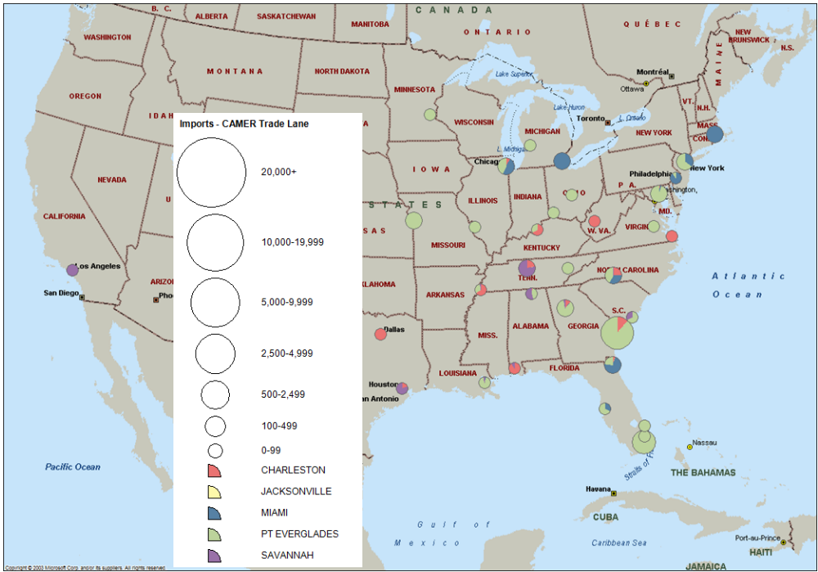

Figure 2.3-46
Share of Southeast Port TEUs Serving Key CENTRAL AMERICAN EXPORT Locations
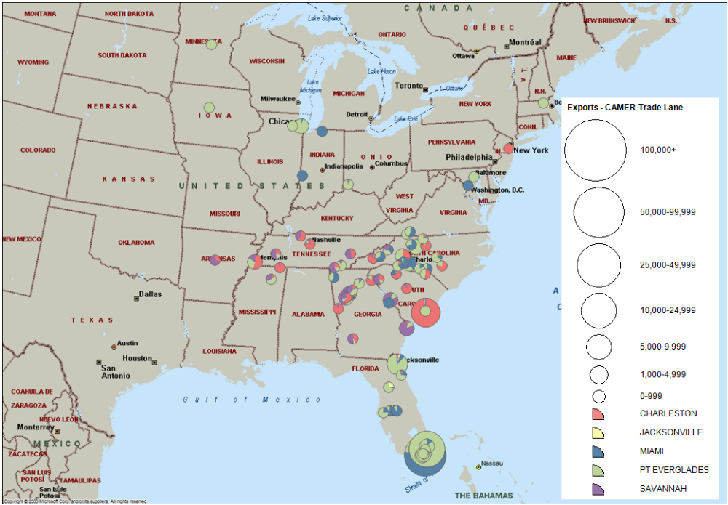
Figure 2.3-47 indicates that the Port of Savannah competes against the Florida ports in serving key Southeast locations for East Coast South American import.

Figure 2.3-47
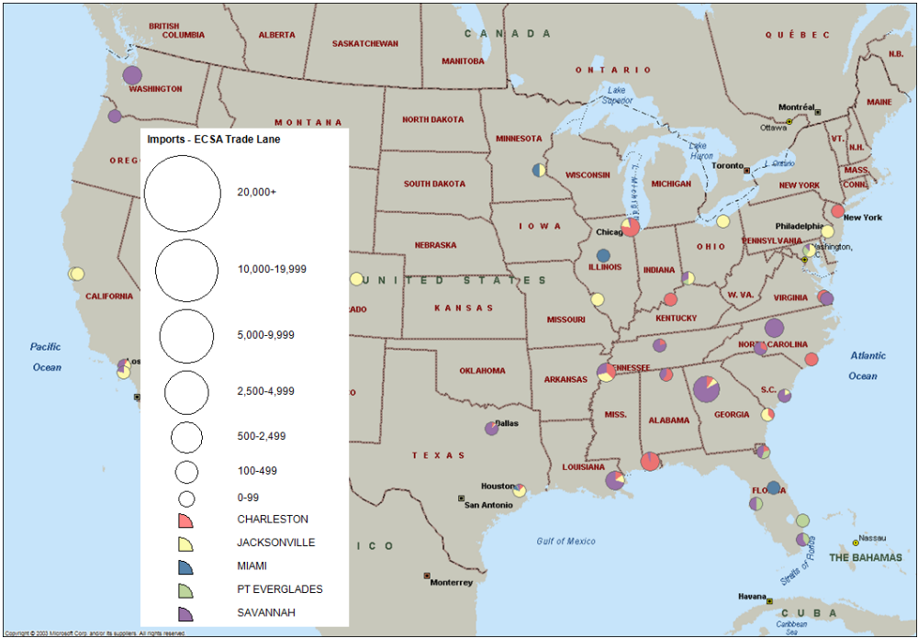
Share of Southeast Port TEUs Serving Key EAST COAST SOUTH AMERICAN IMPORT Locations

In terms of East Coast South American exports, Figure 2.3-48 shows that Port Everglades and the Port of Miami dominate the South Florida market while the Port of Savannah and the Port of Charleston offer more competition in the Carolinas and Georgia. JAXPORT, meanwhile, controls the Midwest markets concentrated in Chicago and Detroit.

Figure 2.3-48
Share of Southeast Port TEUs Serving Key EAST COAST SOUTH AMERICAN EXPORT Locations

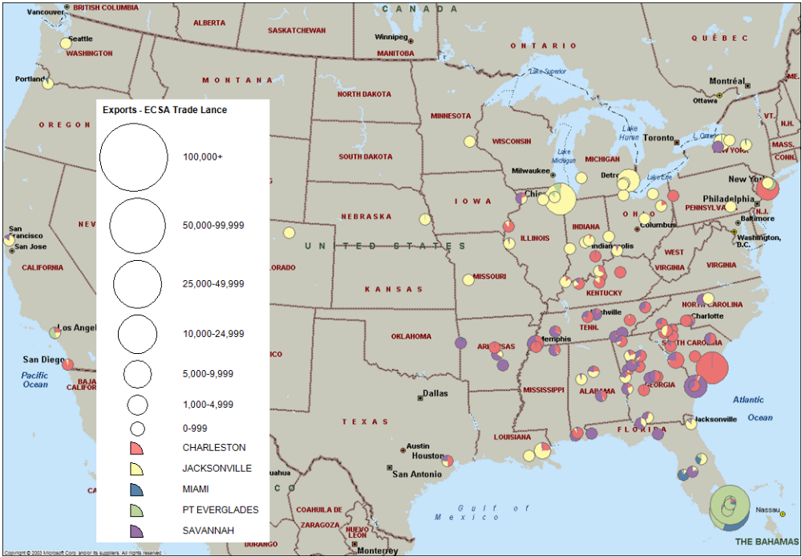
The Port of Savannah and the Port of Charleston appear to compete in key hinterland destinations, for West Coast South American imports, as depicted in Figure 2.3-49.

Figure 2.3-49
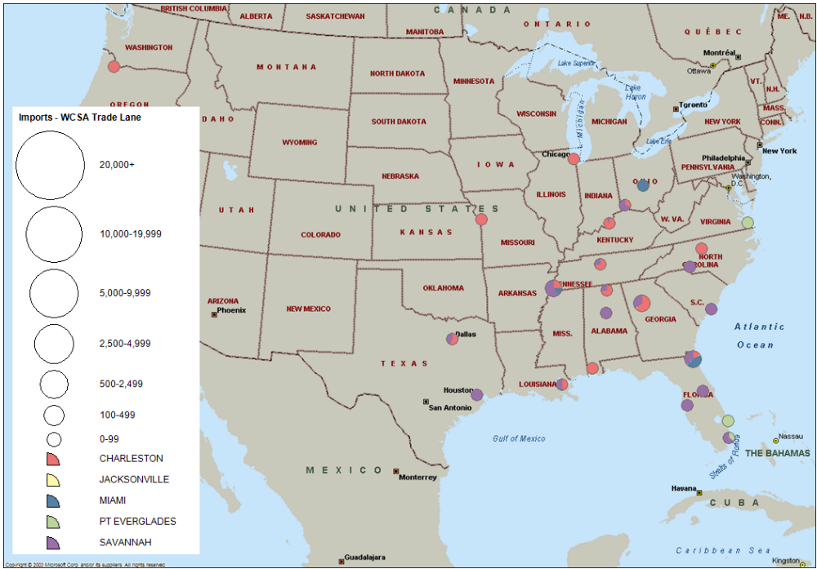
Share of Southeast Port TEUs Serving Key WEST COAST SOUTH AMERICAN IMPORT Locations

Figure 2.3-50, however, shows that the Port of Miami and Port Everglades control the West Coast South American export market in Florida

Figure 2.3-50
Share of Southeast Port TEUs Serving Key WEST COAST SOUTH AMERICAN EXPORT Locations

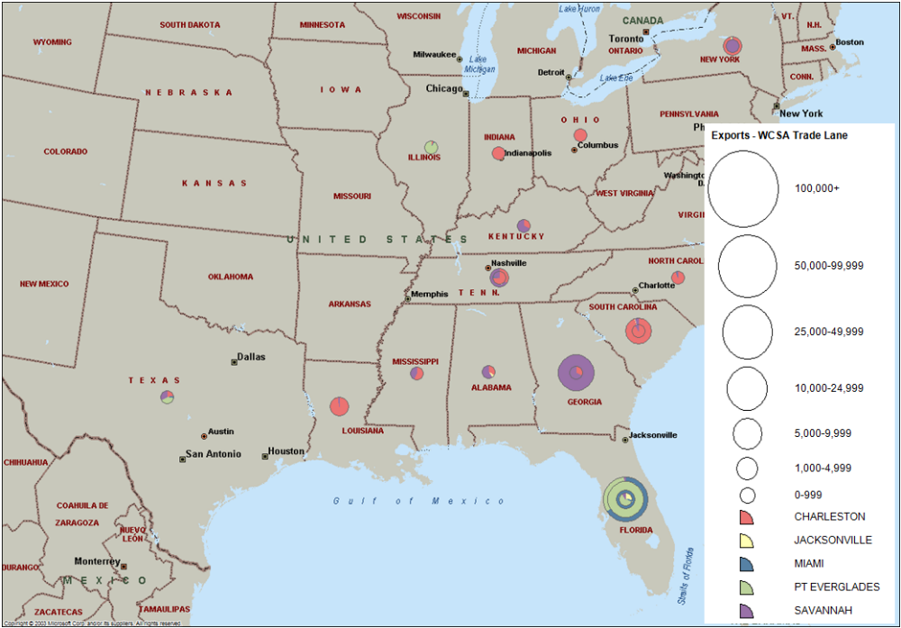
As this series of figures indicate, the Port of Savannah and the Port of Charleston are dominating the South Atlantic market in terms of Asian, Northern European, Middle Eastern, and Mediterranean imports due to the growth of all-water services at these ports. Furthermore, the Port of Savannah is penetrating a significant share of Asian and Mediterranean import markets in South Florida, where Port Everglades and the Port of Miami should maintain a stronghold. In fact, the PIERS data estimates that, in terms of imports, Port Everglades is serving only 28 percent of the local South Florida market. In terms of the Caribbean, Central American, and South American trade lanes, however, JAXPORT, Port Everglades, and the Port of Miami do maintain a significant share of the Florida market. This dominance is more evident in South Florida, where a large presence of consolidation operators uses Port Everglades and the Port of Miami for export operations.
For Port Everglades to increase its participation in the container market, the marine terminals must compete with the other neighboring ports in terms of both voyage and terminal costs as well as inland trucking and intermodal costs to the key consumption points. The results of detailed cost analyses to determine Port Everglades’ competitiveness are described in the following section.

2.3.6 Competitive Analysis of Port Everglades’ Containerized Cargo Market
To identify the potential containerized cargo market for Port Everglades, a detailed cost analysis comparing competing ports in the South Atlantic region is needed. This section identifies comparative voyage costs and inland truck and intermodal costs to determine the hinterland market that Port Everglades can effectively serve.
Comparative Voyage Costs. A proprietary voyage-costing model was used to estimate the voyage costs of calling Port Everglades as well as the competing ports of Charleston, Savannah, Jacksonville, Miami, Tampa, and Mobile. This model has been used to:
- Estimate the national economic benefits of channel deepening and maintenance dredging projects for approval by the ACOE.
- Evaluate fleet deployment and equipment utilization strategies for ocean carriers.
- Develop and define competitive market strategies for public port authorities.
- Assess the impact on transportation costs of using larger vessels, by specific trade lanes.
For this analysis, the voyage-costing model for a 4,800-TEU vessel was calibrated for each port and each trade lane. It was assumed that the vessel was deployed on a direct routing and that 800 containers were discharged at each port. Productivity and vessel turn time were assumed equal at each port. The cost analysis included voyage costs by trade lane, terminal costs, and port costs via each port.
The key inputs into the voyage-costing model are:

- Vessel type.
- Vessel flag of registry.
- Vessel speed (knots).
    - Design speed.
    - Operating speed.
- Design draft.
- Constrained draft.
- TPI (tons per inch of dispersion) due to draft constraints.
- Load port.
- Mileage for entire route.
- Port days (based on vessel load/discharge rate and ports of call on a voyage).
- Use of Panama, Suez Canal.
- Canal fees.
- Vessel capital costs.
  - Capital repayment.
  - Vessel operating costs.
    - Crew wages.
    - Maintenance and repair.
    - Insurance.
    - Stores/Supplies.
    - Miscellaneous.
The input values for the model are derived from several sources. First, the deadweight tonnages and flags of registry are identified. On average, a 4,800-TEU container ship represents the type of vessels currently deployed on the Atlantic and Gulf Coast routings. These vessels are typically foreign-flagged, since the operating costs, particularly crew costs, are significantly less than the crew costs on US flag vessels. A 4,800-TEU vessel typically has a design draft of -43 feet, which is consistent with most container ports on the Atlantic and Gulf Coasts, and is compatible with the current depth dimension of the Panama Canal. With an expanded Panama Canal, however, and the ability of vessels in the range of 7,000 TEUs to transit the Canal, a 50-foot channel depth will be necessary to accommodate these fully laden vessels at first-inbound ports. Furthermore, the ability to use a larger vessel -- a 7,000-TEU vessel rather than a 4,800-TEU vessel -- will provide a significant cost saving per container.
The values for operating costs and capital costs as well as design speed, TPI, design draft, etc. are obtained from the ACOE Deep Draft Self-Propelled Vessel Cost Data Base, while current bunker fuel prices are from Bunker World. For each port, the stevedoring costs, terminal costs, port charges, and pilotage and towing costs have been identified by the Consultant Team.
Figure 2.3-51 shows that, when vessel voyage costs and terminal and port costs at each port are included, the total voyage costs by trade lane are nearly identical for all ports’ marine container terminals on the Trans-Pacific trade lanes. The Atlantic Coast ports typically fall within $60 per box, while the Gulf ports of Tampa and Mobile are at a slight disadvantage on the Singapore and Sri Lanka routings.
Figure 2.3-51
Comparative Voyage Costs/Terminal Costs - Trans-Pacific Trade Lanes
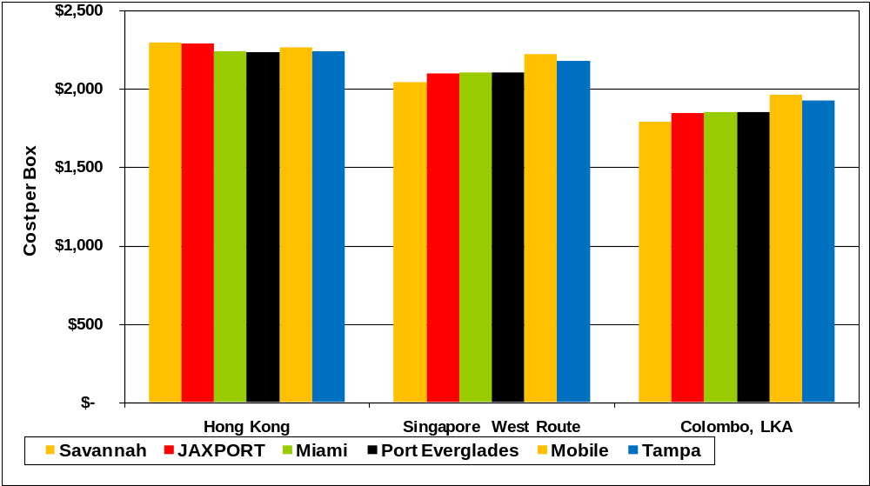
(4,800 TEU Vessel, 800 Containers Moves per Call)

Figure 2.3-52 provides similar information for the Trans-Atlantic and South American trade lanes. The Gulf ports of Mobile and Tampa are at a disadvantage of about $120 to $170 per box on the European and Mediterranean routings
Figure 2.3-52
Comparative Voyage Costs/Terminal - Trans-Atlantic and South American Trade Lanes
(4,800 TEU Vessel, 800 Containers Moves per Call)
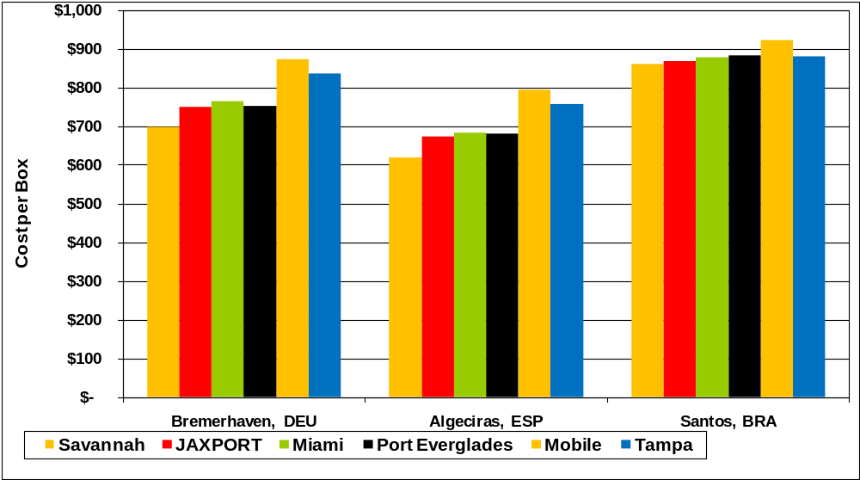

The fact that the voyage costs, including terminal costs, are nearly identical by trade lane to serve the Port of Savannah, the Port of Charleston, JAXPORT, Port Everglades, and the Port of Miami does not appear to be an issue for a new direct all-water service into Port Everglades. Given this finding, the inland cost to access the major container consumption and production centers becomes the key cost component in assessing the competitive position of Port Everglades, particularly for truck market access. The first step in quantifying the potential truck market is to identify the cost-effective hinterland for Port Everglades. Next, the apparent consumption of imported containers is estimated, based on an index of import container consumption per capita. The Consultant Team’s truck travel time cost and actual truck rate analysis to identify Port Everglades’ cost-competitive reach into the identified consumption and production centers is described in the following sections.
Truck Cost-Effective Hinterland. To develop the truck cost-effective hinterland, the Consultant Team developed mileage and truck costs between the Ports of Charleston, Savannah, Jacksonville, Port Everglades, Miami, Tampa, and Mobile to the county seat of each county in Florida, Georgia, South Carolina, and Alabama. This cost-effective truck hinterland is defined as the least truck cost method of serving these counties via the aforementioned ports. The PC Miler data base was used to develop mileage estimates between each port and the county seat of each county, and then, using the Consultant Team’s trucking cost model (which is based on a detailed set of actual trucking costs and fuel surcharge assessments), the mileage was converted into trucking costs.

Figure 2.3-53 shows the cost-effective hinterland of each port in Florida, Georgia, and South Carolina, based on truck costs only, excluding rail. As shown (in yellow) Port Everglades offers the least cost truck routing to serve the counties surrounding Lake Okeechobee and can compete with the Port of Miami for both Broward and Miami-Dade Counties. The Port of Tampa (in purple) has the pure truck cost advantage to serve the Tampa and Orlando markets, which is due to the amount of distribution center activity along the I-4 Corridor.

Figure 2.3-53
Truck Cost-Effective Hinterland Excluding Rail Competition
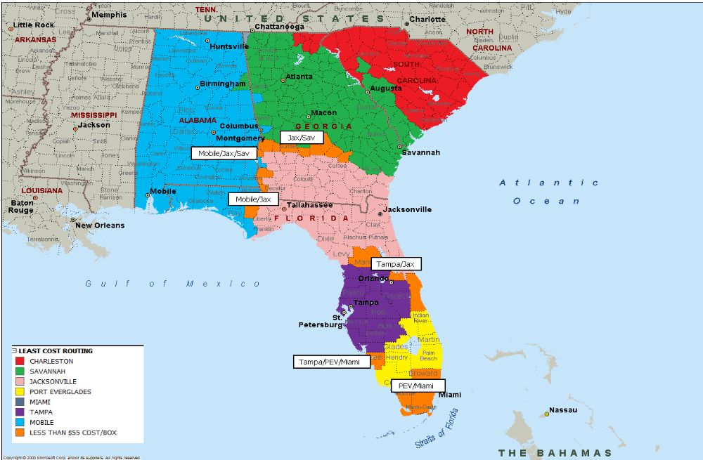

Estimate of Potential Container Market. Two methods were used to estimate Port Everglades’ potential container market. For the first method, the following steps were taken. The Consultant Team collected total loaded import TEUs at US ports, plus an additional 40 percent of the Canadian loaded TEUs, and developed a total per-capita imported container consumption index for the United States. This loaded import TEU per-capita consumption index was applied to the population in each county within the four-state area of Florida, Georgia, South Carolina, and Alabama to estimate the size of the respective import consumption markets. Based on this analysis, the total consumption for these four states is 2.2 million loaded inbound TEUs. Furthermore, based on the ratio of loaded exports and empties to loaded import TEUs, developed from data supplied by the American Association of Port Authorities (AAPA), it is estimated that, for every loaded import container, 1.62 loaded export containers and empty containers move via the Ports of Savannah, Charleston, Jacksonville, Mobile as well as Port Everglades. This suggests that the total TEU market in these four states is about 5.7 million TEUs.
The second method of defining the potential market in which Port Everglades competes was to use the Journal of Commerce’s PIERS data. Using these data, the Consultant Team estimated the total number of loaded imports and export containers destined for or originating within the four states. Based on this analysis, the PIERS data indicated that 1.8 million loaded import TEUs are consumed in these states, and 2.3 million loaded export TEUs originate there, for a total of about 4.1 million loaded TEUs. Based on AAPA data, the ratio of empties to fulls at the South Atlantic ports averages about 32 percent. Applying this ratio to the 4.1 million loaded TEU export and import market from the PIERS data, the total potential container market within the four-state region is about 5.4 million TEUs, compared with the potential 5.7-million TEU market estimated using the population data. This represents about a 5 percent differential.
That the market size estimated with the PIERS data is less than the market size estimated by the per- capita TEU consumption method reflects several key factors inherent in the use of the PIERS data to quantify market size by geographic area:
- First, the PIERS data do not reflect the fact that cargo received at the Port of Savannah or the Port of Charleston may be devanned at distribution centers in proximity to these ports, reloaded in domestic 53-foot vans, and then distributed to inland points as a domestic move.
- Second, the consignee/shipper locations may represent company headquarters, and thus not reflect the true consumption or production point.
- Third, the PIERS data will not reflect imported Asian cargo received at a West Coast port, then moved intermodally to a rail yard in Atlanta, Memphis, or Chicago, and then trucked into the consuming states. Again, the truck move would be recorded as a domestic move and not recorded in the PIERS data.

Figure 2.3-54 details the population consumption by county for the four-state region.

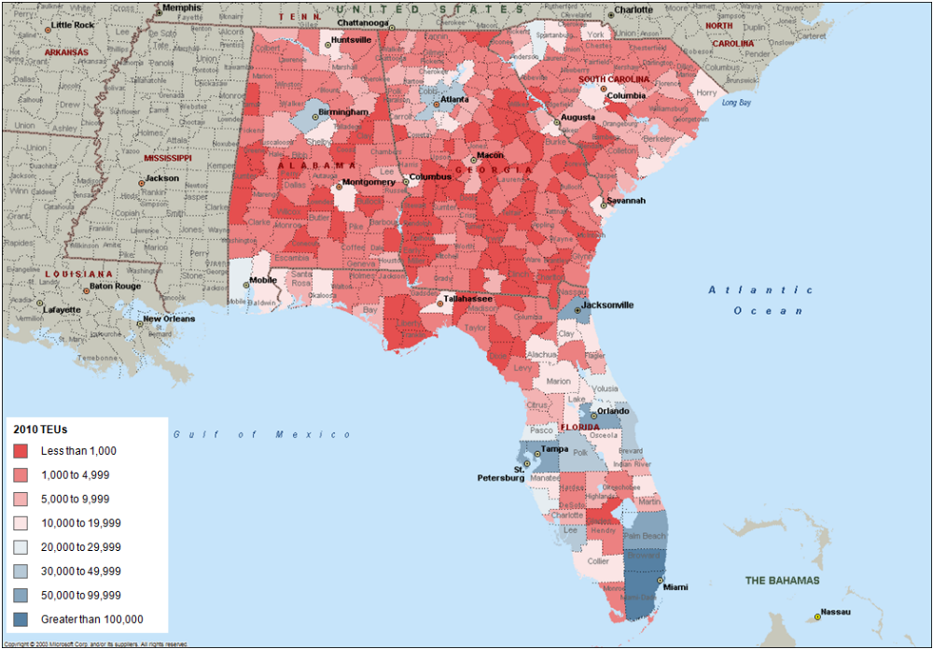
Figure 2.3-54
TEU Consumption by County for Florida, Georgia, South Carolina, and Alabama

As voyage costs, terminal costs, and port costs for an all-water direct service appear to be nearly equal for a call at all the South Atlantic ports, the truck cost to the key consumption markets is critical for market penetration. The estimated number of TEUs by county in those counties for which Port Everglades provides a truck cost-effective market was next computed. Based on this computation, it is estimated that the current Port Everglades cost-effective hinterland, using only truck transport, represents a containerized cargo consumption market of 380,000 loaded inbound TEUs.
Figure 2.3-55 shows the potential TEUs consumed by each county in the truck cost-effective hinterland, excluding rail.

Figure 2.3-55
Potential TEUs Consumed by County in the Cost-Effective Hinterland,
Excluding Rail Competition
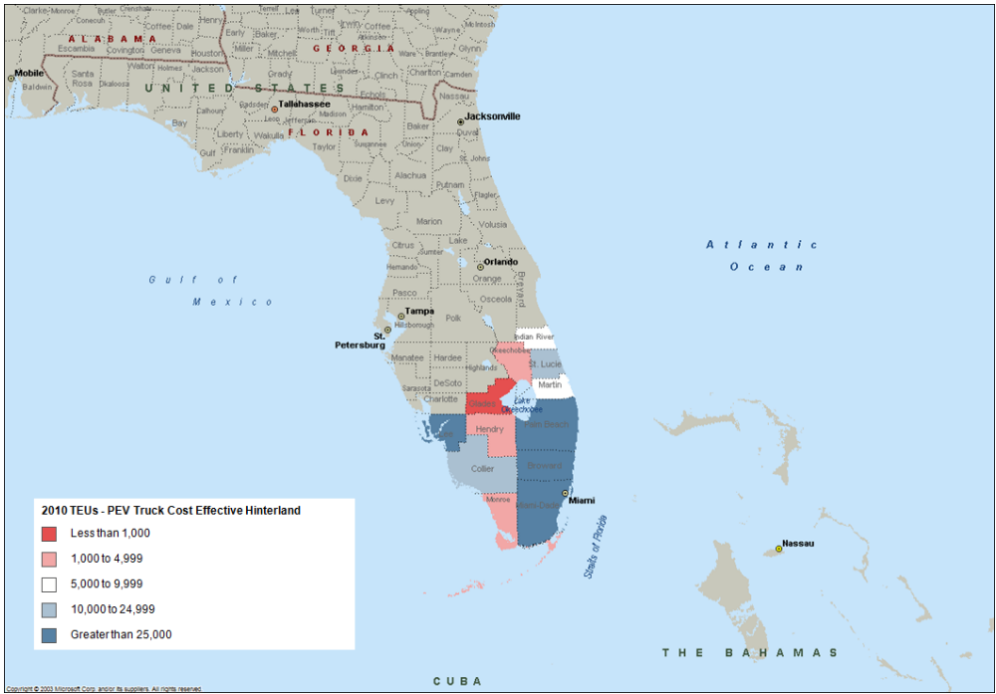

Based on PIERS and AAPA data, it is estimated that Port Everglades is handling about 28 percent (approximately 80,000 loaded TEUs) of the 380,000 import TEUs within the Port’s competitive truck hinterland. Assuming that Port Everglades could capture 50 percent of the remaining 300,000-TEU market, an additional 150,000 import loaded TEUs and a balanced trade of 150,000 export and empty TEUs represent an additional 300,000-TEU market in the near term.
Furthermore, Port Everglades can compete against the Port of Miami, JAXPORT, and the Port of Savannah for the Central Florida (Tampa-Orlando) market, which totals approximately 400,000 inbound TEUs. Assuming that Port Everglades can capture 25 percent of this market, an additional 100,000 import loaded and 100,000 export and empty TEUs are near-term potential.
Therefore, based on Port Everglades’ estimated FY 2009 market of 850,000 TEUs plus the additional 300,000 TEUs within the South Florida truck hinterland and the 200,000 Central Florida TEUs, the current potential truck market for containerized cargo at Port Everglades is initially estimated at 1.3 to 1.4 million TEUs.
Given Port Everglades’ plans to develop a near-dock ICTF, it is assumed, under a high scenario that the Port can maintain its 10 percent intermodal share of the current initial hinterland market of 1.3-1.4 million TEUs (as described in the previous section), and grow to 15 percent intermodal in the long-term. By incorporating the potential intermodal capture, an initial high scenario container market is estimated at 1.5 million TEUs.

Estimate of Potential Intermodal Rail Market. In addition to the already identified truck and local intermodal markets, the ability for Port Everglades to participate in the intermodal market, primarily for cargoes originating in/destined for production areas such as Atlanta and Charlotte must be examined. The majority of the current intermodal traffic handled at the Port is 807 cargo, which comprises textile materials that are railed from North Carolina and Georgia, loaded onto vessels destined for Central American and Caribbean sewing operations, and imported back into the United States as apparel.

To assess the Port’s competitiveness to capture additional intermodal markets, the Consultant Team developed logistics cost routings from the South Atlantic ports of Savannah, Jacksonville, Miami, and Port Everglades as well as from North Atlantic, Gulf, and West Coast ports. These cost routings were used to compare the total cost to serve the key intermodal hubs, including Atlanta, Memphis, St. Louis, Chicago, Kansas City, and Dallas.
To determine the Port’s potential market over the 20-year planning horizon, the analysis focused on both the pre- and post-Panama Canal expansion markets. It is assumed that, once the Panama Canal expansion is complete, a fully laden 7,000-TEU vessel with a -47-foot draft will be capable of transiting the Canal. Therefore, using data available at the time of this analysis, assumptions were made on vessels calling the ports in both the pre- and post-expansion markets. These include:
- Pre-expansion vessel sizes:
  - 4,800-TEU vessel Miami, Everglades, Jacksonville, Tampa, Savannah, Charleston, Houston, New York, Norfolk, and Baltimore.
  - 6,000-TEU vessel Los Angeles/Long Beach, Oakland, and Seattle.
- Post-expansion vessel sizes:
  - 7,000-TEU vessel Savannah, New York, Norfolk, Baltimore, Jacksonville, Port Everglades, Miami, and Houston (included are those ports that have a -50 foot channel, those authorized for a -50 foot channel, and those ports under ACOE review for authorization of a -50 foot channel). Baltimore and Norfolk currently have a -50-foot channel depth, and Miami is authorized to -50 feet. Charleston currently has a -45-foot. channel.
  - 8,500-TEU vessel Los Angeles/Long Beach, Oakland, and Seattle.
Intermodal rates used in this analysis were developed from averages of data collected from various sources, including the Surface Transportation Board (STB) 1 Percent Waybill Sample, Intermodal Department of Ocean Carriers, and Martin Associates’ in-house data bases. Intermodal lift charges and drayage rates were applied to ports that do not have on-dock rail access. It was assumed that Port Everglades would develop the planned near-dock ICTF and JAXPORT would complete on-dock or near-dock rail service to the Dames Point Marine Terminal to serve MOL/TraPac and Hanjin. These rates and charges were then paired with corresponding vessel costs for each trade lane to determine the potential intermodal market penetration.
Based on this analysis, Table 2.3-3 demonstrates the least-cost routing to serve various intermodal hubs through key US ports on the Hong Kong trade lane. The rates presented in this figure include all logistics costs, including ocean, inland truck or intermodal rail, and applicable loading and intermodal charges. The least-cost routing for each key intermodal hub is highlighted in yellow.
Table 2.3-3
Comparison of Total Logistics Costs to Serve Key Intermodal Hubs on a Hong Kong Routing
(Fully Laden, First Inbound Port-of-Call)
PRE | Hong Kong Routing | Atlanta | Chicago | Memphis | St. Louis | Kansas City | Dallas / Fort Worth
4800 | New York | $3,648 | $3,003 | $3,619 | $3,178 | $3,544 | $4,558
4800 | Norfolk | $4,056 | $3,133 | $4,047 | $3,326 | $4,293 | NA
4800 | Savannah (Atlanta served via truck) | $2,991 | $3,772 | $3,577 | $4,556 | $3,854 | $3,858
4800 | Savannah (Atlanta served via rail) | $3,161
4800 | Jacksonville (Atlanta served via truck) | $3,258 | $3,363 | $3,220 | $3,454 | $3,460 | $3,513
4800 | Jacksonville (Atlanta served via rail) | $3,046
4800 | Port Everglades | $3,115 | $3,625 | $3,418 | $3,574 | $6,856 | $4,408
4800 | Miami | $3,198 | $3,708 | $3,501 | $3,657 | $6,939 | $4,491
4800 | Houston | $3,597 | $3,374 | $3,041 | $2,941 | $3,105 | $2,886
6000 | Los Angeles | $3,256 | $2,695 | $2,589 | $2,549 | $2,551 | $2,605
6000 | Oakland | $3,450 | $2,723 | $2,617 | $2,577 | $2,579 | $2,633
6000 | Seattle/Tacoma | $4,866 | $2,418 | $2,711 | $2,497 | $2,453 | $2,722
PRE | Least Cost (Savannah)-PEV Differential | $124
POST | Hong Kong Routing | Atlanta | Chicago | Memphis | St. Louis | Kansas City | Dallas / Fort Worth
7000 | New York | $2,888 | $2,243 | $2,859 | $2,418 | $2,784 | $3,798
7000 | Norfolk | $3,307 | $2,384 | $3,298 | $2,577 | $3,544 | NA
7000 | Savannah (Atlanta served via truck) | $2,254 | $3,035 | $2,840 | $3,819 | $3,117 | $3,121
7000 | Savannah (Atlanta served via rail) | $2,424
7000 | Jacksonville (Atlanta served via truck) | $2,524 | $2,629 | $2,486 | $2,720 | $2,726 | $2,729
7000 | Jacksonville (Atlanta served via rail) | $2,312
7000 | Port Everglades | $2,400 | $2,910 | $2,703 | $2,859 | $6,141 | $3,693
7000 | Miami | $2,482 | $2,992 | $2,785 | $2,941 | $6,223 | $3,775
7000 | Houston | $2,878 | $2,655 | $2,322 | $2,222 | $2,386 | $2,167
8500 | Los Angeles | $2,797 | $2,236 | $2,130 | $2,090 | $2,092 | $2,146
8500 | Oakland | $3,015 | $2,288 | $2,182 | $2,142 | $2,144 | $2,198
8500 | Seattle/Tacoma | $4,451 | $2,003 | $2,296 | $2,082 | $2,038 | $2,307
POST | Least Cost (Savannah)-PEV Differential | $146

As Table 2.3-3 shows, on the Hong Kong routing through the Panama Canal, Savannah is the most cost-effective port to serve the Atlanta market by truck. It is estimated that the truck rate from the Port of Savannah into Atlanta is about $450 to $500 per container. In contrast, the rail rate to serve Atlanta via a South Florida port (Port Everglades or the Port of Miami) is in the range of $550 to $600. The South Florida-to-Atlanta rate does not include the intermodal lift charge, which is assessed at both origin and destination yards, nor does it include the drayage rate from the Atlanta yard to the final distribution center destination. Therefore, even assuming transit time would be equal for a truck move from the Port of Savannah to Atlanta and a rail move from South Florida to Atlanta, which is unlikely, it appears it is not cost-effective, and would be a challenge to serve the Atlanta market via rail from Port Everglades. Thus, Port Everglades’ intermodal market share will remain at about 10 to 15 percent of the total throughput. Also, as shown in Table 2.3-3, other key intermodal hubs, specifically in the Midwest, are served more effectively from the West Coast ports.
The estimates in Table 2.3-3 suggest that the deployment of a 7,000-TEU, fully laden, direct first inbound port-of-call with a 1,500-unit discharge into Port Everglades, unrestricted by depth, berth or crane limitations would result in a cost saving of $700 per container to the ship operator over a 4,800-TEU vessel. Assuming the 7,000-TEU vessel operating a fully laden, first inbound port-of-call with a 1,500-unit discharge, this cost saving would also be realized in all ports with the ability to handle a 7,000-TEU fully laden vessel. Ultimately, if both the Port of Savannah and Port Everglades were able to handle a 7,000-TEU fully laden vessel, the differential to serve Atlanta between the Port of Savannah and Port Everglades would remain and Savannah would continue to serve the Atlanta market cost effectively. Similarly, if the Port of Miami were to have the ability to handle a 7,000-TEU vessel, the cost differential would also remain relatively consistent.
The Port of Savannah is, however, currently at an $800 per box container cost disadvantage over Port Everglades in serving the Broward County/South Florida market. Should a larger 7,000-TEU, fully laden, first inbound port-of-call service be deployed at Savannah while Port Everglades remains at current channel dimensions, this cost differential would narrow considerably, again assuming a full discharge of 1,500 containers in Savannah.
In conclusion, if Port Everglades remains at current channel dimensions, constraining the ability of a fully laden 7,000-TEU ship on a first inbound call, it risks losing market share in its competitive hinterland. This situation could be exacerbated, given the Port of Miami’s authorization to go to -50 feet, which would enable it to handle a fully laden, 7,000-TEU first inbound port-of-call service.
The previous analysis focuses on the comparisons of vessel deployment under a first inbound port-of-call scenario. For services connected to feeder operations out of transshipment ports in Panama and the Caribbean, the water-depth issue at Port Everglades would not likely impact market share in the South Florida hinterland market as these vessels would likely also call the Port of Miami, the Port of Jacksonville, and the Port of Savannah. It should be further emphasized that only a small percentage of the vessels will be fully laden 7,000-TEU ships, and a significant portion of the traffic will continue to be served via 4,800- to 6,000-TEU vessels. Furthermore, as all-water services increase from other world areas outside of Hong Kong and China, including Singapore and the India Sub-Continent, Suez routings will be preferred. Although most vessels will not be fully laden, first inbound port calls, most carriers desire ports with a -50 foot channel, given the expansion of the Panama Canal.

2.3.7 Port Everglades Container Forecast
The factors contributing to the future growth of Port Everglades’ container business comprise a variety of parameters: growth of existing business by current tenants, Florida/South Florida consumption patterns, and the addition of carriers or new terminal operators. To capture Port Everglades’ full potential in the containerized cargo market, low (baseline), medium, and high scenario forecasts were developed incorporating the previous truck and rail assessments.
Forecast Assumptions and Sources. The low, medium, and high container forecasts are based on the following assumptions:
- The forecast base year is a FY 2009 estimate, reflecting the extrapolation of actual first six months of data (October 2008 through March 2009) provided by the Port Everglades Department.
- All current terminal/liner services are incorporated.
- The forecasts incorporate both full and empty TEUs.
- The forecasts represent unconstrained growth.
- The forecasts factor in potential new tenants/services under contract or being pursued by the Port or carriers/terminal operators.
Sources included in developing the forecasts include:
- Historical container throughput data from AAPA.
- Throughput data by trade lane from terminal interviews and PIERS data.
- Published Florida population data.
- Published data from the International Monetary Fund (IMF).
- Carrier/terminal operator interviews.
Historical growth at Port Everglades and the Port of Miami has averaged a modest 2.2 percent annually over the past ten years. Furthermore, the combined volume of the two South Florida ports over the past four years has remained flat. Figure 2.3-56 shows the historical combined container throughput of Port Everglades and the Port of Miami since 1995.
Figure 2.3-56
Port Everglades and Port of Miami Combined Historical Container Throughput (TEUs)

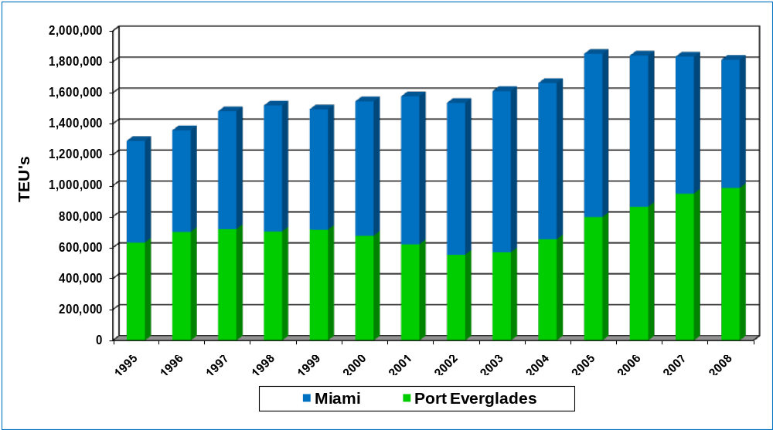

Source: American Association of Port Authorities

The Port Everglades export market serves Latin American and Caribbean countries with consumer goods and supplies and replenishes the cruise and tourism industries with the goods they need for their visitors. Historical and projected growth was examined in terms of gross domestic product (GDP) in the Latin American and Caribbean countries. In recent years, the region’s GDP has experienced average annual growth rates ranging between 4 and 6 percent. GDP rates for 2009 and 2013 are expected to range between 3 and 5 percent. Figure 2.3-57 illustrates the recent and projected 2009 and 2013 GDP growth in Latin America and the Caribbean.

Figure 2.3-57
Latin America and Caribbean GDP Growth
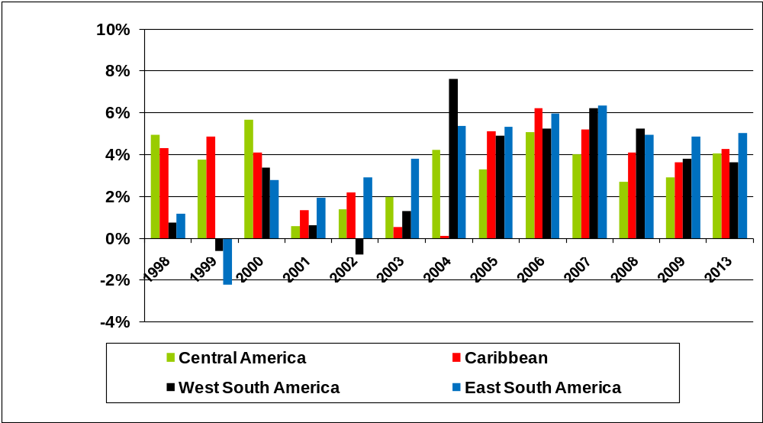

Source: IMF World Economic Outlook, April 2008
Resumption of Free Trade with Cuba. Although it is difficult to forecast the impact of the resumption of free trade with Cuba, it is appropriate to examine the order-of-magnitude throughput of this potential containerized cargo traffic. At the outset, terminal, road, and rail infrastructure improvements would be needed at the Port of Havana as well as at other key deepwater ports on the island, including the Ports of Mariel, Matanzas, Cienfuegos, and Santiago de Cuba. Initial traffic is anticipated to consist of infrastructure equipment, foodstuffs, and household goods for both domestic consumption and an increased tourism industry. It is expected that Cuban-Americans concentrated in South Florida would ship goods to the island.
It is assumed that this trade with Cuba would eventually develop into a two-way trade, with Cuba most likely shipping northbound perishables such as coffee, fruit, vegetables, and cane sugar to the US. It is likely, however, that a majority of the trade would be served via transshipment ports in the Caribbean as well as directly from sources such as Asia. Furthermore, the average Cuban’s propensity to consume would likely be extremely low until economic conditions improved.
The initial demand would most likely result in extremely competitive freight rates. Due to the limitations of current terminal infrastructure, it is expected that regional RO/RO or barge operators that have an already established presence in Florida (specifically, at Port Everglades, the Port of Miami, the Port of Palm Beach, and JAXPORT) and the Caribbean trade would emerge as the key players in the US-Cuba trade. For example, Crowley Latin America currently operates a service to Cuba from Port Everglades.
Forecast Scenarios. Based on the estimated FY 2009 containerized volume and interviews with Port Everglades’ tenants, a low scenario container forecast by terminal was developed assuming a 3 percent growth of base cargo and no new market penetration. The medium scenario assumes a 50 percent capture of the local truck hinterland market and a 25 percent capture of the Central Florida market by 2014, with a 3 percent growth thereafter. The high scenario assumes the capture of the local truck hinterland and Central Florida market shares. It also assumes an initial 10 percent additional intermodal market, growing to 15 percent as the Port’s proposed ICTF develops.
By 2029, the unconstrained container throughput at Port Everglades is projected to range between 1.5 million and 2.5 million TEUs. The low (baseline), medium, and high container forecasts are graphically depicted in Figure 2.3-58. For the facility-need assessment in this Plan, the unconstrained high forecast will be used.
Figure 2.3-58
Low and High Unconstrained Forecast

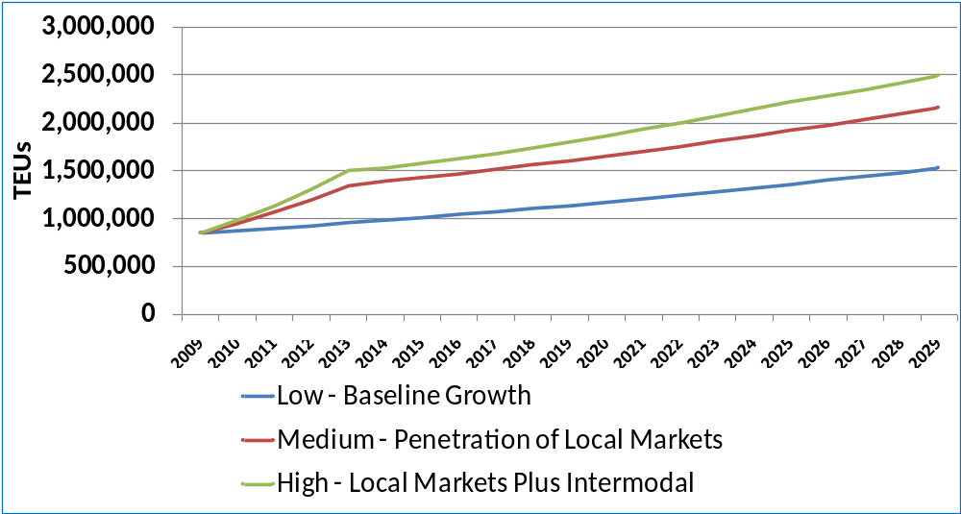

Containerized activity by trade lane is expressed in terms of tonnage rather than container moves or TEUs, since the international trade data focuses on tonnage only and does not include empty container moves
Cross-dock or transload operations refer to the activity whereby marine containers are stripped, i.e., emptied, and the contents are loaded into larger 45- and 53-foot domestic trailers as the Asian cargo tends to cube out (i.e., by area) rather than weight out (i.e., by weight limit). The use of the domestic containers reduces the effective surface transportation cost per ton or unit, as more cargo can be placed into these large trailers without causing the trucks to be in an overweight situation.
United States Department of Agriculture, Animal and Plant Health Inspection Service, Plant Protection and Quarantine.
DR-CAFTA includes the Dominican Republic, Belize, El Salvador, Honduras, Nicaragua, Guatemala, and Costa Rica
“807 cargo” comprises textiles from the US which are sent to Central American and Caribbean countries to be sewn into garments and then are imported back into the US.

