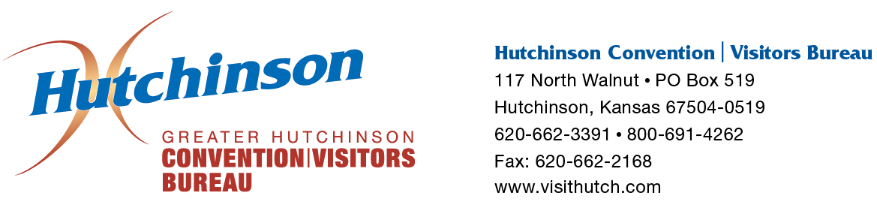

FOR IMMEDIATE RELEASE
CONTACT: LeAnn Cox, Vice President of Operations & Tourism
620-662-3391
leannc@hutchchamber.com

NJCAA to Keep The Tournament in Hutchinson for Next 25 Years

The NJCAA, the national governing body of two-year college athletics, and the American Legion Lysle Rishel Post No. 68 are set to sign a 25-year contract that solidifies the NJCAA Division I Men’s Basketball Championship at the Hutchinson Sports Arena until 2041. Hutchinson has been the home to the NJCAA’s premier basketball championship since 1949 and the event is known locally as “The Tournament.”
Last April, the Hutchinson community sent a clear message to the NJCAA when they voiced their overwhelming support for The Tournament by voting to approve a 0.35 percent sales tax increase to fund a $29.5 million renovation to the Sports Arena. This helped set the stage for the contract extension.
“Without the support of the Hutchinson community, keeping The Tournament here for the next 25 years would not be possible”, said LeAnn Cox, Vice President of Operations and Tourism for the Greater Hutchinson Convention/Visitors Bureau. “The Tournament brings an estimated $1.3 million economic impact to our community which drives much-needed revenues to our hotels, restaurants and retail locations.”
The planned improvements include replacing the plumbing, electrical and heating systems and adding air conditioning and new locker rooms. Additional plans include a new main entrance, lobby and ticketing area, multi-purpose rooms, more restrooms, three full-sized practice gyms, a Hall of Fame and a new weight room. Additional seating compliant with the Americans with Disabilities Act will be also be created on the upper level of the arena.
According to Jerry Ricksecker, American Legion representative and longtime tournament chairman, “The American Legion has partnered with the NJCAA for over 67 years. We rely on our 200 volunteers who are willing to give their time towards putting on The Tournament each year. For some volunteers, this amounts to a year-long commitment. We’re honored that we’ve been able to sign a contract for The Tournament through 2041 and that the NJCAA has confidence in our ability to host a successful championship.”
The NJCAA is the second-largest intercollegiate athletic association in the United States, with over 500 member colleges, and nearly 60,000 student-athletes competing in 48 national championships each year.
“Hutchinson holds a special place in the heart of the NJCAA and we are excited to continue returning to Hutchinson every March,” said Mary Ellen Leicht, Executive Director of the NJCAA. “The Sports Arena renovations will have a positive impact on the student-athletes who earn the right to compete in one of the best collegiate championships in the country.”
A formal signing of the contract will occur during a ceremony hosted by the Hutchinson/Reno County Chamber of Commerce and Convention/Visitors Bureau at the Sports Arena on Monday, February 15 at 10:00 a.m. The public is invited and encouraged to attend this historic event.

###

