CRM Instructions
Updating My Member Records

http://extranet.denver.simpleviewcrm.com

Viewing Your Member Record
Depending on your access levels, there are various items that can be viewed under your Member Record:
- Contacts
- Listings
- Web – Listing Images, Videos, and Coupons
- Amenities
- Benefits Summary

Contacts:
1. To update your contact records, edit the current contact by clicking “Edit” (pencil icon) to the left of the contact.

2. To add a new Contact, click the “New Contact” button.

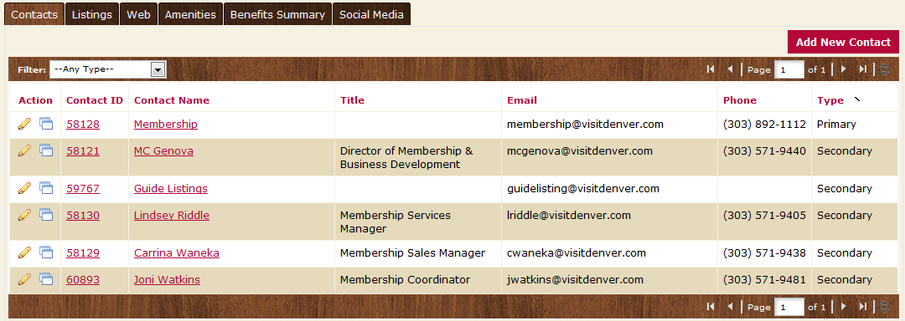

Please note: If a staff member leaves and a new one arrives, please make the old contact inactive and create a new contact record for the new person. You can do this by changing the “Contact Type” to Inactive.

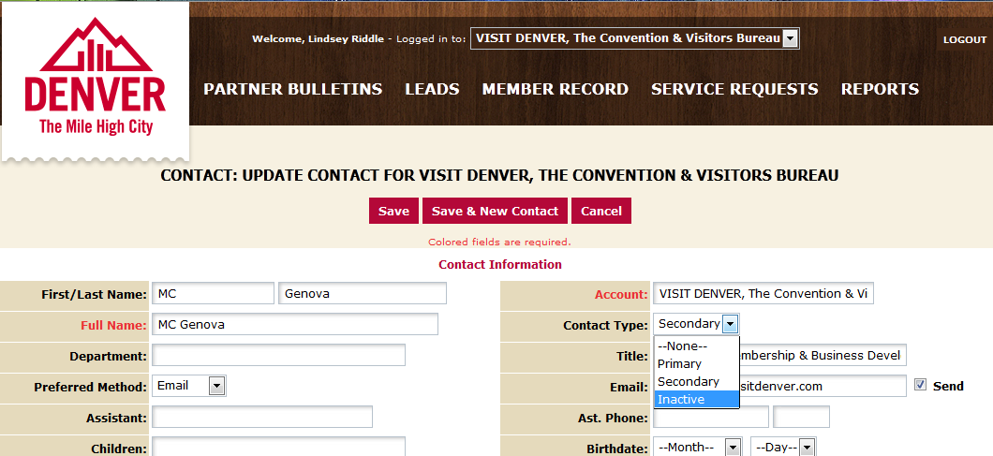
Listings:
- In order to update your listing, click the “Edit” icon to the left of the appropriate listing.
- Change your description.
- Your changes will go into a pending status until a representative from VISIT DENVER approves them. You cannot alter a listing that is pending approval.
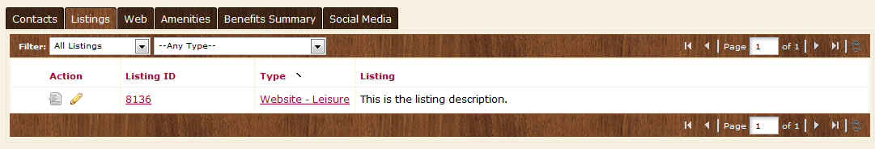
Editing a Listing:
- There are three types of listings:
  - Website – for the www.visitdenver.com website
  - Destination Planning Guide
  - Official Visitors Guide
- Contact Drop-down: This contact will be the main contact for your listing if we were to send a referral to a visitor or group.
- Address Type: Select “Physical” to display the main address on your account
- Listing: Enter descriptive text for your venue.
- Search Keywords: Enter keywords that can be used on the website to locate your listing in a search.
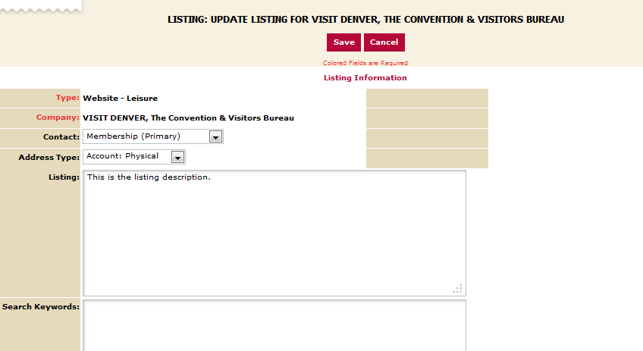

- Listing Details: This information will pull in from your Account Detail; however, by clicking the “Overwrite” box next to each field you may replace it with alternate text
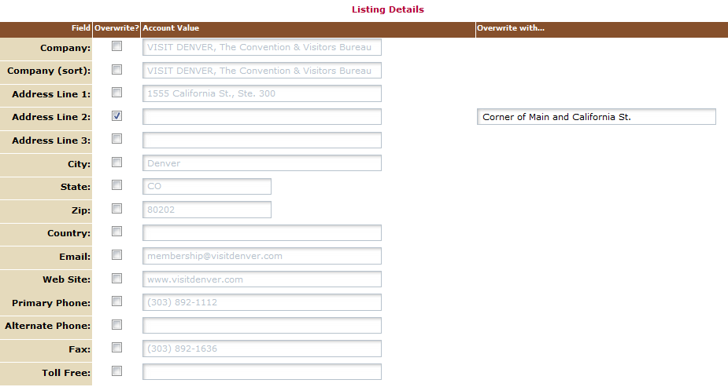

- Website Notifications: Enter any email addresses you would like to be notified with website listing view updates (how many times it has been viewed). You may select re-set intervals or enter a desired one.

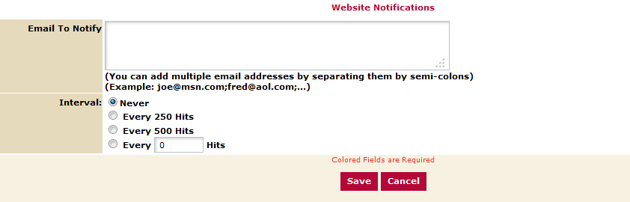

- Click the “Save” button when you are finished making any changes
- When you return to your listing screen, you will be able to tell that your listing changes are pending by seeing that the far left icon is no longer grayed out but blue and yellow

Coupons/Special Offers:
- To create a new coupon/special offer to be included on the website with your listing, click on the “Web” and then “Coupons” sub-tab
- Any past offers you have posted will be listed in this screen
  - You can filter them so that only the pending coupons show
  - They can also be sorted by column/feature

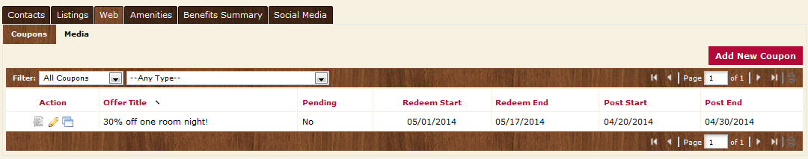

- To add a new coupon, click on the “Add New Coupon” button
- Complete the fields on the form
  - Offer Title
  - Offer Link (if you have a page on your site that specifically details this offer)
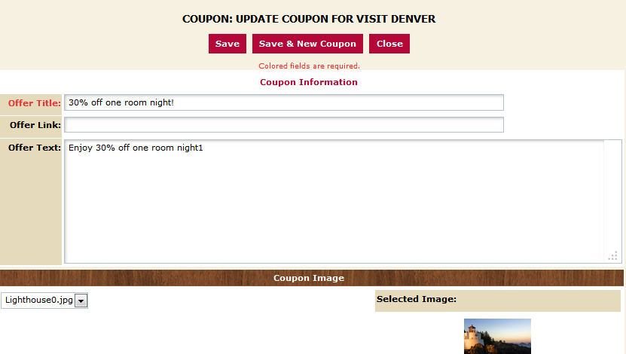
  - Offer Text – Description/details of the offer – include benefits, price, restriction dates and how to redeem offer if applicable

  - The “Redeem From” & “Redeem To” Dates – these will print on the coupon as dates which the coupon is valid (e.g. expiration date)
  - The “Post To” and Post From” Dates – determined by you, your coupon will only show up on the website during these dates – it will automatically be removed on the day after the “Post To” date
  - Select the category of your listing and move it over to the right hand column
  - Click the box next to the listings that you want your coupon to be attached to
  - Click “Save” to submit the coupon to the CVB for approval

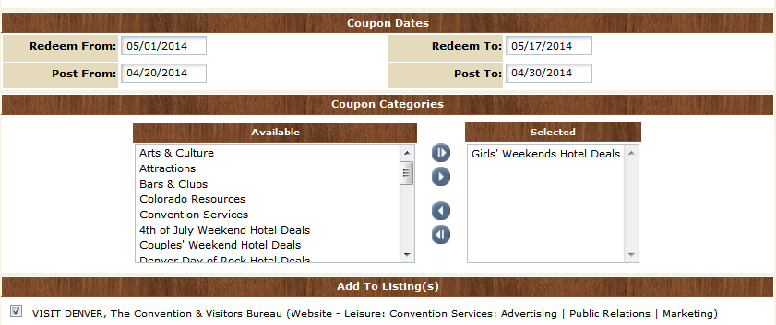

- Upon approval, your offer will appear on your individual listing, as well as on a page listing all Coupons/Special Offers that our members have available
- To edit the coupon, you just need to click on the “Edit” link to the left of your coupon, and make the desired changes
Listing Images
To attach an image to your listing(s), click on the Web tab, and then the Media tab. If you have any images already uploaded you will see them there.

To add new images:
- Click on the “New Logo/Image” button on the right hand side of the screen
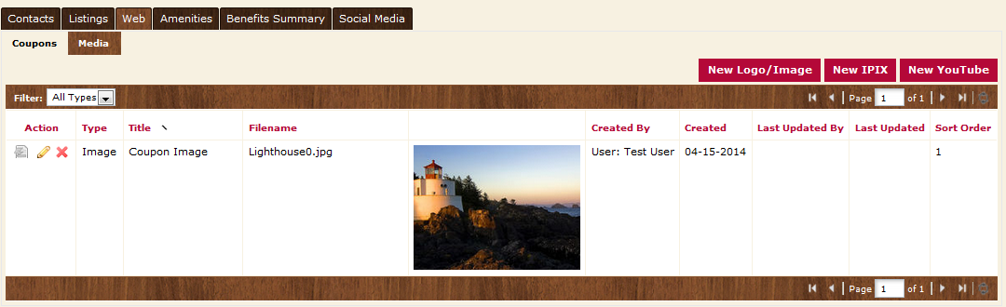

- For your main thumbnail, choose “logo” for type; for photo gallery images choose “image” for type
- Enter the Title of the photo you are uploading
- Browse to find the file on your computer
- Click the box to the left of the listings you would like the image to appear on (Publication Guide listings do not apply)
- Click save to save your image to your account

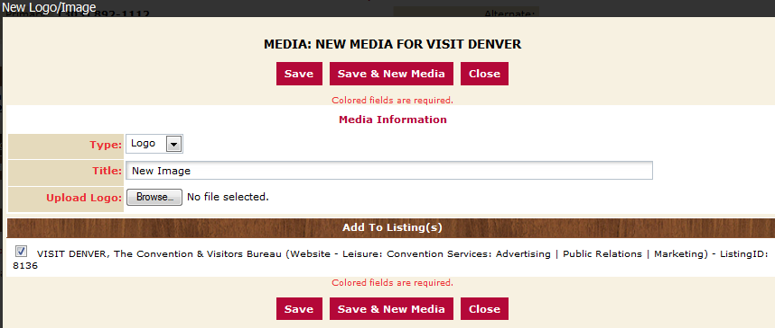

Amenities
You will see a variety of sub-tabs under the Amenities area.
- General and Meeting Facilities

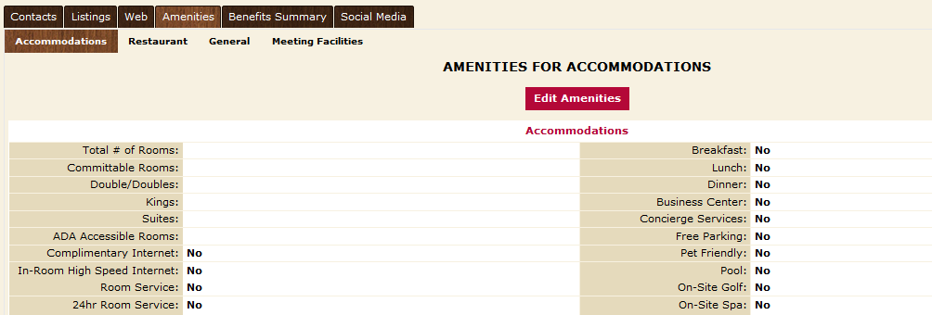

- To edit this information, click the “Edit Amenities” button, make your changes and then save.

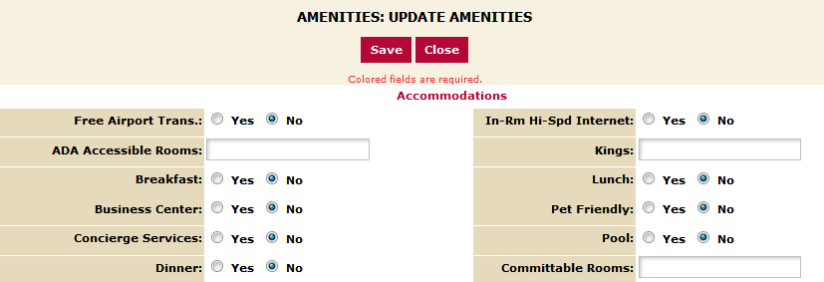

It is important to keep your amenity information up to date as this information displays on the website. This information is also used by CVB staff when searching for venues that can accommodate groups of various sizes.
The “Meeting Facilities” tab allows you to enter information about your meeting and conference space. You also have the ability to add details for each room by clicking the “Add New Room” button at the bottom right hand corner.
NOTE: Attraction providers should be sure to update the fields “Hours of Operation” and “Ticket Prices”

Benefits Summary:
There are various items you can currently view under the Benefits Summary tab):
- Leads (explained in Meeting Sales & Group Tour instructions)
- Services
- Events
- Articles
- Website
- Coupon Hits
- Advertising Opportunities
- FAMs/Site Inspections

Please note: Some of the tabs may have very little or no information available. The CVB now has the ability to track many of these items in their new software. As time goes by and data is populated, you will begin to see more information available to you.
Leads:
This tab will display a detailed list of all Leads that were sent to your business by the CVB. The list is broken down by department & shows the number of Leads in a particular status during the selected time frame.
- Total Number of Leads Sent-This is the number of Leads sent to your business during the selected timeframe.
- Number of Leads Pending-The number of Leads that have been sent, but the winning property has not been selected.
- Number of Assists-The number of Leads where the CVB assisted in the booking. This means the CVB was notified by the client who already knew they wanted to stay at your property.
- Number of Leads Lost to Another City - The number of times the piece of business was lost to a competing city.
- Number of Leads Lost to Another Property - These Leads are committed to Denver, but selected a property other than yours.
- Number of Leads Won, but Cancelled - Your property was originally awarded the business, but the client was forced to cancel

Each of these breakouts is hyperlinked. You can click to view the details of the specific leads that fall under that definition.

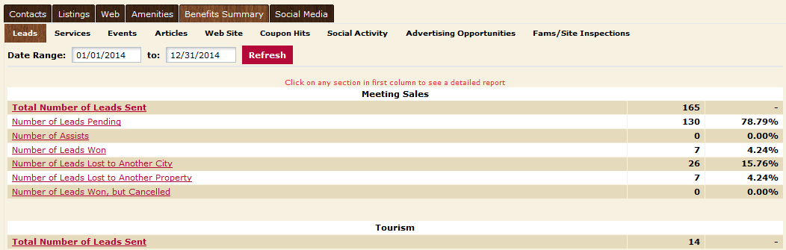

Services:
The “Services” tab allows you to see how many times you to see how many Service Requests were sent to your property. In this section you can see:
- Number of Services Requests Sent – This is the number of Service Requests that have been sent to your property.
- Number of Service Requests Lost – This is the number of Service Requests that have been sent to your property which were not won.
- Partner Referrals Sent – This allows you to see how many times VISIT DENVER has referred your business to clients and/or visitors. Note: The number in this area may seem low. There are numerous times that your business is recommended at conventions or other events where CVB staff does not have the ability to track each individual referral.
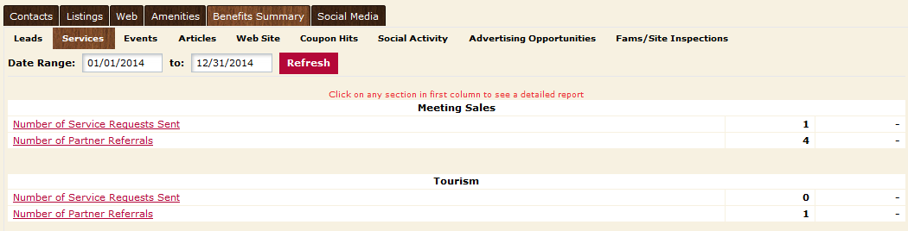

Website & Coupons:
- Under the Website tab, you can view the following:
  - How many times your listing has been viewed during the specified dates (you can view month-by-month by using the drop-down menus as seen below)

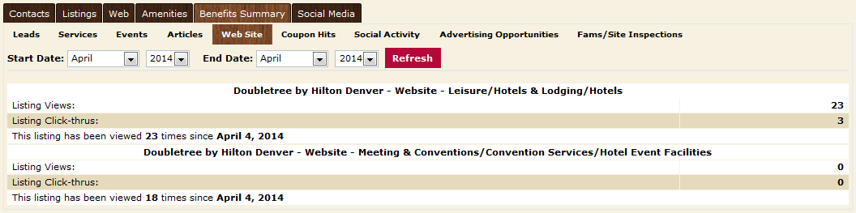

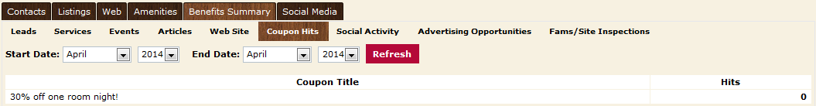
- The Coupons tab will show how many times your Special Offer has been viewed on the website.

Events:
The “Events” tab lists all events that you have been invited to participate in, including member events, tradeshows, etc.

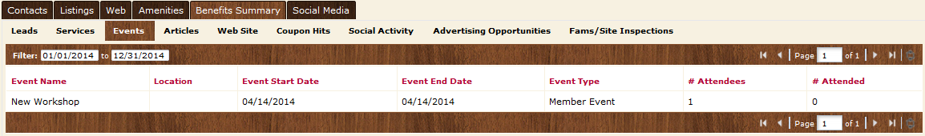

Articles:
Under the “Articles” tab, you can view if your property has been included in any articles that have been generated in publications due to the efforts of VISIT DENVER.

The article date, title, author, medium and circulation (if known), and the article attachment (when available) are all shared in this tab.

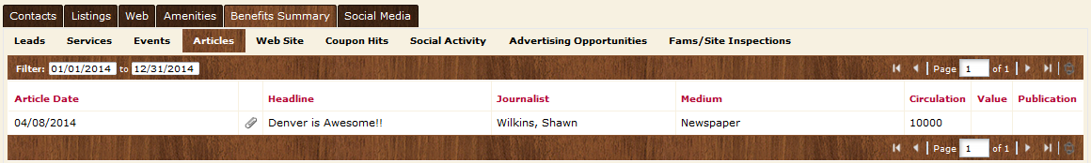

FAM/Site Inspection:
Similar to the “Events” tab, this section lists all instances of FAM tours or Site Inspections that you have participated in.

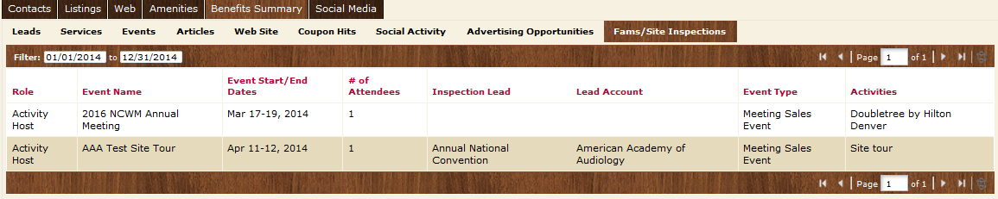

Advertising Opportunities:
- Under the Advertising Opportunities tab, you can view all the promotions in which you participated with VISIT DENVER. You can view the amount of participation whether it was cash or in trade or both.

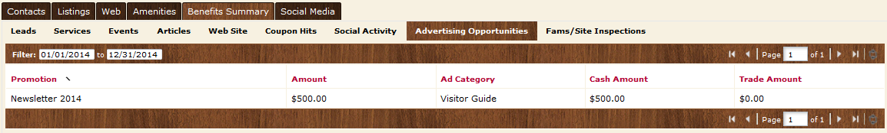

Social Media:
Under the Social Media tab, you currently have the ability to share your link for Face Book. Check back often as other Social Media outlets will be added in the future. To update these fields, fill in the information requested and click Update.
