CRM Instructions
Updating Amenities

http://extranet.denver.simpleviewcrm.com

Viewing Your Member Record
Depending on your access levels, there are various items that can be viewed under your Member Record:
- Amenities

Amenities
You will see a variety of sub-tabs under the Amenities area.
- General and Meeting Facilities

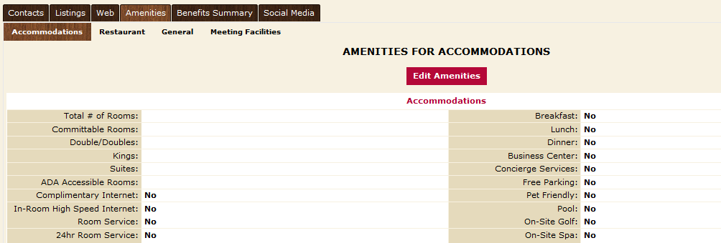

- To edit this information, click the “Edit Amenities” button, make your changes and then save.

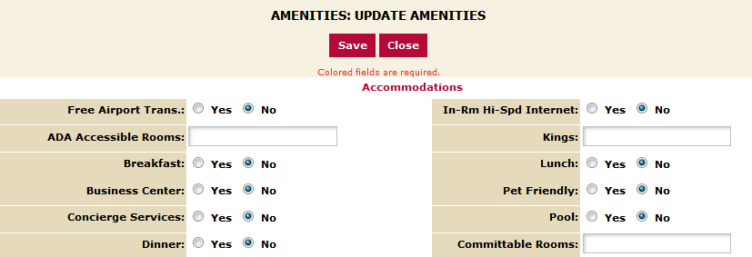

It is important to keep your amenity information up to date as this information displays on the website. This information is also used by CVB staff when searching for venues that can accommodate groups of various sizes.
The “Meeting Facilities” tab allows you to enter information about your meeting and conference space. You also have the ability to add details for each room by clicking the “Add New Room” button at the bottom right hand corner.
NOTE: Attraction providers should be sure to update the fields “Hours of Operation” and “Ticket Prices”

