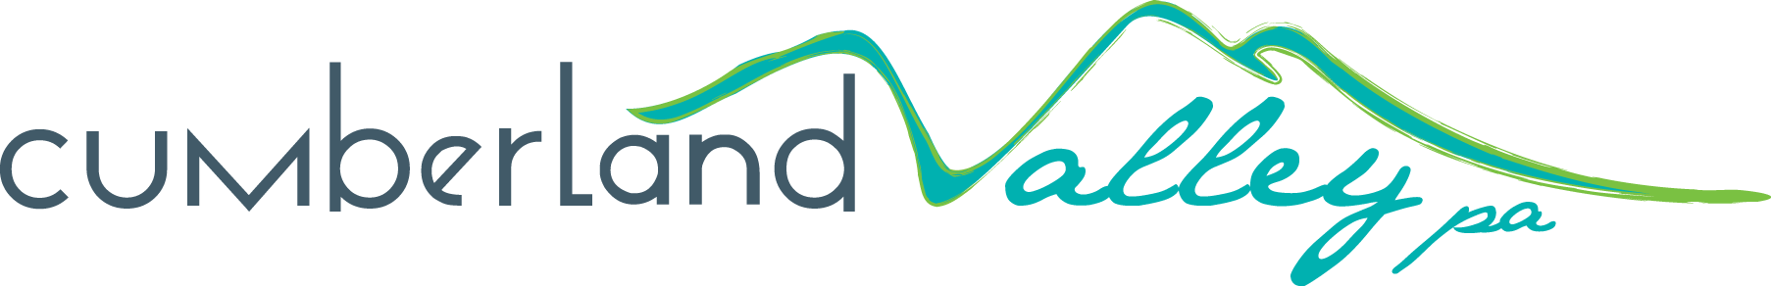
Meetings & Motorcoach
Application Program (MMAP)
Sponsored by the Cumberland Valley Visitors Bureau

Applications due by the 15th of every month for review/approval by the 30th

Section One: Overview
Organization Name:
Street Address:
City/State/Zip:
Contact Name & Title:
Contact Phone & E-mail:
MMAP Request: $________________________ Early Bird Rate: $____________________
EIN #:________________________________________________________________________
Sales Representative: ________________________________________________________
First date in Sales Position at business/property: ________________________________
Please check or note the appropriate Tourism Tradeshow (s):

American Bus Association PA Bus Association

Collaborate Society of GVT Meeting Planners

HSMAI Small Market Meetings

Maryland Motorcoach Your Military Reunion Connection

Other______________________________

Tourism Tradeshow Partner: __________________________________________________

Section Two: Application Requirements

To submit an application for the MMAP Grant the following registration requirements must be met:
- Destination partner must be in business for at least one year.
- Destination partner representative must be in an active sales role at business/property for at least one year.
- Destination partner representative agrees to review the tradeshow collaboration information with the CVVB sales department at least 30 days prior to tourism tradeshow event.
- Destination partner agrees to share tourism tradeshow Leads with CVVB sales department within one week of returning from tourism tradeshow.
Section Three: Application Checklist

- Include the following items to your completed application:

- Copy of completed registration form
- Copy or draft design (for any brochures, or other flier handouts) that includes destination logo

- Submit a digital copy of this application with attachments to:

Cumberland Valley Visitors Bureau (CVVB)
Attn: Dawn MS Rickenbach, Tourism Development Manager
dawn@visitcumberlandvalley.com

- Please also call Dawn to confirm receipt of your application:

Dawn MS Rickenbach, Tourism Development Manager
(717) 240-7191

I/We affirm that all information in this application and all attachments are true and correct to the best of my/our ability, and that the receipt of any funds relative to this request will be used for the purpose detailed within this application. I/We agree to abide by all local, state and federal regulation as they apply. I/We understand that the MMAP Review Committee may request additional information and/or personal interview from applicants.

Name: Title:
Signature: Date:

