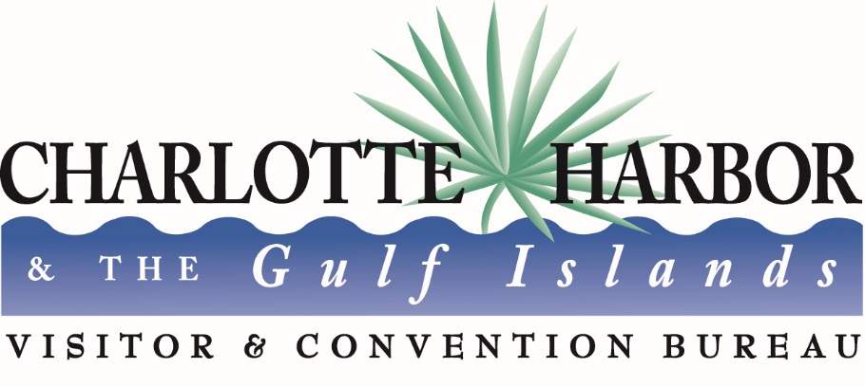

Charlotte County, Florida
Event Development Program
First Year Events

Guidelines and Application

The Charlotte County Event Development Program (EDP) provides funding to assist in the development of new events, occurring between April 1 and December 15 each year, which promote Charlotte County as a tourist destination for visitors. Events which have been held previously in Charlotte County but have not held for at least one year will be considered new events. Funds received pursuant to the Event Development Program may only be used for the purposes authorized in Section 125.0104(5) of the Florida Statutes and specified in these guidelines. The primary objective of this program is to attract overnight visitors to Charlotte County and to promote tourism in Charlotte County.

The Program is administered through the Charlotte Harbor Visitor and Convention Bureau. Applicants are required to provide the following information.

Applicants must substantiate the potential to draw visitors to the area with a regional marketing plan. In addition, applicants must be able to project a number of overnight visitors staying in Charlotte County accommodations. The following application should specify the dollar amount requested and a detailed proposed use of the requested funds.

Resumes of the Event organizers must be included with this application.

The number of awards and the amount of each will be dependent upon the availability of designated funds and specific allocations. The maximum single event allocation is $20,000. If an applicant’s request is above the cap amount the TDC will impose the cap. The total amount available for events occurring between April 1, 2016 and September 30, 2016 is $40,000. The program renews on October 1, 2016 and a budget for the program will be established in the FY 2017 budget process.

Each application will be evaluated by the TDC using the following criteria.

- Production of Room Nights - 50 pts.

  - Does the marketing plan provide a well-researched plan for attracting visitors from outside Charlotte County?

  - What is the projected room night generation? Is it reasonable based upon the marketing plan?

  - Has a host hotel or accommodation partnership(s) been established?

Score ___/ 50

- Out of County Advertising - 20 pts.
To be considered for funding, the proposed Event must be advertised outside of Charlotte, regionally, or nationally.

  - Does the Event provide opportunities for state, regional, national, and/or international exposure?

  - Is the Event proposed to be advertised outside a 50-mile radius of Charlotte County?
Regionally? Nationally? Internationally?

  - Is the Event proposed to be advertised using new media (Constant Contact, e-magazines or social networking)?

  - Has one person (or a committee) been established to handle publicity/media relations?

  - How does the applicant plan to measure their promotions and marketing campaigns for the Event?

  - Is there an itemized marketing/ad budget for the proposed Event?

Score ___/ 20

- Marketing Plan - 10 pts.

  - Does the applicant propose co-op advertising opportunities with other Events or TDC?

  - How creative is the marketing plan?

  - When are the advertising/promotional plans for the Event? Are they planned in advance to promote travel to the Event and produce overnight visitors?

Score ___/ 10

- Economic Impact - 10 pts.
  - How strong is the overall benefit to tourism in Charlotte County?

  - How strong is the out-of-town day trip visitor impact to Charlotte County? Not necessarily overnight visitors but producing an impact for our stakeholders: restaurants, shops, gas, food, entertainment, etc.

  - What area businesses will benefit from this Event?

Score ___/ 10

- Timing of the Event. For multi-day events - 20 pts. / For one day events -10 pts.

  - How unique is the proposed Event?

  - Is the schedule for the Event created in a manner to lure overnight visitors?

  - Does the Event occur on date when hotels are full or near full due to a competing event?

Score ___ / 20

- Additional Organization Information - (5 additional points possible per question)
  - What people or organizations within the community are supporting this event?
  - With what organizations, events or businesses is the event organizer collaborating?
  - Is the event cross promoting with another event that occurs at the same time, before or after this event?
  - Does the event already have sponsorship commitments?
  - Does the Event Funding Program request represent more than 50% of the total event budget?

Score ___/ ₂₅

- Statement of Policies

    - Local Special Event Grant funds are intended to supplement the applicant organization's budget.

    - All applicants are strongly encouraged to review their applications with VCB staff prior to submitting their applications for TDC review.

    - All Event Development Program funding recipients for are required to attend a workshop on reimbursement procedures and promoting/marketing your event outside of Charlotte.

    - All funded Events must provide proof of event insurance and name Charlotte County Board of Commissioners as an additional insured. – Added by TDC but pending approval from County Attorney’s office

- The Charlotte Harbor Visitor and Convention Bureau will calculate the scores and submit the averaged totals to the TDC. After review of the final scores, the TDC will have an opportunity to adjust the total scores if necessary.

- A minimum score of 70 is required for funding.

Upon the conclusion of the funded Event, the Post Event Report, see Exhibit A, attached hereto, must be completed and submitted to the Charlotte Harbor Visitor and Convention Bureau.

Once completed, submit the following application to the Charlotte Harbor Visitor and Convention Bureau, 18500 Murdock Circle, B-104, Port Charlotte, FL 33948.

For reference, retain the prior pages of this packet.
I. APPLICANT INFORMATION
Entity Legal Name: Click here to enter text.
Entity FED #:
Is the Entity a Florida corporation or registered to do business in the State of Florida?
See http://www.sunbiz.org/ Yes: ☐ No: ☐

Application completed by:
Title/relationship to Entity named above:
Telephone No.:
Mailing Address:
Email Address:

II. EVENT INFORMATION
Event Title:
Date(s):
Event Location(s):
Projected number of overnight visitors staying in Charlotte County accommodations:

Hotel/Accommodation Partner Contact Person Telephone Number

Projected number of local attendees/participants (not overnight):

Projected number of out-of-county attendees/participants (not overnight):

Explain how you arrived at the numbers projected.

Attach your marketing and promotional plan. Include: Media and size (if applicable) cost, run dates and area targeted. Examples: Newspaper, 1/8 page, $475, July 1, Tampa Bay area. OR, Facebook boosted post, $200, June 25 until budget is reached,

What are the demographics of the potential attendees of the proposed Event? How will the effectiveness of the promotion of the event be measured? What metrics will you use? Attach separate sheet if needed.

III. LIST EXPENSES TO BE FUNDED THROUGH THE EVENT DEVELOPMENT PROGRAM

IMPORTANT: Funds must be used exactly as specified. Any deviation must be approved by the TDC. Please attach an itemized budget for the entire event.

Item | Costs
Total Expenses | $

Total Grant Amount Requested:
Total Event Budget:
Percent of Total budget represented by EDP funding:
IV. SIGNATURE/DISCLAIMER
On behalf of __, I certify that I have completed this Event Sponsorship Application and attest that all information provided herein and attached hereto is true and accurate:

Authorized Signature Title Date

ROOM NIGHT CERTIFICATION FORM

TO: Accommodation General Manager and/or Director of Sales

The purpose of this form is to quantify the actual number of room nights utilized in Charlotte County for a specific Event. Your cooperation in documentation of these room nights is very important to the Tourist Development Council and our Event Marketing efforts. Thank you in advance for your assistance. Please provide the following information.

Hotel/Location:

TRACKED ROOM NIGHTS
GROUP NAME
EVENT
DATE
PAID ROOM NIGHTS
COMP ROOM NIGHTS

Please provide any comments:

Hotel Representative Signature:

I certify the organization/event listed above utilized the reported room nights.

Print Name: __ Title:

Telephone Email:

Your cooperation in completing this form is greatly appreciated. For additional information please contact the director of the Charlotte County Charlotte Harbor Visitor and Convention Bureau at (941) 743-1900

Event Development Program Visitor Survey

1. What is your zip code?

2. How many are in your visiting party?

3. What was the PRIMARY reason for visiting CHARLOTTE COUNTY?

☐--This event ☐- Vacation ☐- Visit Friends/Relatives ☐-Business ☐-Other

4. How did you travel to Charlotte County?
☐- Vehicle ☐- Plane ☐- Bus ☐-Other

5. How many nights did you stay in Charlotte County?
#Nights Day Trip Only

6. Where are you staying in Charlotte County?
☐-Hotel ☐-Vacation Rental ☐-Friends/Relatives ☐-Bed & Breakfast

☐-Campground ☐-Other Name of Accommodation _

7. How much did you spend on average per day in Charlotte County? Check one

☐$0-25 ☐$26-50 ☐$51-75 ☐ $76-100

☐$101-125 ☐$126-150 ☐$151-and up

8. What activities did you participate in while in Charlotte County? Circle all that apply
☐-Ecotourism ☐-Downtown ☐-Beach/Fishing ☐- Dining Out

☐-Arts/Culture ☐- Sports ☐-Other

9. How did you find out about our event? Check all that apply

☐- Newspaper Ad ☐- TV/Radio ☐- Website ☐- Social Media ☐- Word-of-Mouth ☐- Magazine ☐- Returning Visitor ☐- Other

Optional Information:

Name:

Address:
City: State:

Zip:

Email:

Allowable Expenses

1. Entertainment fees, e.g. musicians/singers compensation, meals & lodging

2. Exhibits or materials for special activities as a part of an event or festival.

3. Advertising, marketing, postage, printing (applications & registration forms) and the purchase of mailing lists.

4. Transportation for larger venues, i.e., carriages, wagons, shuttles, particularly if additional transportation options are needed to increase attendance.

5. Equipment rental (staging, lighting, etc.).

6. Event signage

7. Prize money can be eligible if prize is:

a) published in all advertising;

b) subject to published guidelines;

c) does not exceed $2000;

d) at least three people are responsible for determining the prize winner if a decision is required for that determination. Prize money may only be for an activity that requires skill and may not be used for raffles, lotteries or any game of chance where something of value is required to enter and prizes are awarded by chance or lot.

8. Location fees, permitting fees for event.

9. Event insurance

Ineligible Expenses
1. Any event expenses not approved for funding under “Eligible Expenses.”

2. Salaries, administrative expenses or other monetary compensation to event organization staff.

3. Food and beverage or any hospitality or social functions.

4. Any entertainment that is not for the general audience of the event.

5. Legal, medical, engineering, accounting, or other consulting services.

6. Interest or reduction of deficits or loans.

7. Police or other security during the event.

Post Event Report

1. Document approved expenditures. Please provide original receipts for all EDP funded expenses. Provide copies of signed contracts if applicable. The VCB will make copies and return the originals to you.

2. Provide documentation (hotel affidavits or survey results) that shows room nights generated by the event.

3. Provide evidence of local partnerships, if applicable.

4. Attach a summary of placed advertising

5. Submit results of event survey

6. Provide attendance estimates and the process used to determine attendance numbers, e.g.: ticket sales, aerial photos, law enforcement estimates, etc.

7. Attach all relevant media coverage. This may be done in an excel spreadsheet. Include:

Type of Media (print, radio, television, etc.)
If social media, include stats for the event page
Circulation or audience reach
Geographic coverage of each placement – local, regional, national or international

