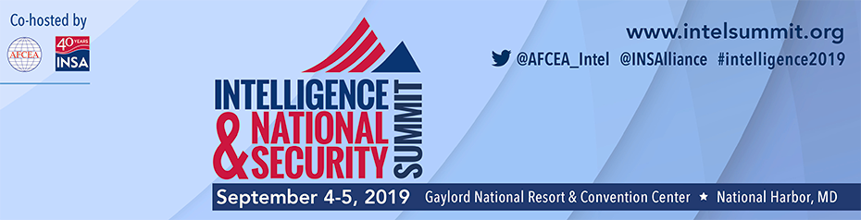

Day | Time | LIST of Continuing Education Sessions  as of July 17, 2019  Approvals for CompTIA CEUs, GIAC CPEs, and/or CertNexus CFR CECs are for 1 unit per full hour of session content so help meet the session time requirement by asking questions. | CertNexus CFR | GIAC | CompTIA
 |  |  |  |  | A+ | Network+ | Security+ | Cloud+ | CySA+ | CASP | PenTest+ | Linux+
9/4/19 | 1:35 p.m. – 2:45 p.m. | Cyber Supply Chain Risk Management: Identifying & Mitigating Threats to the IC*
9/5/19 | 10:20 a.m. – 11:30 a.m. | Active Cyber Defense: Whether or Not to Hack Back*
9/5/19 | 11:30 a.m. – 12:30 p.m. | Defending Cyberspace*
9/5/19 | 2:10 p.m. – 3:20 p.m. | Continuous Evaluation: Balancing Security & Privacy*

If in doubt, please check with your supervisor to confirm which sessions meet your training requirements.

*Session is under review for certification maintenance
Our Continuing Education (CE) program is designed to support certifications related to U.S. Federal Government requirements. Several Intelligence & National Security Summit 2019 sessions have been approved to meet CompTIA, GIAC, and/or CertNexus, and may also support (ISC)2, National Contract Management Association (NCMA), Project Management Institute (PMI), GAGAS, and Defense Acquisition Workforce continuing education and/or certification maintenance requirements.

- How do I identify symposium sessions that are approved for CompTIA CEUs, GIAC CPEs or CertNexus CECs? Approved sessions are noted on the reverse side of this flyer, and will be included in the event show guide and mobile application, and on the event website.

- How do I obtain the session documentation required for me to submit to CompTIA, GIAC and/or CertNexus? Formal attendance documentation is a benefit of AFCEA membership and a service provided to attendees who purchased a continuing education (CE) pass for the event. Participation in an event session qualifying for CompTIA CEUs, GIAC CPEs, CertNexus CECs is required. On exiting the session, get your event badge scanned so that we can document your attendance. We will email documentation of attendance to AFCEA members by October 11, 2019.

- Will attendance documentation be available for all approved sessions listed on the flyer? Only sessions which last at least one hour will qualify for CEUs, CPEs and/or CECs so be sure to take the opportunity to ask questions of the speaker. Formal attendance documentation is only provided for current AFCEA members and for CE Pass holders who had badges scanned for attendance purposes at applicable sessions.

- What if I need additional information about specific continuing education programs?

CompTIA allows individuals to keep their skills current and many of their certifications up to date without retesting by
participation in CEU-qualified training activities. For details on CompTIA Continuing Education Program FAQs: https://certification.comptia.org/continuing-education/how-to-renew/earn-continuing-education-units.

AFCEA members can receive up to a 15% discount on Certification Vouchers at www.traintestcert.com
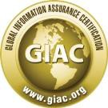 | Each GIAC certification remains valid for 4 years. Two years after certification the renewal process will begin, and individuals must maintain their credentials through Continuing Professional Experience (CPE). For details visit: http://www.giac.org/pdfs/cert-renewal/faq.pdf. You may also email cert-renewal@giac.org.
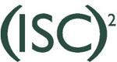 | Credential holders must earn the minimum number of Continuing Professional Experience (CPEs) annually during each year of the three-year certification cycle. Members must earn and submit the minimum annual number of CPEs to maintain their certification in “good standing.” For more information visit https://www.isc2.org/maintaining-your-credential.aspx.
 | Each CertNexus certification remains valid for 3 years. The maintenance process for an LO certification can and should begin immediately upon receiving the certification.
For information about Project Management Institute’s program to maintain credentials visit: http://www.pmi.org/Certification/Maintain-Your-Credential.aspx.

GAGAS: Session content may also support GAGAS (Generally Accepted Government Auditing Standards) Requirements for Continuing Professional Education. We recommend consulting with your supervisor to determine which sessions would help met your individual requirements. A CPE hour may be granted for each 50 minutes of participation in group programs and activities that qualify. http://www.gao.gov/assets/80/76894.pdf
 | Defense Acquisition Workforce: Members of the Defense Acquisition Workforce may qualify for continuous learning points (CLPs) at the rate of .5 point/hour for a maximum of 4 points/day and 20 points/year for attendance at relevant sessions. http://www.dau.mil/CLC/Pages/PointCredit.aspx

If in doubt, please check with your supervisor to confirm which sessions meet your training requirements.

